**DAY 1**

**\* What is a software?**

**\* What is API?**

- We do API testing at the backend level

- To perform API testing we use two postman and rest API

**\* What is client & Server?**

- A client is a computer hardware device or software that access a service made available by a server. The server is often (But not always) located on a separate physical computer.

(From where we are trying to access the application example through browser we are accessing the applications, Client is not always a browser it can be mobile applications)

- A server is a physical computer dedicated to run services to serve the needs of other computers. Depending on the services that is running. It could be a file server, database server, home media server, print server, or web server.

(From where the data is actually coming, many time the server are available on the remote environment)

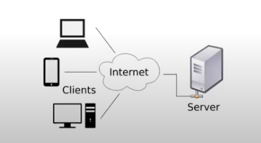

**\* Client/Server Architecture**

**-** Web application mostly follow 3 tier architecture

- 1 tier means (singe system, we save the data on the system only) run the client and server under one machine

- 2 tier means (multiple client server, and have a different data base server)

- 3 tier means (multiple client server, Different database server and between the both the business logic tier shall be there which shall take the response from the client and send the request to the database server to fetch the data)

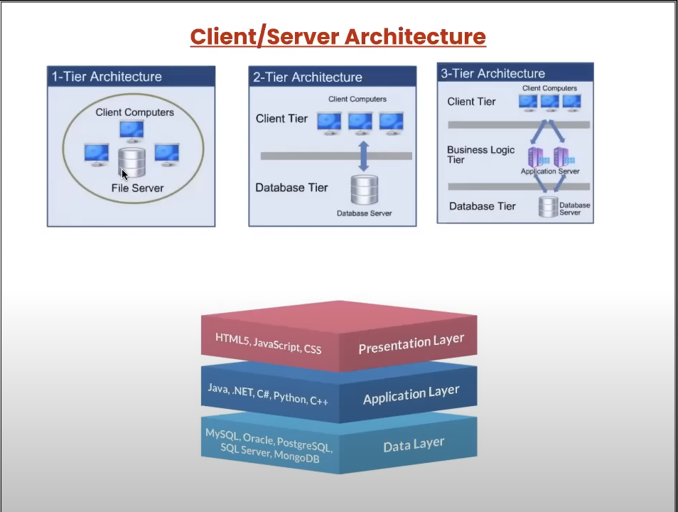

**\* What is an API?**

**Application Program Interface (API)** is the way of communication between two applications where applications may differ in their platforms or in terms of technology.

**API is a way of communication between two layers.**

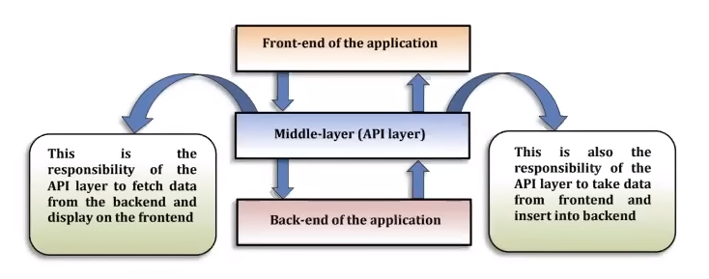

There are two different application like (Make My trip needs the data of the flights from there server so we shall use the API to fetch the details for the flights from there server)

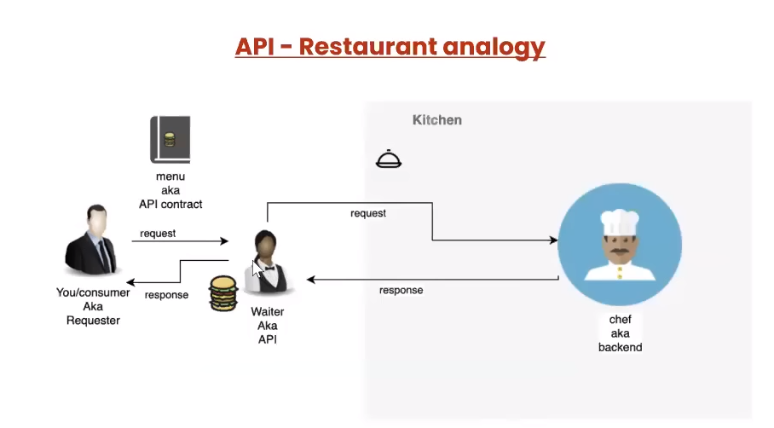

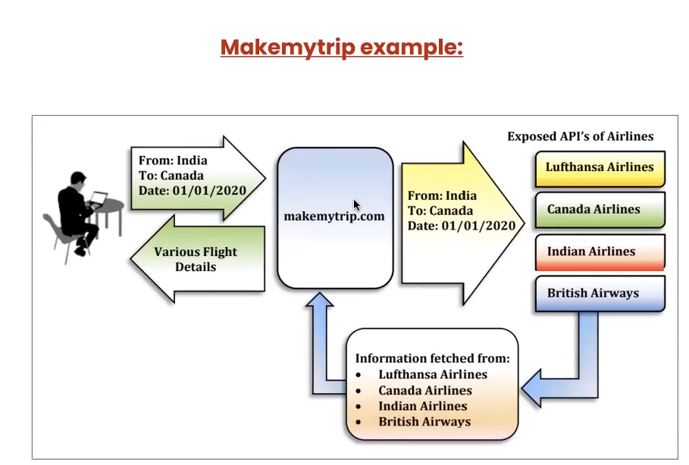

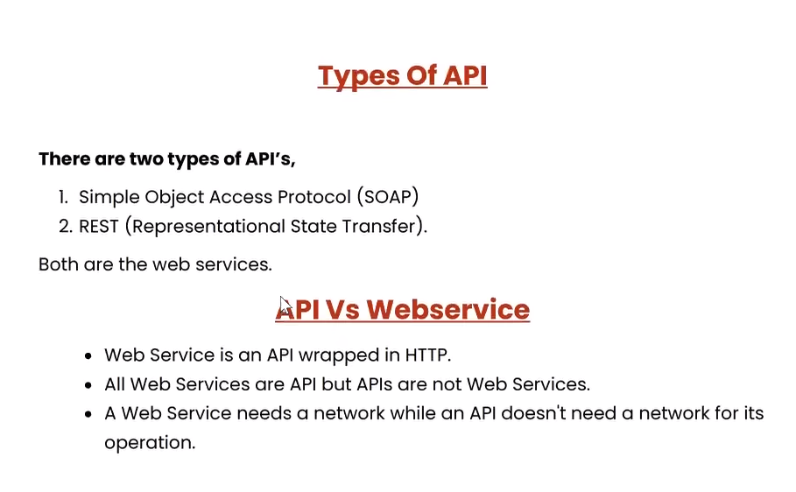

Latest one is REST API.

* SOPA supports only .xlm type of data
* REST supports xlm,json,html,txt type of data

**All web service are API only, but all APIs are not web services. – Interview Question**

Web service means the APIs which are available to the public.

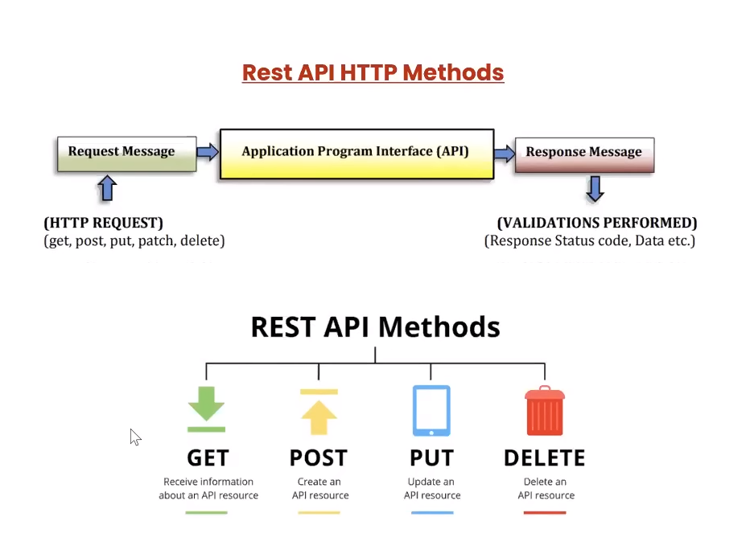

**\* REST API Methods / http request**

- (200) **Get** 🡪 Retrieve the resource from database

- (201) **Post** 🡪 Create resource on database

- (200) **Put** 🡪 Update existing resource on the database

- (204) **Delete** 🡪 Delete existing resource from database

- **Patch 🡪** update the partial resource from database (Not much frequently used)

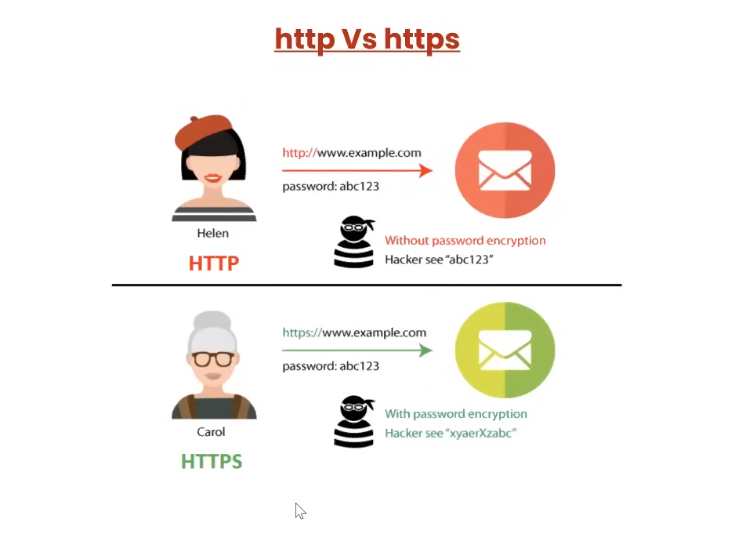

**HTTP:** Hyper Text Transfer Protocol

**HHTPS**: Hyper Text Transfer Protocols

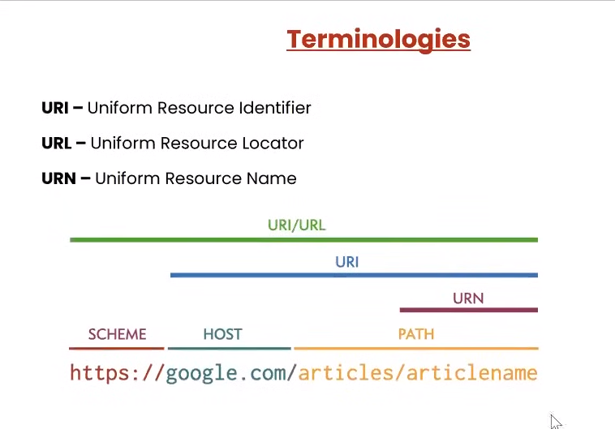

**Host:** We can also call it as a domain.

* Only the path shall fetch the exact data
* Resource is something which is there in the server, which the requestor is requesting for.
* **Path** is also called as **endpoint**
* Shall get all the endpoints from the development team (Also they shall provide with the location where are the APIs are deployed) for the testing and based on that the host name shall be changed.

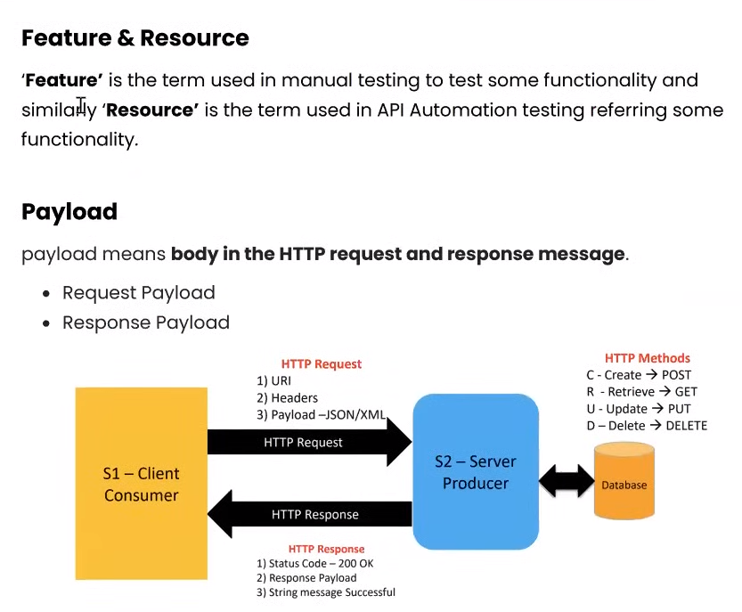

**What is payload?**

The data which we are sending along with the request is called payload. And also the data coming along with the response.

* **Consumer** is whoever is sending the request or we can call them as client.
* Only **get request** is possible through the browser

**Sample API Sites**

* Reqres.in

**Whenever we test an API, we have to pass some request/input (Data/URL/Keys). And in the response we shall get some data, status code, cookies, and headers**

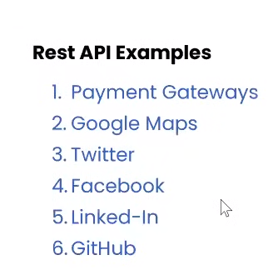

**DAY 2**

**WHAT IS POSTMAN**

* It is an API testing tool.
* We can do manual testing of APIs using postman.
* Postman tool supports both **desktop/web.**
* As soon as we start the API desktop version we need to create a **workspace.**

**WHAT IS A WORKSPACE**

* It is an area where we maintain the files and save
* There are 4 types of **Visibility** options in the workspace (**Personal** – Only you will have the access, **Private** – Only the you and the invited team members shall have the access to it, **Team** – All the team members shall have the access, **Public** – Anybody can view it)
* Most of the time the **Team** option shall be used in the workspace.
* Create, Rename, Delete

**WHAT IS A COLLECTION**

* Collection contains the folder in which we shall save our requests.
* Inside one workspace we can create end numbers of collections.
* Create, Rename, Delete, and Run the collection, Create duplicate collection, Can export the collection as json file. And also import the same in postman.

**API Test Cases:**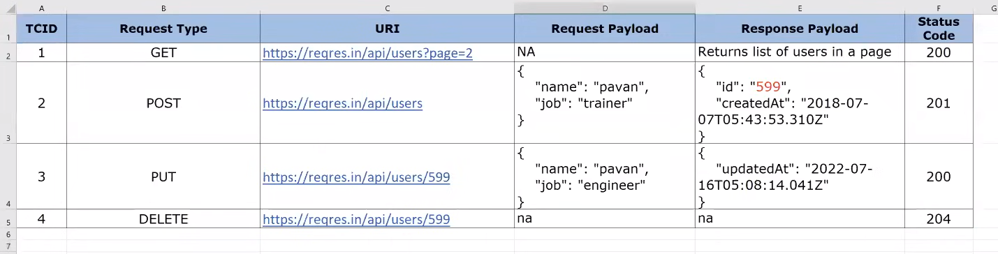

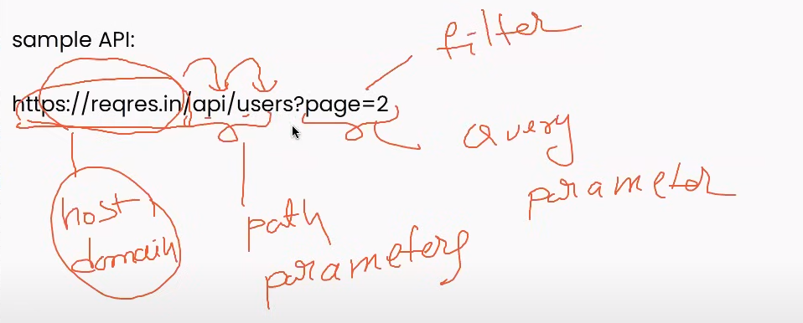

**We do validation on response payload – Interview Question**

**Cookies** are the temporary files which are created while browsing some pages.

**WHAT ARE THE VALIDATIONS WE CHECK FOR?**

* Status code
* Time
* Size of data
* Response body (json / xml)
* Cookies
* Headers

**HTTP STATUS CODES:**

3 levels of status code.

* **200** 🡪 Request is successful done
* **400** 🡪 Unauthorized access of APIs
* **500** 🡪 Server issues

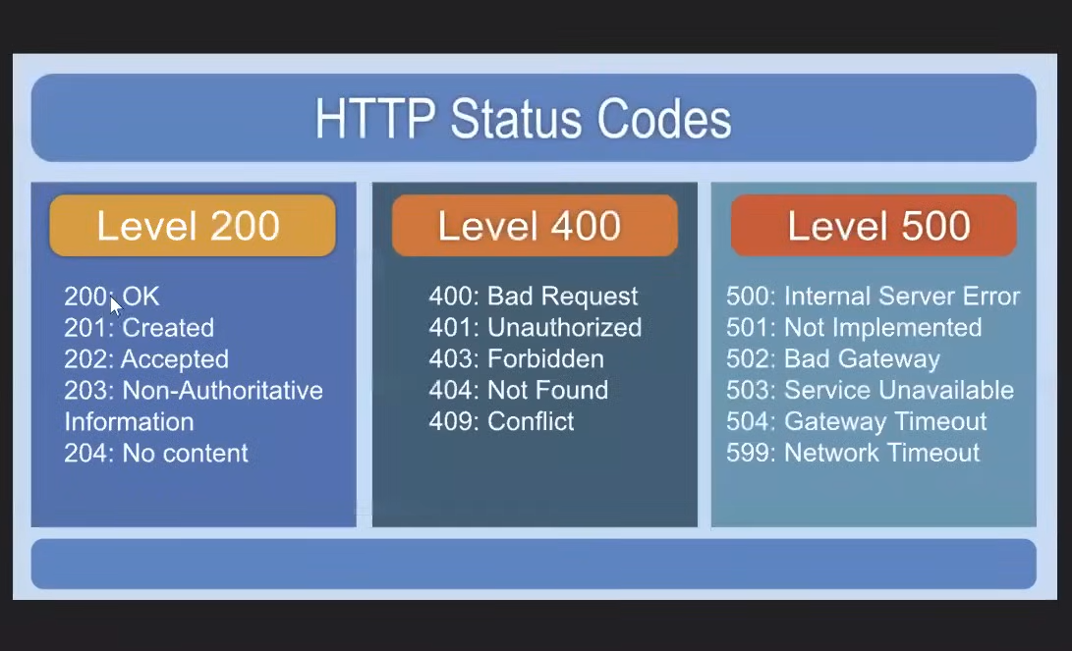

**DAY 3**

**HOW TO CREATE OUR OWN API:**

* Node JS software need to be installed. (Node package manager -- NPM)
* Install json server then.

Install Node JS : <https://nodejs.org/en/download>

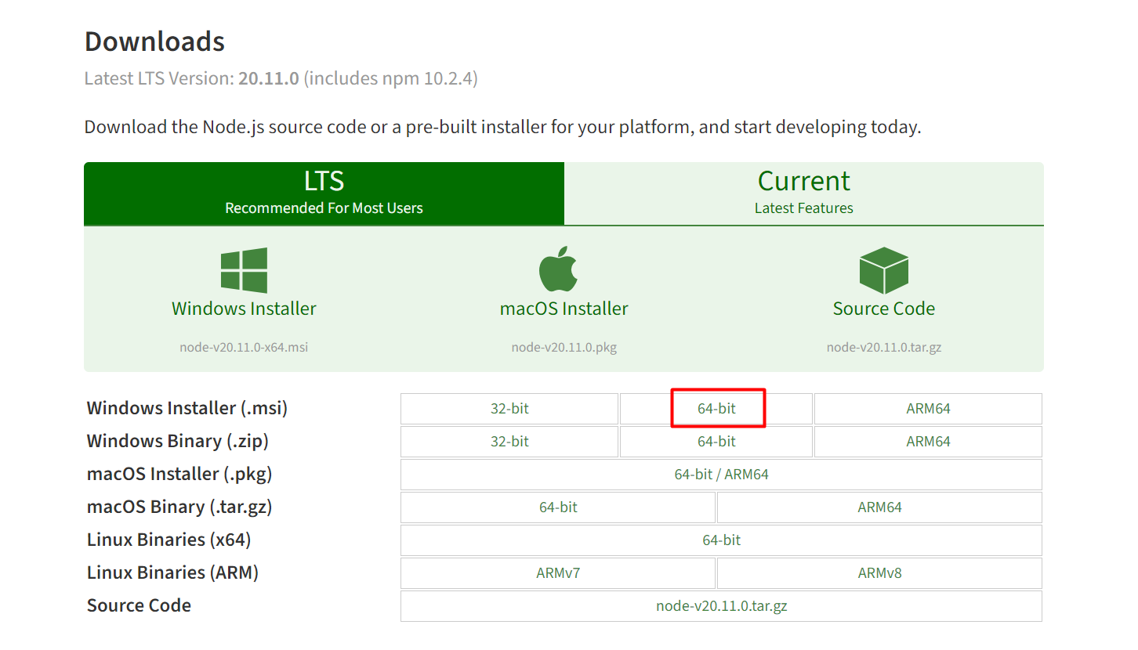

Once installed check for the environment variable > My PC > Advanced system settings > Environment variable > Click on Path > Edit

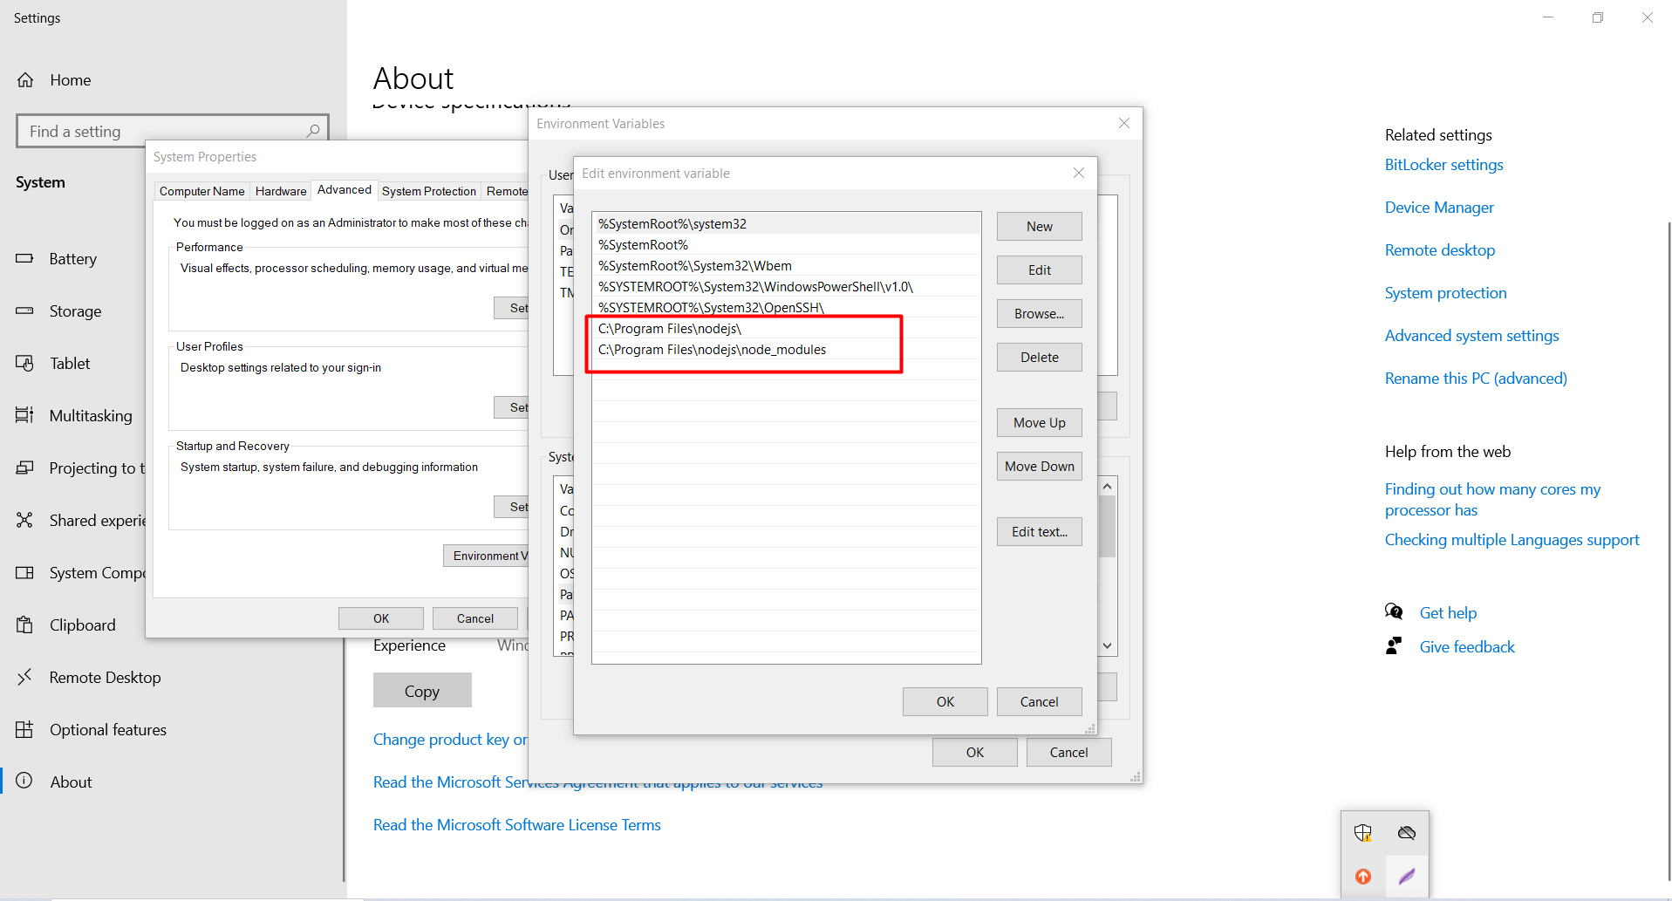

Check Node & npm version (npm comes along with node.js)

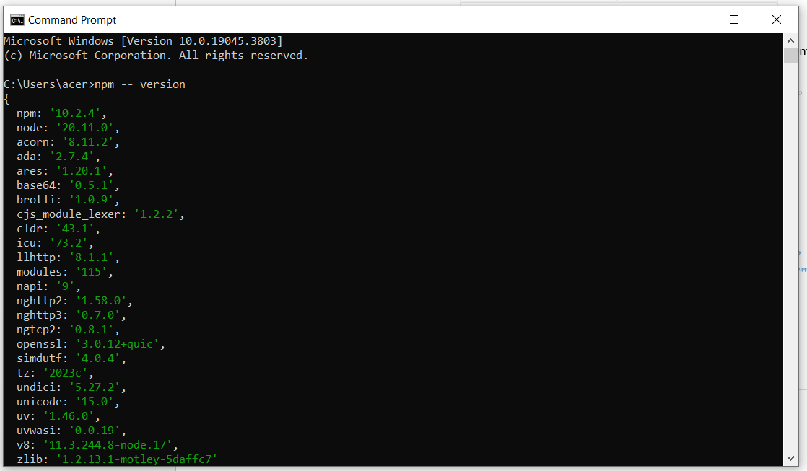

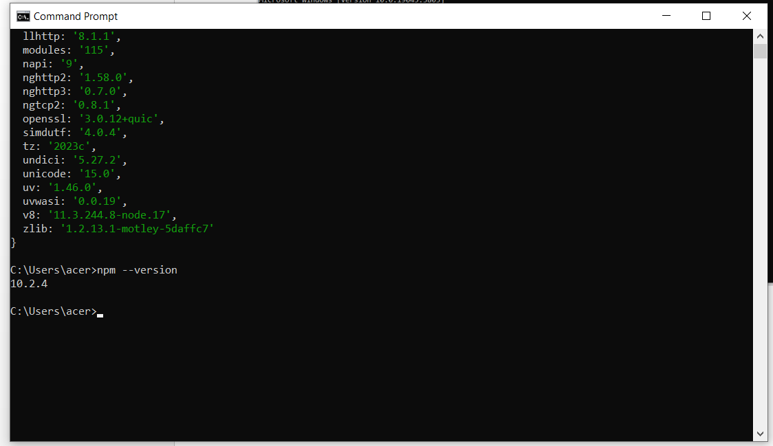

**INSTALL JOSN – server (Required to run the json files)**

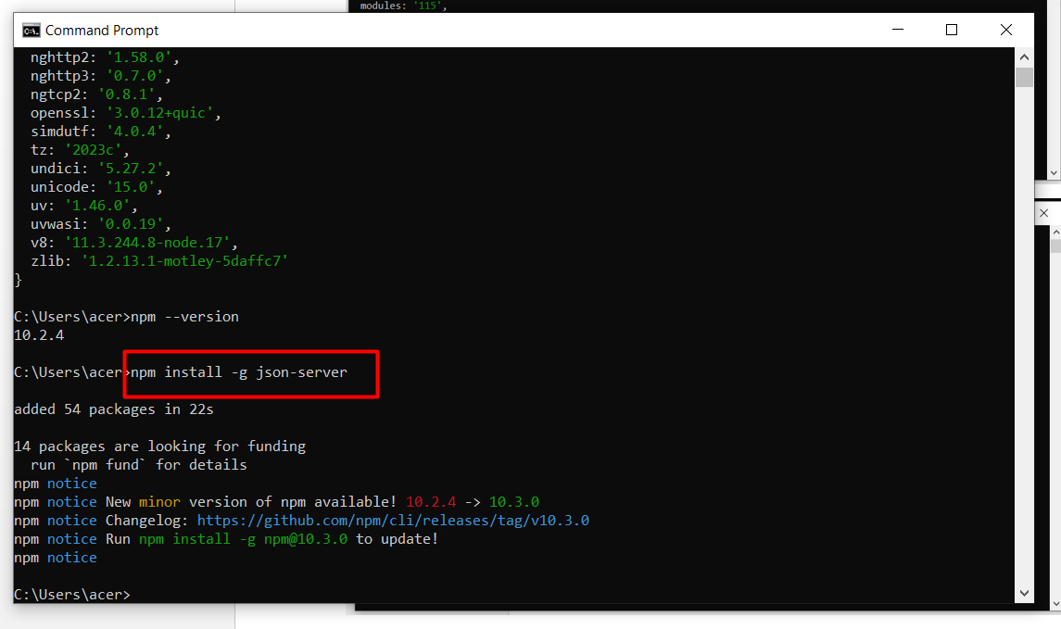

How to run the json file.

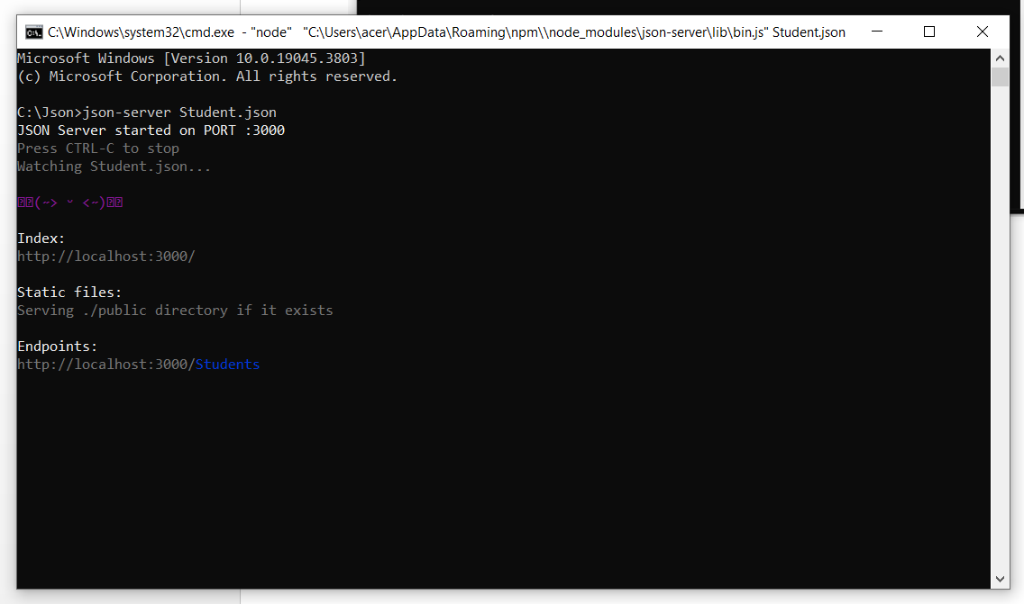

Now you can test your own API in the postman tool.

**WHAT IS JSON?**

* **JSON :** Java Script Object Notation (Data format)
* The communication which happen between the client and the server is through json or sometimes it is in the .xml format.
* Whenever we are transferring the data between the client and the server we need to change the format type into json.
* Need to convert into json because it is a low weighted data.
* The data should be encryption and decryptions.
* .xml services shall be used in SOPA.
* .json services shall be used in the REST.
* Json object is which contains multiple key: value pairs.

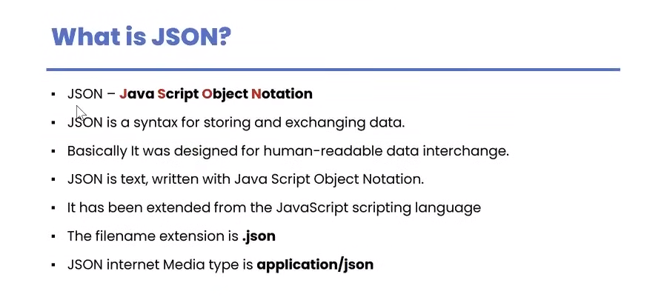

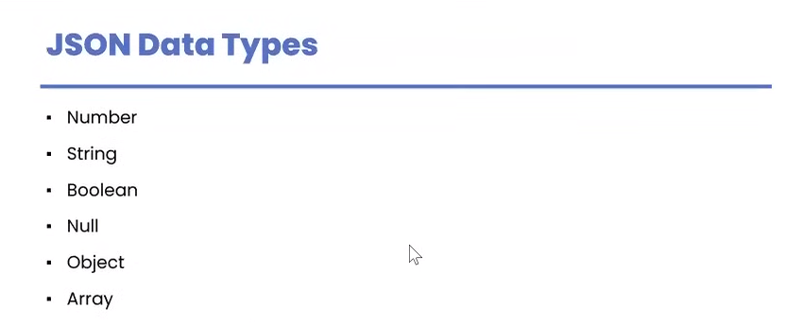

Boolean: True or False.

**In json we have to represent the data in the form of key and value pair.**

Key: Value

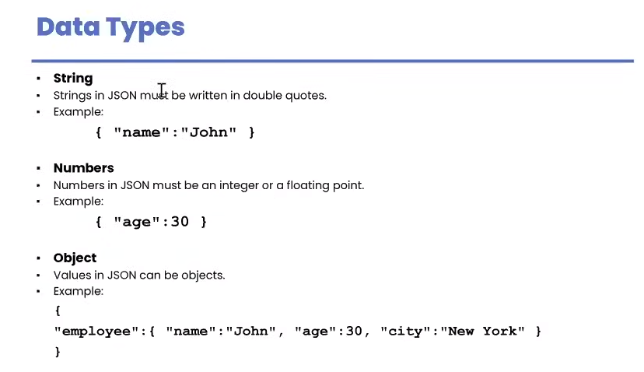

Key is always included in the double “ ” quotations

If we have to put in the multiple values for a particular key we need to put the data into square brackets [“A”, “B”, “C”] it is called as Array.

In Boolean True or False is not a number or string it is a representation.

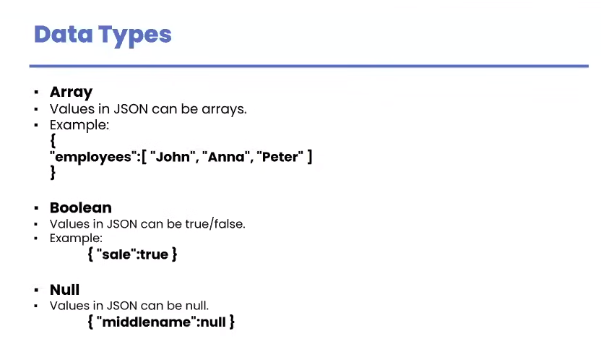

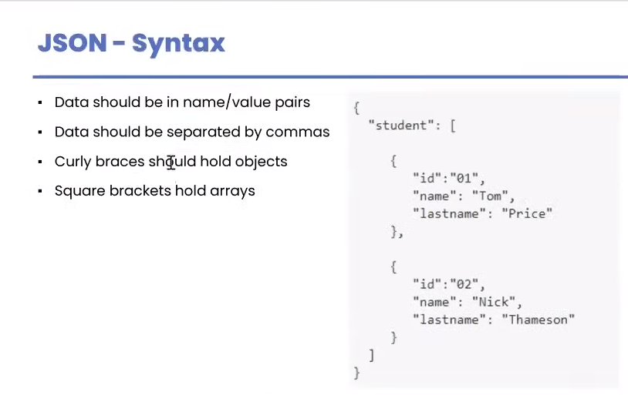

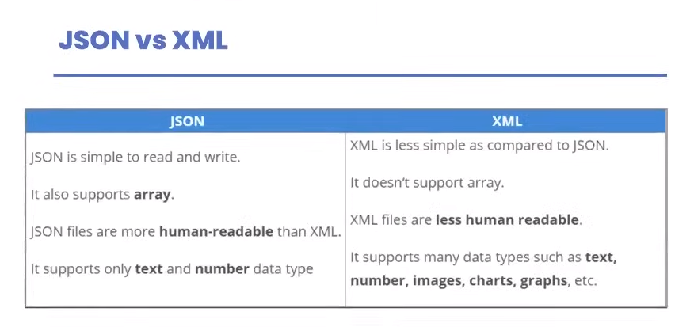

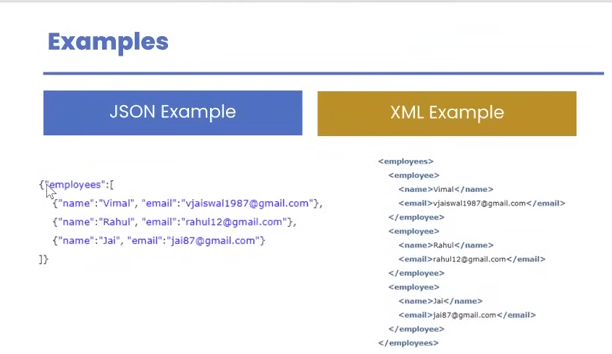

**JSON Object & JSON Array.**

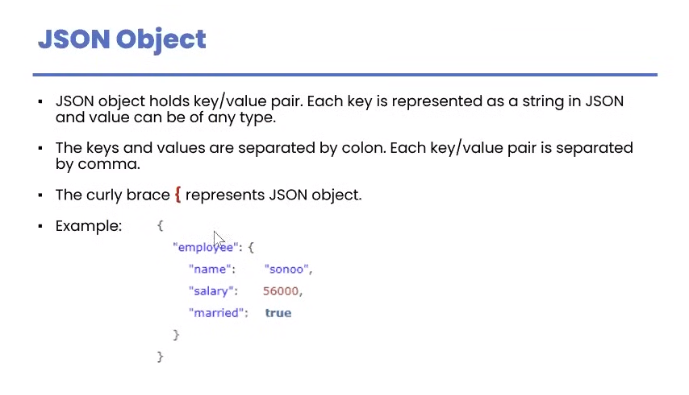

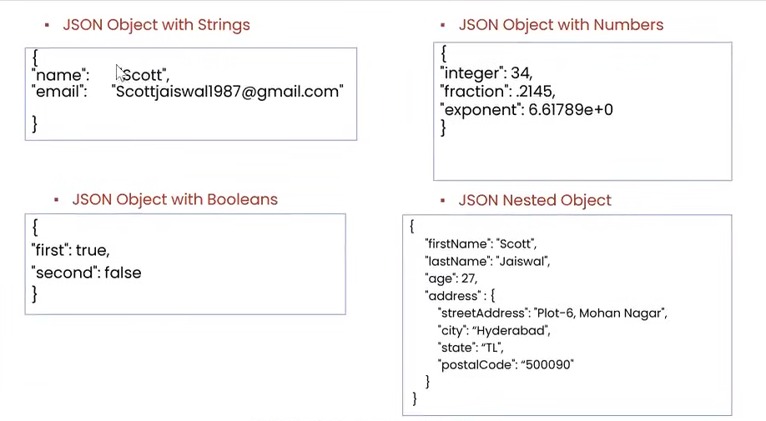

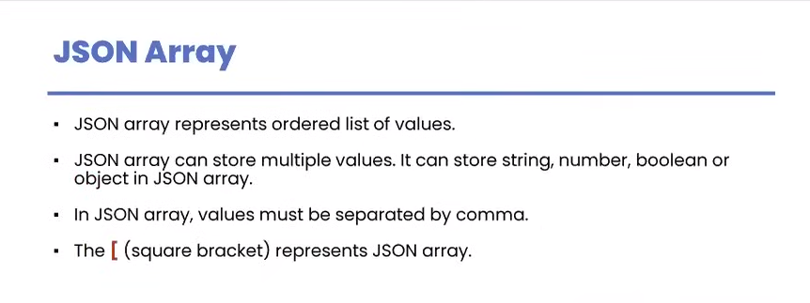

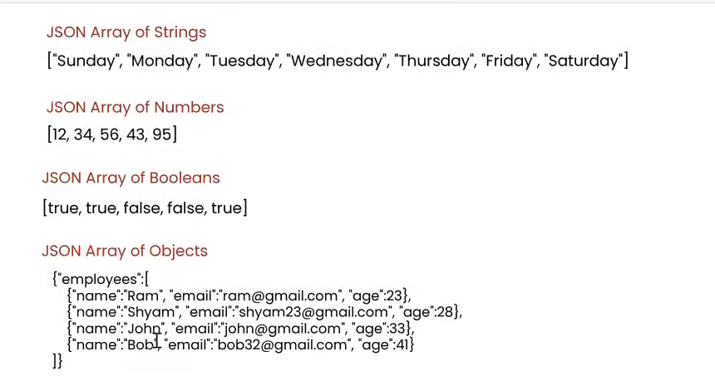

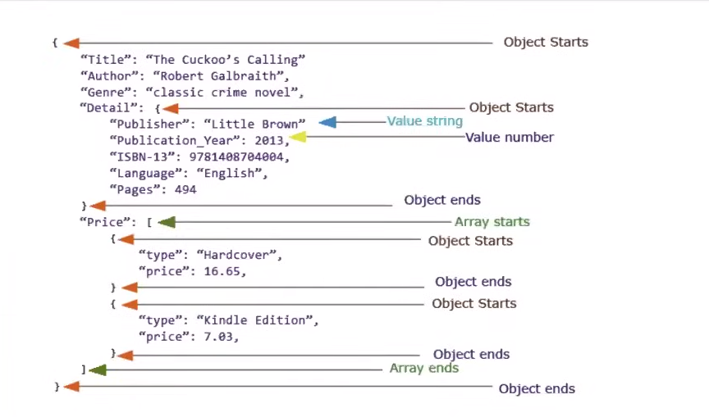

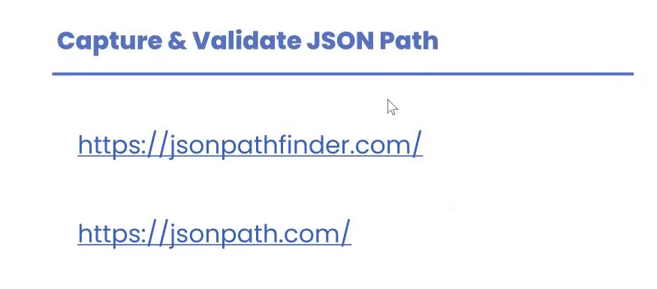

With the help of json path we shall be able to extract the data from the json file.

Array index shall be start from zero.

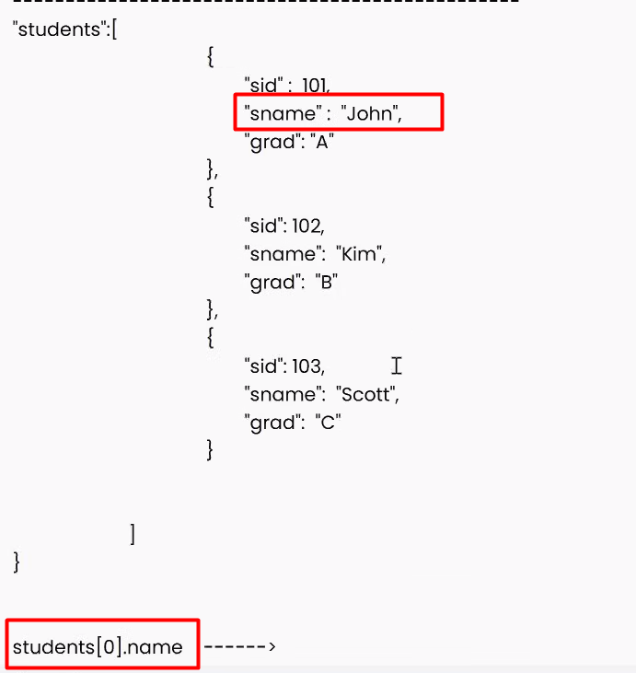

Generate json path:

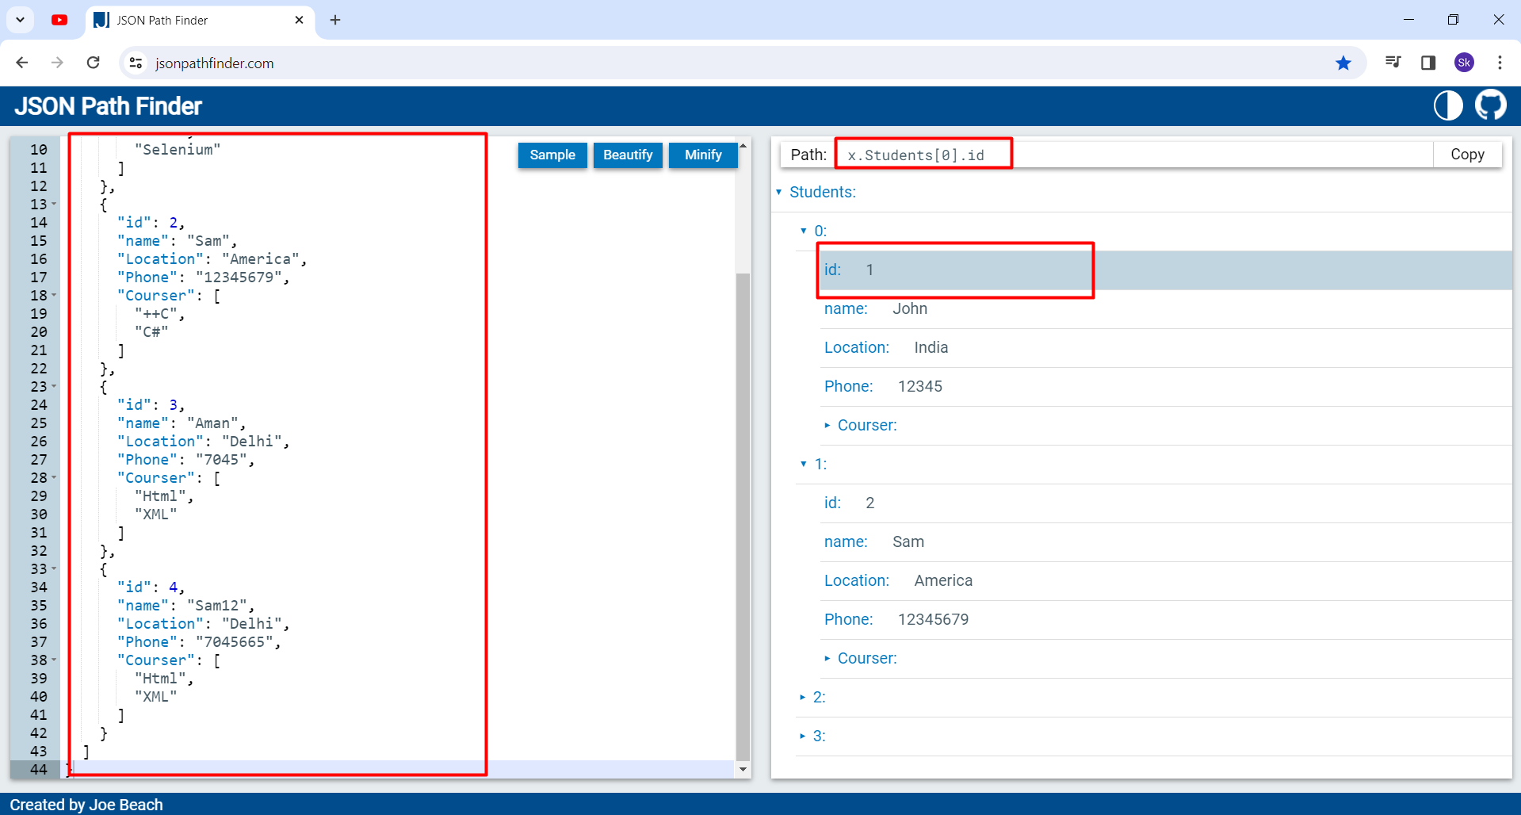

Json Path: Shall check whether we have putted the correct path or not.

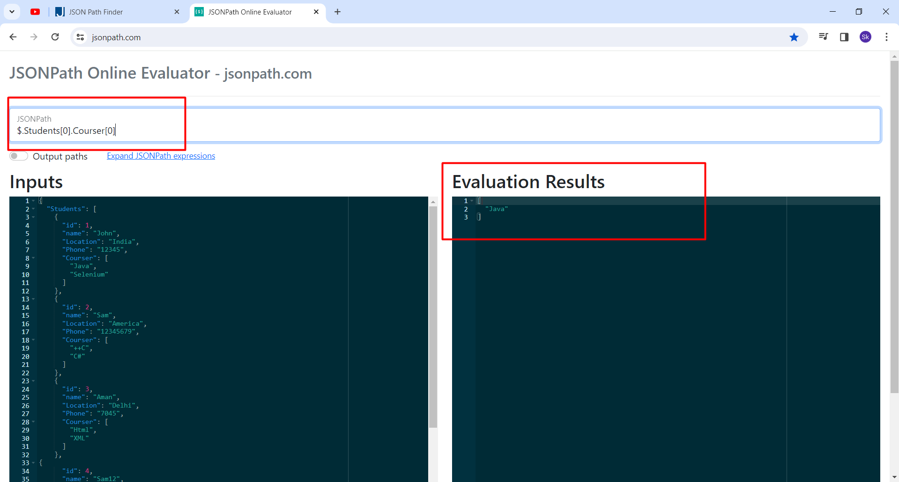

**DAY 4**

**Response Validations**

* Status code
* Headers
* Cookies
* Response Time
* Response Body

To test the validations we need to add some **ASSERTIONS**

The is a library in the postman called as **PM**

This functions are using the java script.

There are two functions

* Normal Function 🡪 **function()**
* Arrow function 🡪 **() =>**

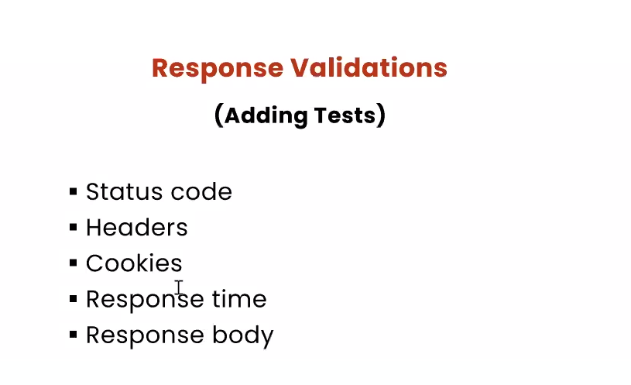

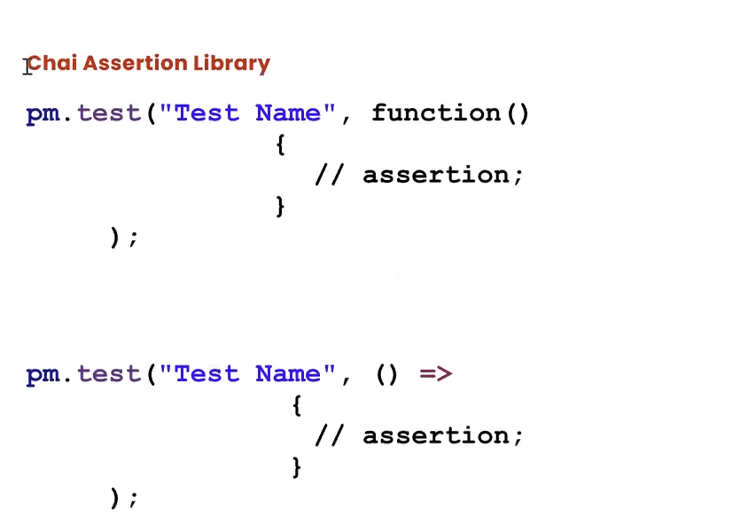

* Pm is the post man
* Test is a function
* Function implementations start from the curly braces and end on the curly braces { }
* => (Equals to , and greater than the combination)
* //assertion; is a syntax.

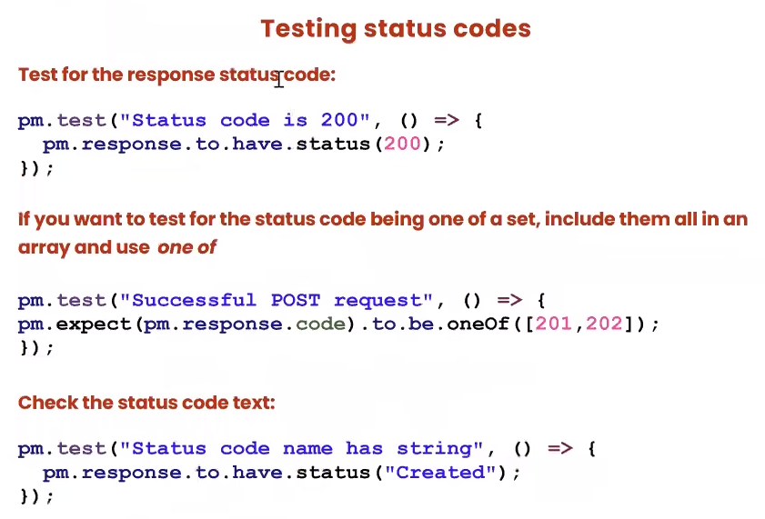

We need to write the script in the test tab.

* **Response.to.have.status**(200) is a **method** and 200 is a part of response.

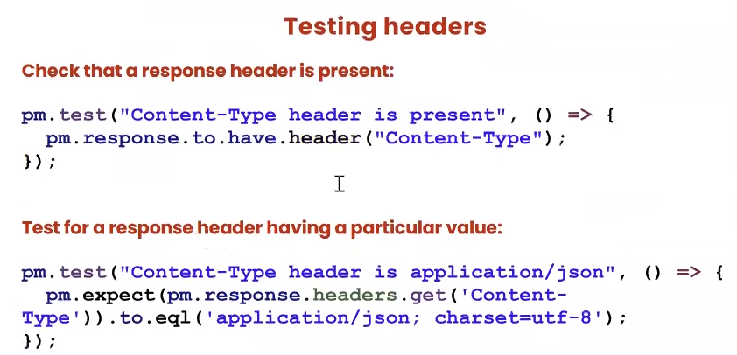

* Header is talking about data, server information’s, network information’s
* We need to check the headers are having proper values or not.
* So mainly in the header part we are checking for **Content-Type (Mime type – type of data), Content-Length (It is dynamic every time)**
* Content type is what kind of response format (josn, xml, html).

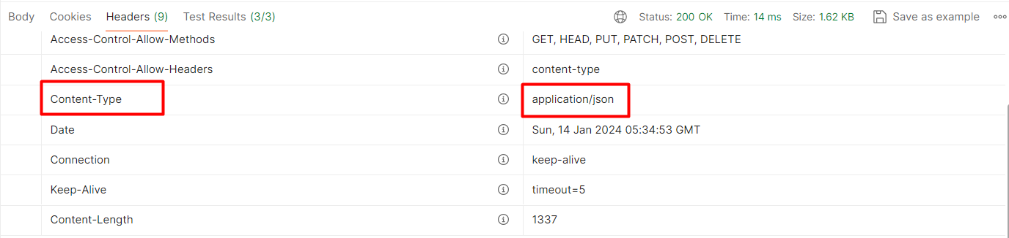

* Dynamic values are ‘Cache-Control’, ‘Date’, and ‘Keep- Alive’.

pm.test("Content-Type header is application/json", ()=>{

    pm.expect(pm.response.headers.**get**('Content-Type')).to.eql('application/json');

});

* pm is a library
* expect is a function
* get is to get the particular header
* That should be equals to the exact data which we are expecting.

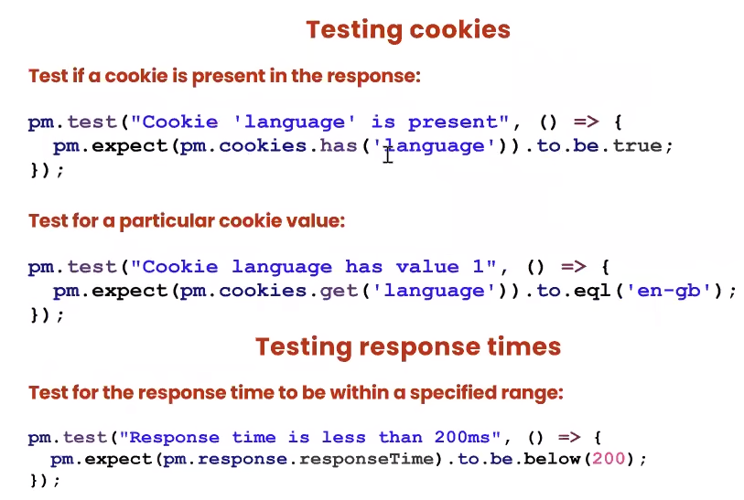

* Values are dynamic in nature.
* We need to verify the cookie and then the value.



* We cannot match the exact time we shall use the above and below condition for the time validation.
* It depends on the network speed, complexity of the data.

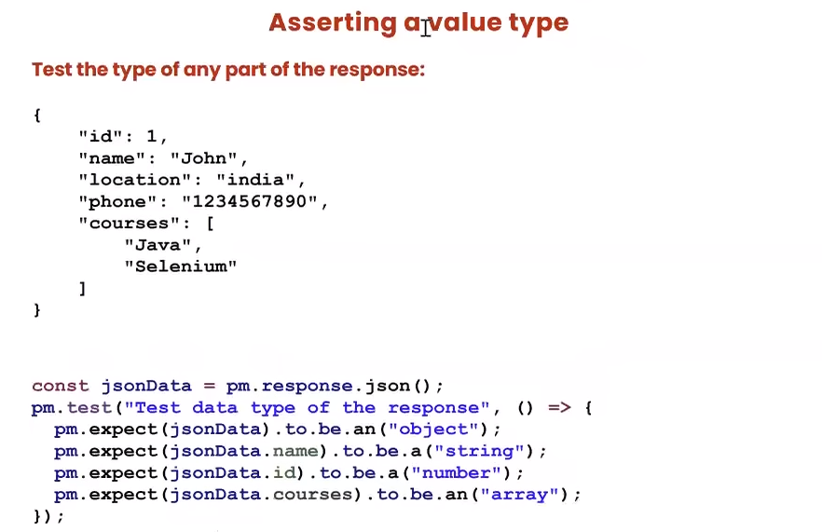

* Const jsonData 🡪 (jsonData) it is a variable in which we store a particular value and (Const is a type, there are multiple type such as var,let)
* Const jsonData = pm.response.json(); it shall store all the response data in the jsonData variable.
* We can also write the above statement in the function also.
* When we create the above statement outside the function it is called as global variable.
* So we can access the variable in all other function.
* To.be is a function.

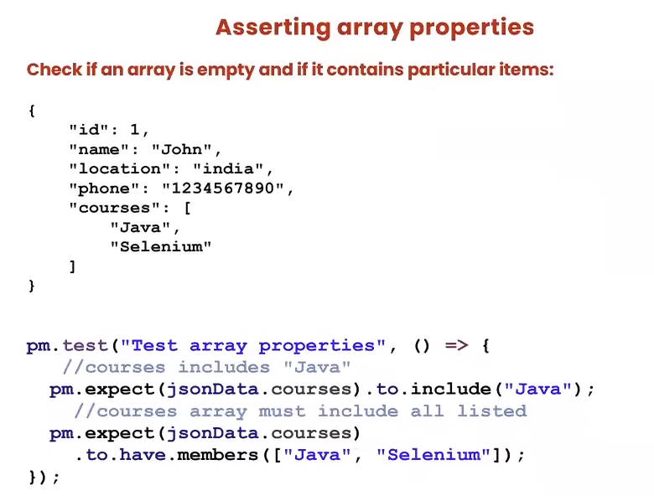

* For array function we use **to.have.members** and not the **OneOf**.
* When we use the **to.include** function we shall be able to put in **only one specific value.**
* Values need not be in the order for multiple validations.

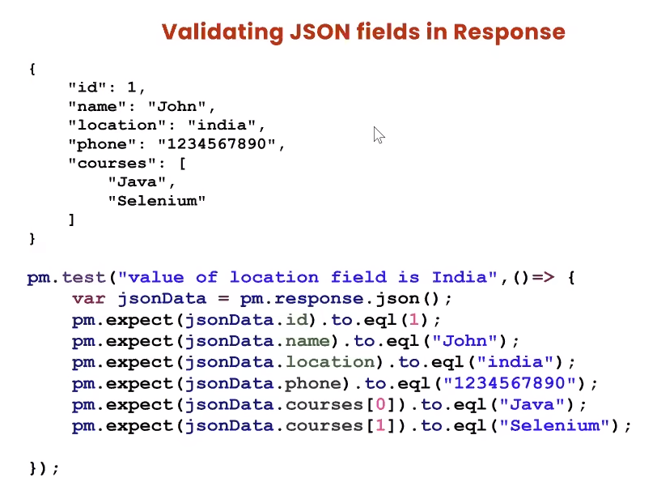

**WHAT IS JSON SCHEMA?**

* Schema is a structure for the data.
* Meta data (data about the data).

**Tools to generate schema.**

* **https://www.liquid-technologies.com/online-json-to-schema-converter**

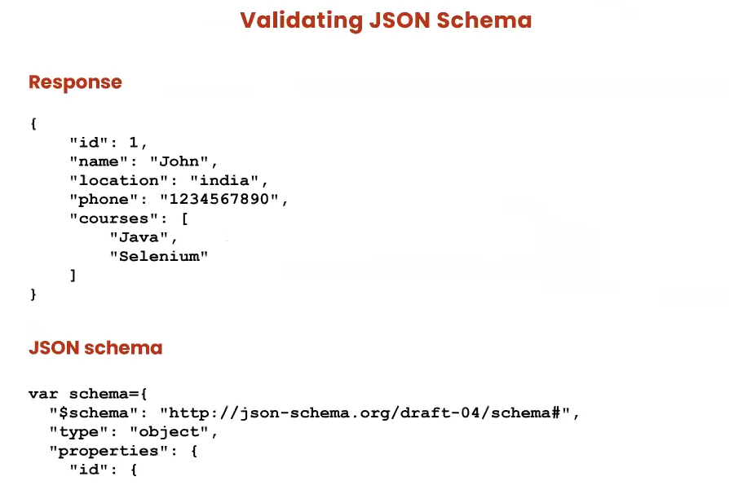

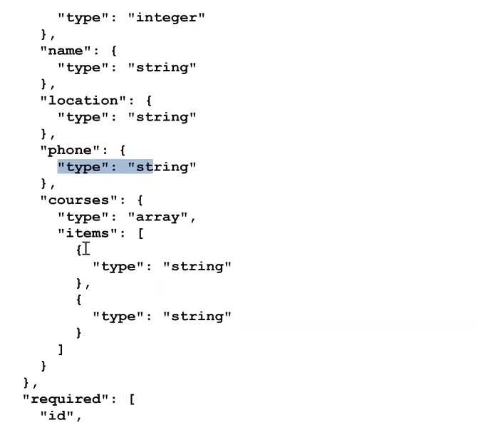

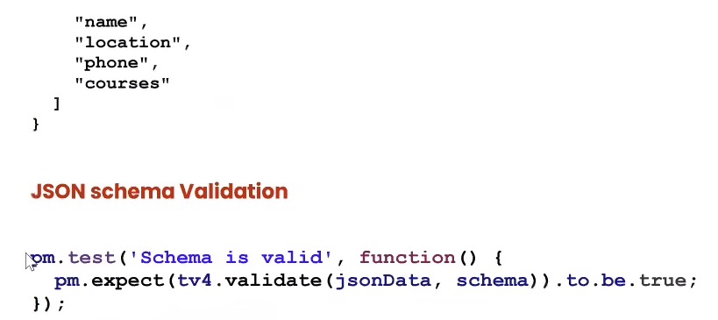

* **tv4** 🡪 tiney validator version no. 4 it is a library in the postman.

**DAY 5**

**THERE ARE TWO KINDS OF SCRIPTS:**

* **Test script** – This scripts shall be executed after sending a particular request
* **Pre-request scripts** – This scripts shall be executed before sending a particular request

Pre-request script 🡪 Request 🡪 Response 🡪 Test script

The pre-request and test scripts are available at 3 different levels.

* Collection level
* Folder level
* Request level

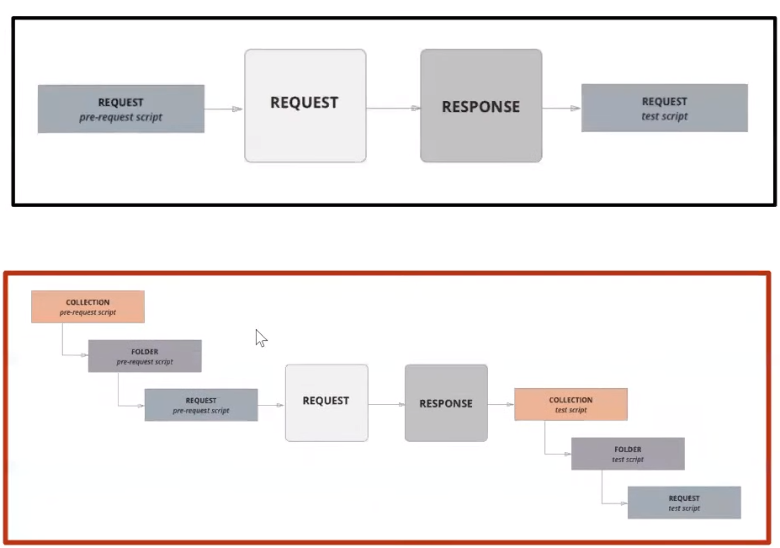

console.**log**(“ ”)

* It is a print statement in java script what every we put in the bracket shall be printed in the console window of the postman.

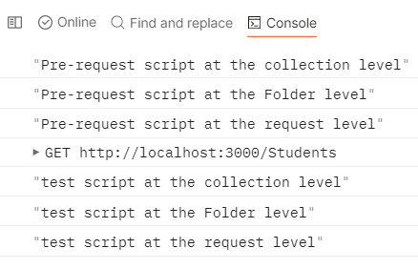

**USE OF PRE-REQUEST SCRIPT:**

* Can generate the data dynamically.
* Request requires parameter, we can access through variables.

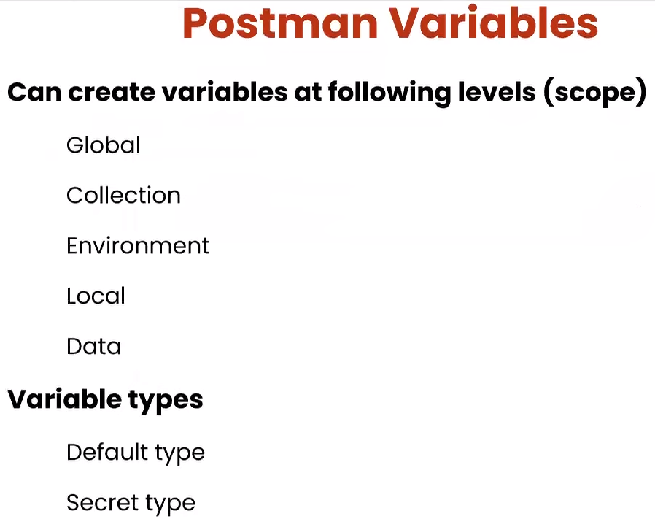

**WHAT IS VARIABLE?**

**WHY WE NEED THIS VARIABLE?**

**WHERE WE NEED THIS VARIABLE?**

* Take an example if we are having a student API and having a particular URL in which the domain name (<http://localhost>) is common at all the request we just need to define a variable for the same so we can use the variable in the place of the domain name. The reason is that if the domain name gets changed we shall not need to change it at all the request level just we have to change it at the variable level once.

**There are 5 types of variables:**

* **Global** 🡪 we can access this variables throughout the workspace. (Workspace 🡪 Collection 🡪 Request). We have to call the variable in double curly braces {{variable name}}

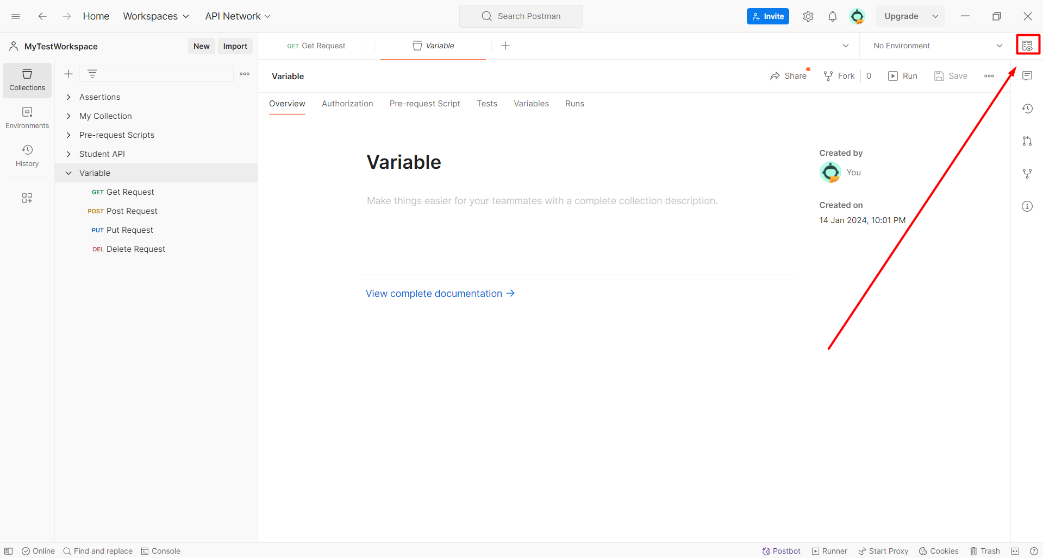

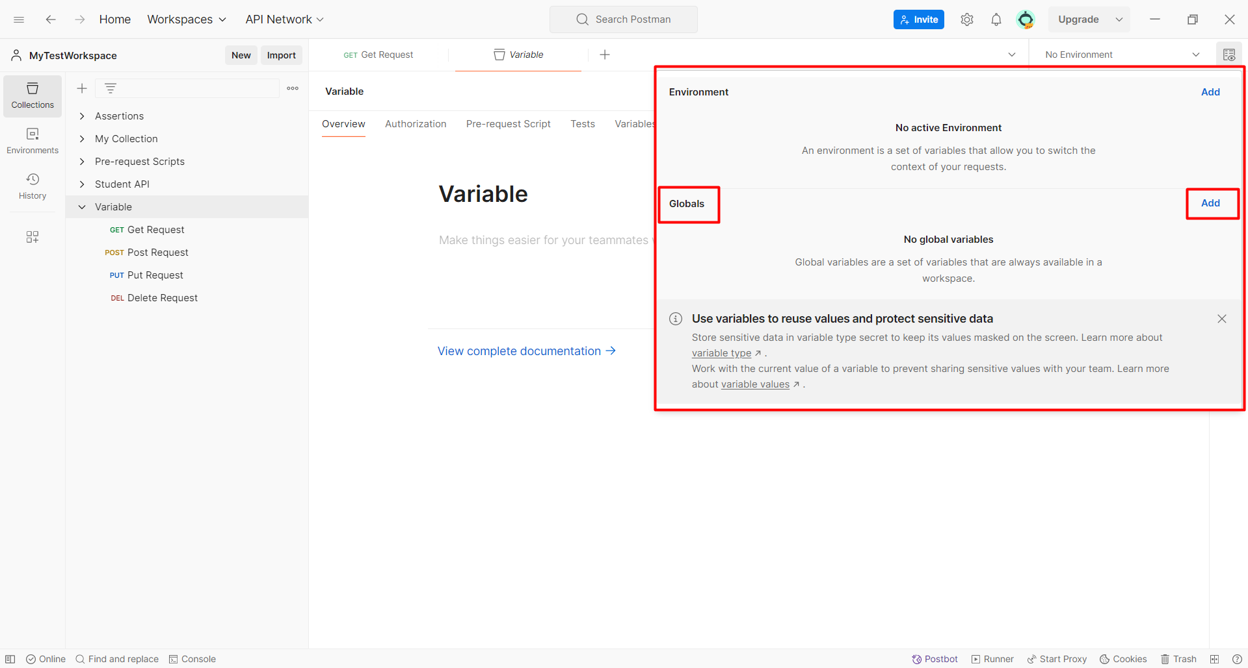

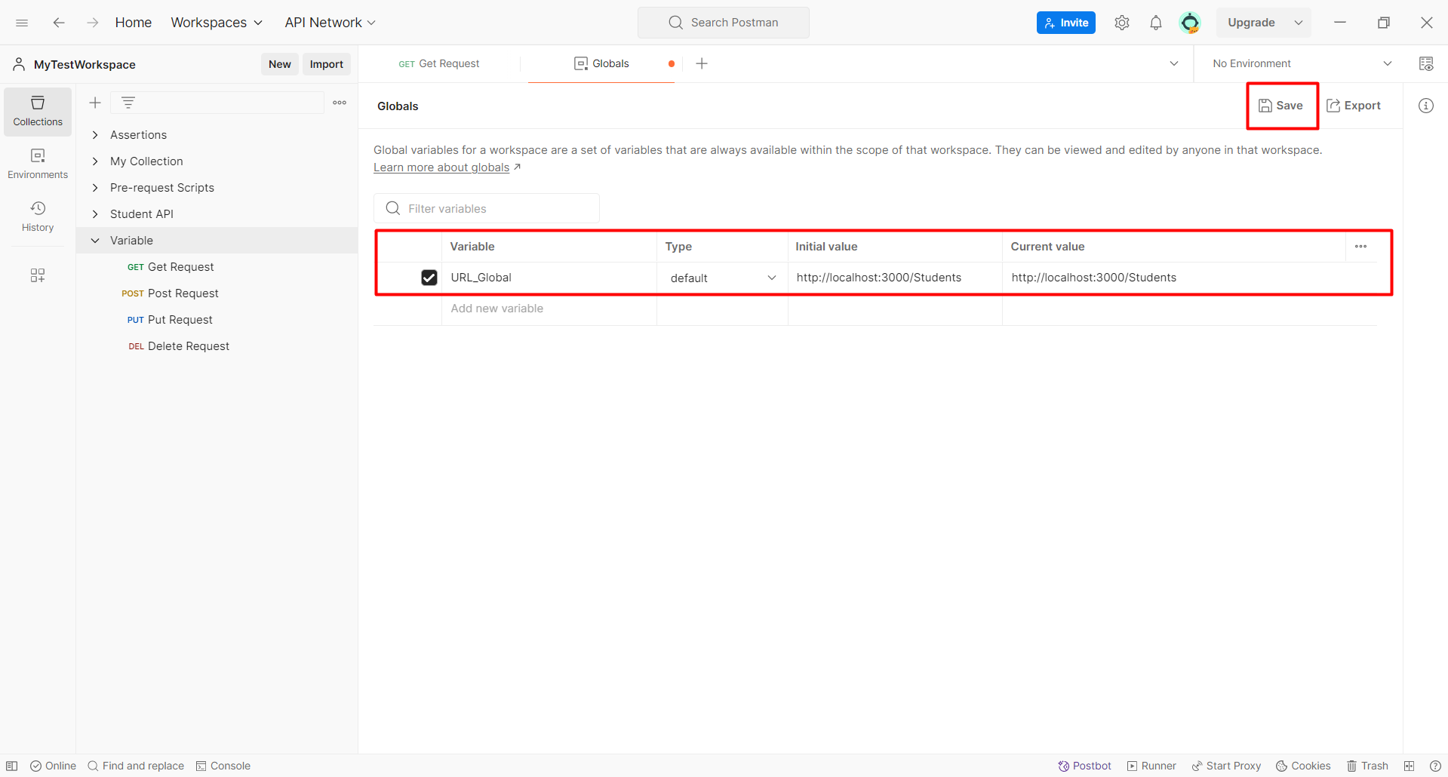

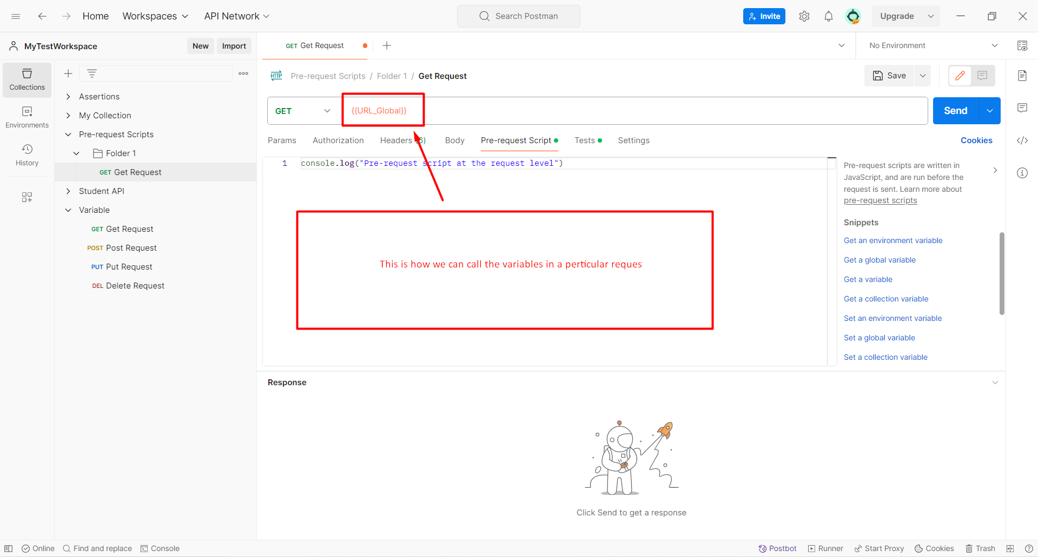

* **Collection 🡪** We can access this variables with in the collections only. (Collection 🡪 Folder 🡪 Request)

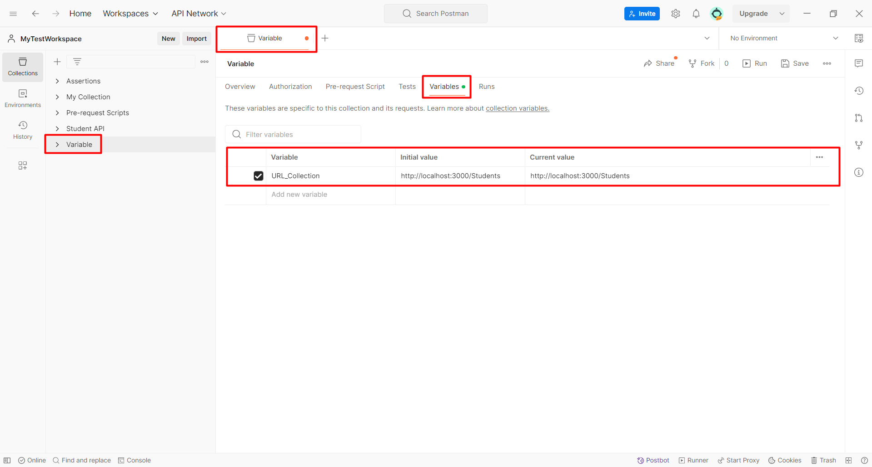

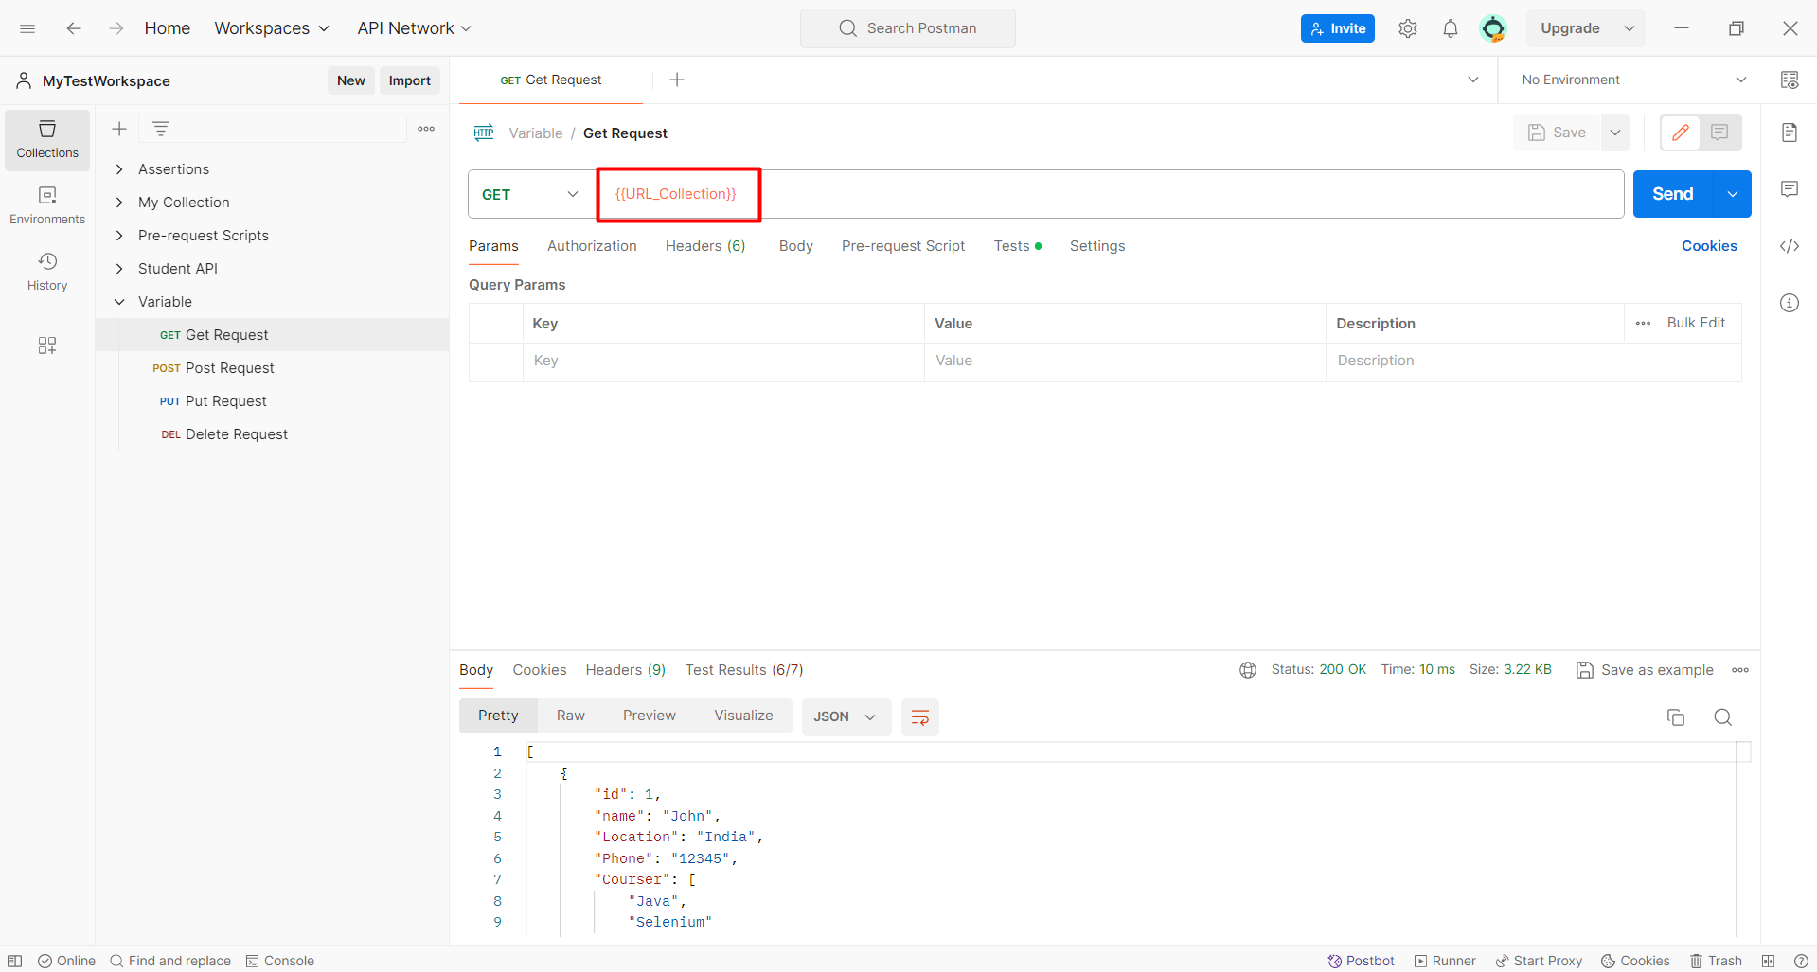

* **Environment 🡪** If we have created multiple request and we have to execute all the request in a particular environment (e.g. QA, Prod, Dev.). And every environment is having different variables in the sense different URLs.
* An environment is a set of variables that allow you to switch the context of your requests.
* Accessible in all the collections but we need to choose the environment first and then run our request.



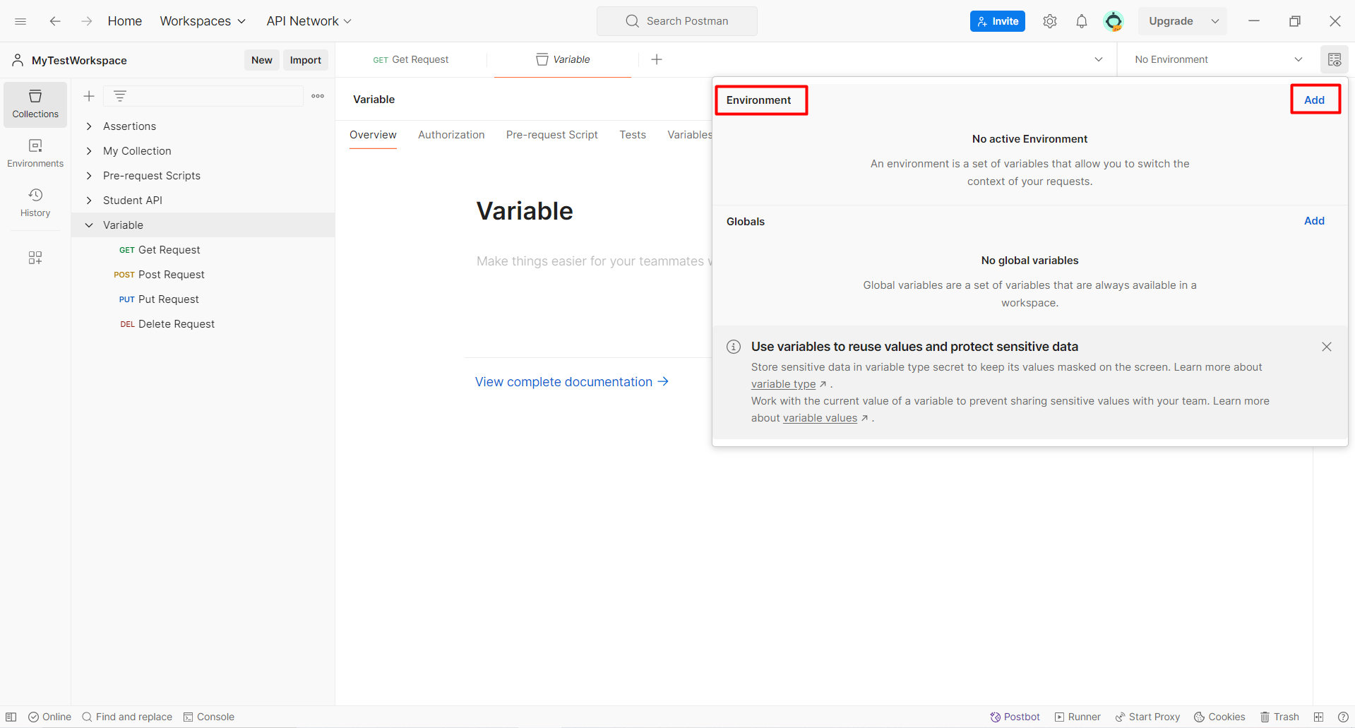

* **Local 🡪** we can create them at the request level. We have to define it at the pre-request script page.

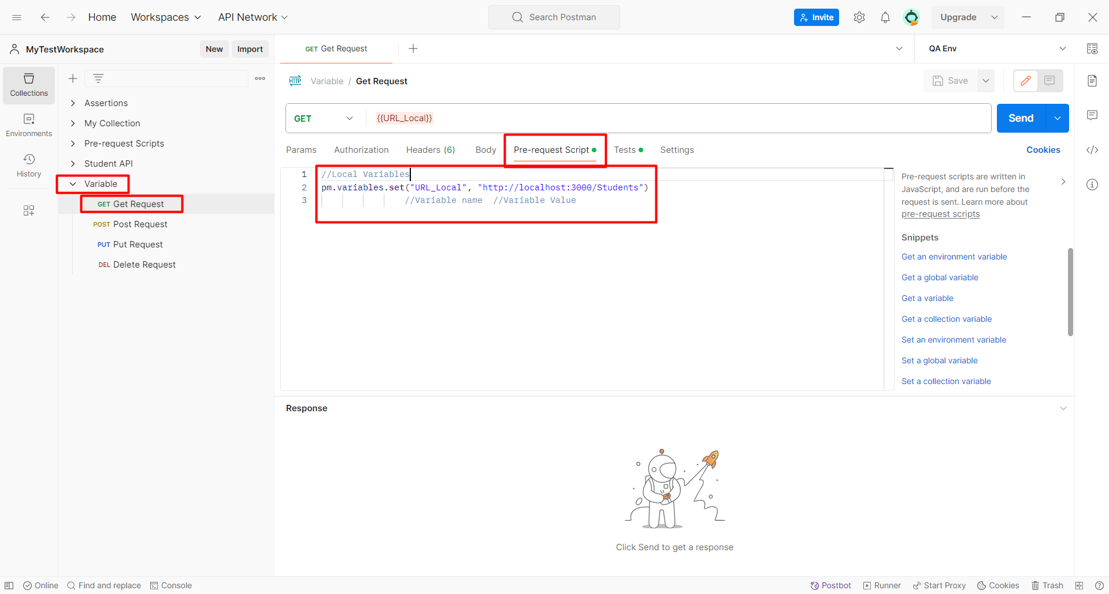

* **Data 🡪** We have to create the variables in the external file it can be csv, txt, etc. This shall be mainly used in the data driven testing.

**CREATE THE VARIABLES THROUGH THE SCRIPTS:**

* At the run time the variables shall be created and after the request execution we can unset those variables.
* Put the below request in pre-request script and unset in test script.
* While creating a script we use both key and value.
* During unsetting we only use the key.
* First the name of the variable and the main data field name.
* Example “Userid” is the variable name and 2 is the data field name.
* **Global variable:**

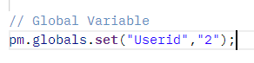

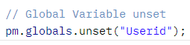

* **Environment Variable:**

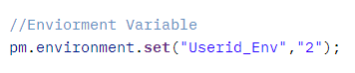

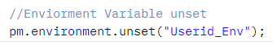

* **Collection Variable:**

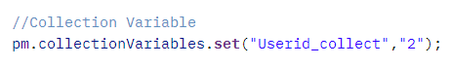

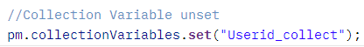

**How to print the data for the variables in console:**

* Before unsetting the variables

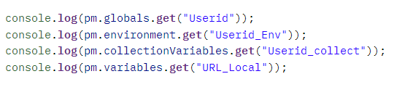

**DAY 6**

**API Chaining concept.**

* When we send any API request we shall get a response and the response shall be used in another request.
* The response of one API becomes the request of another API (Not exactly the whole response but some part of it we use in the request of another API).
* We need to store the response in different variables and shall use those variables as part of request.

**In test tab:**

var jsonData**=** JSON.**parse**(responseBody);

pm.environment.**set**("id",jsonData.id);

* Var is a variable in which we store the data
* JSON.parse is a library.
* responseBody is a keyword.
* Pm.environmet.set shall create an environment variable.
* Key is “id”.
* Value is jsonData.id.

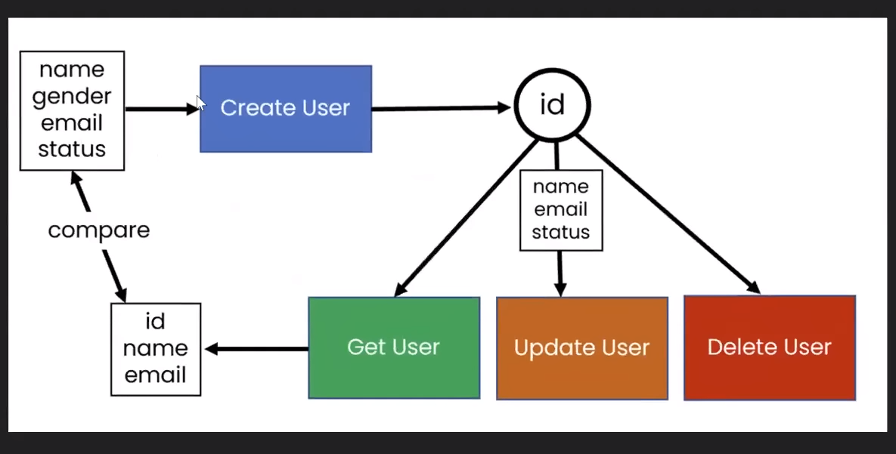

**HOW TO GENERATE THE VALUES ON RANDOM BAISIS FOR A REQUEST:**

* **Math** is a library inside that we have a method called **random** inside this there is a method **String(36).subString(2)**
* **2** is the value how much length do you want.
* The above statement shall return us a random value that we shall store it in a variable.

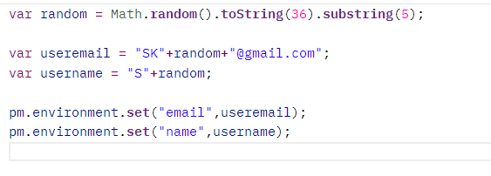

**Shall define the main name first and then the environment variable name in which we are storing the data**

We have to put the script in the pre-request.

To generate the random number in java we shall use the below statement in the pretest script

**const** randomnum = Math.floor((Math.random()*100+1));

Validate the json data is GET:

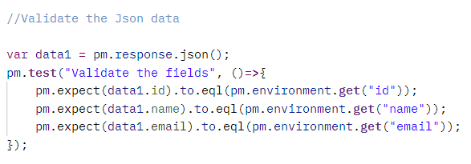

* First we shall store the response in a variable
* Then we shall store then we shall get the environment id of the previous post request
* Then we shall compare the current get request value and the post request value.
* We have to pass in the main column name in the enviorment.get(name of the data field)

**DAY 7 – Data driven testing**

Book API

<https://simple-books-api.glitch.me>

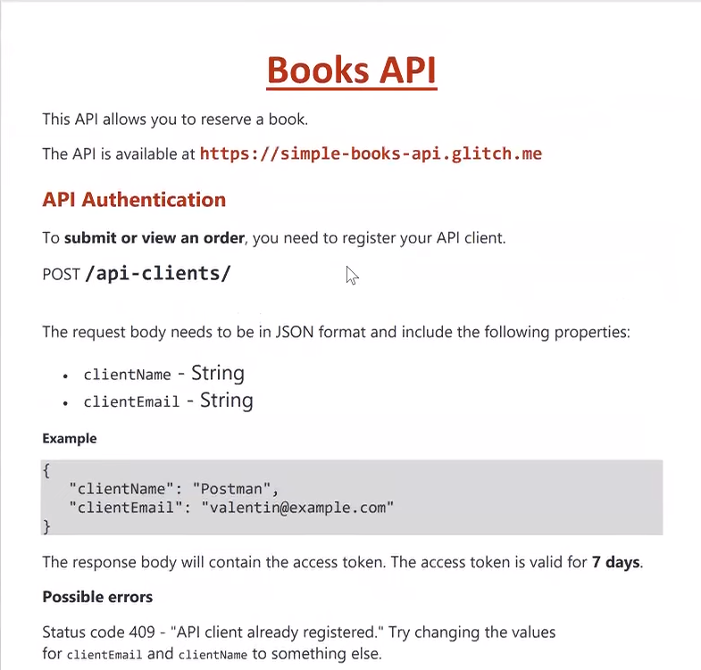

**ENDPOINTS**

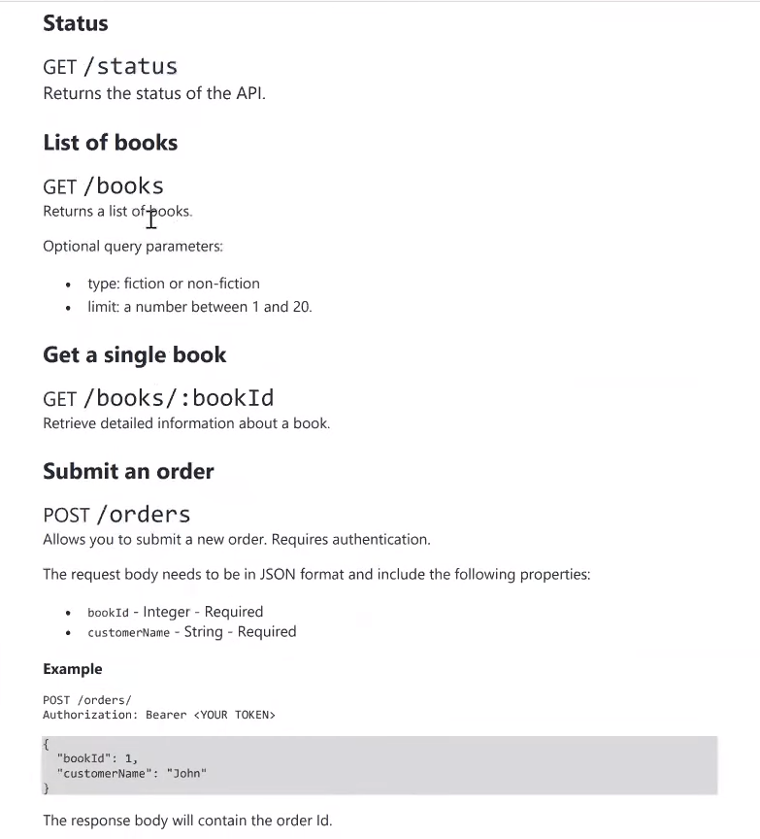

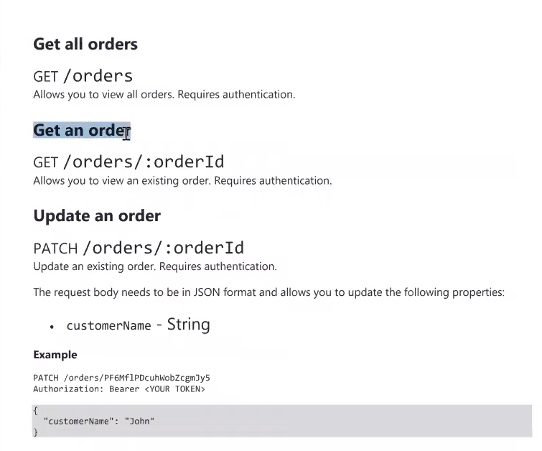

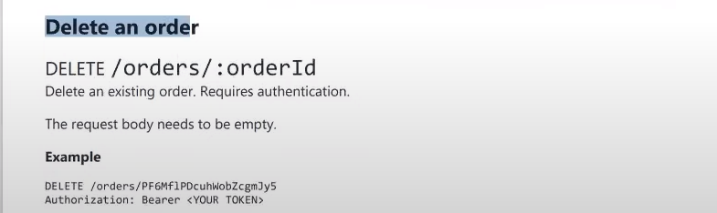

**WHAT IS DATA DRIVEN TESTING**

* We can execute the request with multiple data sets.
* Create the below excel which support the csv
* Also supports the json format for the data driven testing.

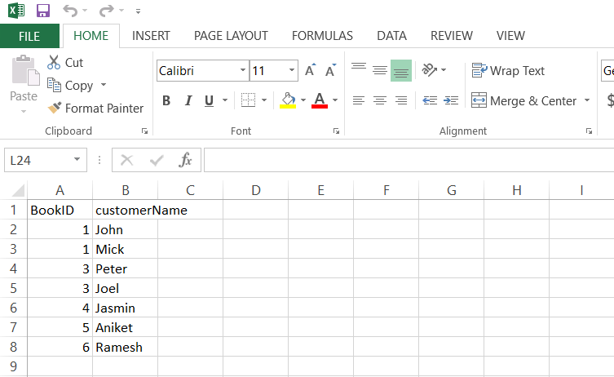

Once the data has been made for the request. We shall put in the mail columns name in the post order request.

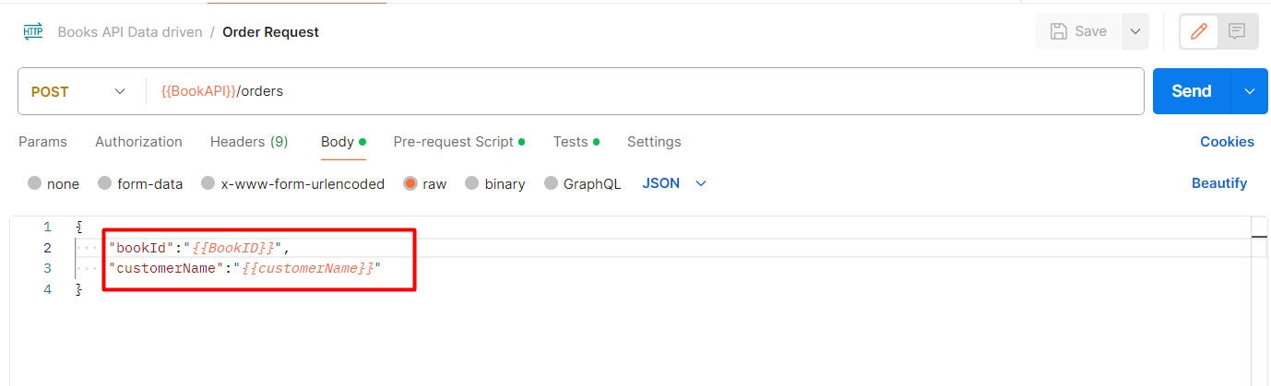

Then we shall run the collect. Once click on the run collection, we shall get the below screen for the same in that we have to **select** the **particular** **file**. As shown in the below screenshot.

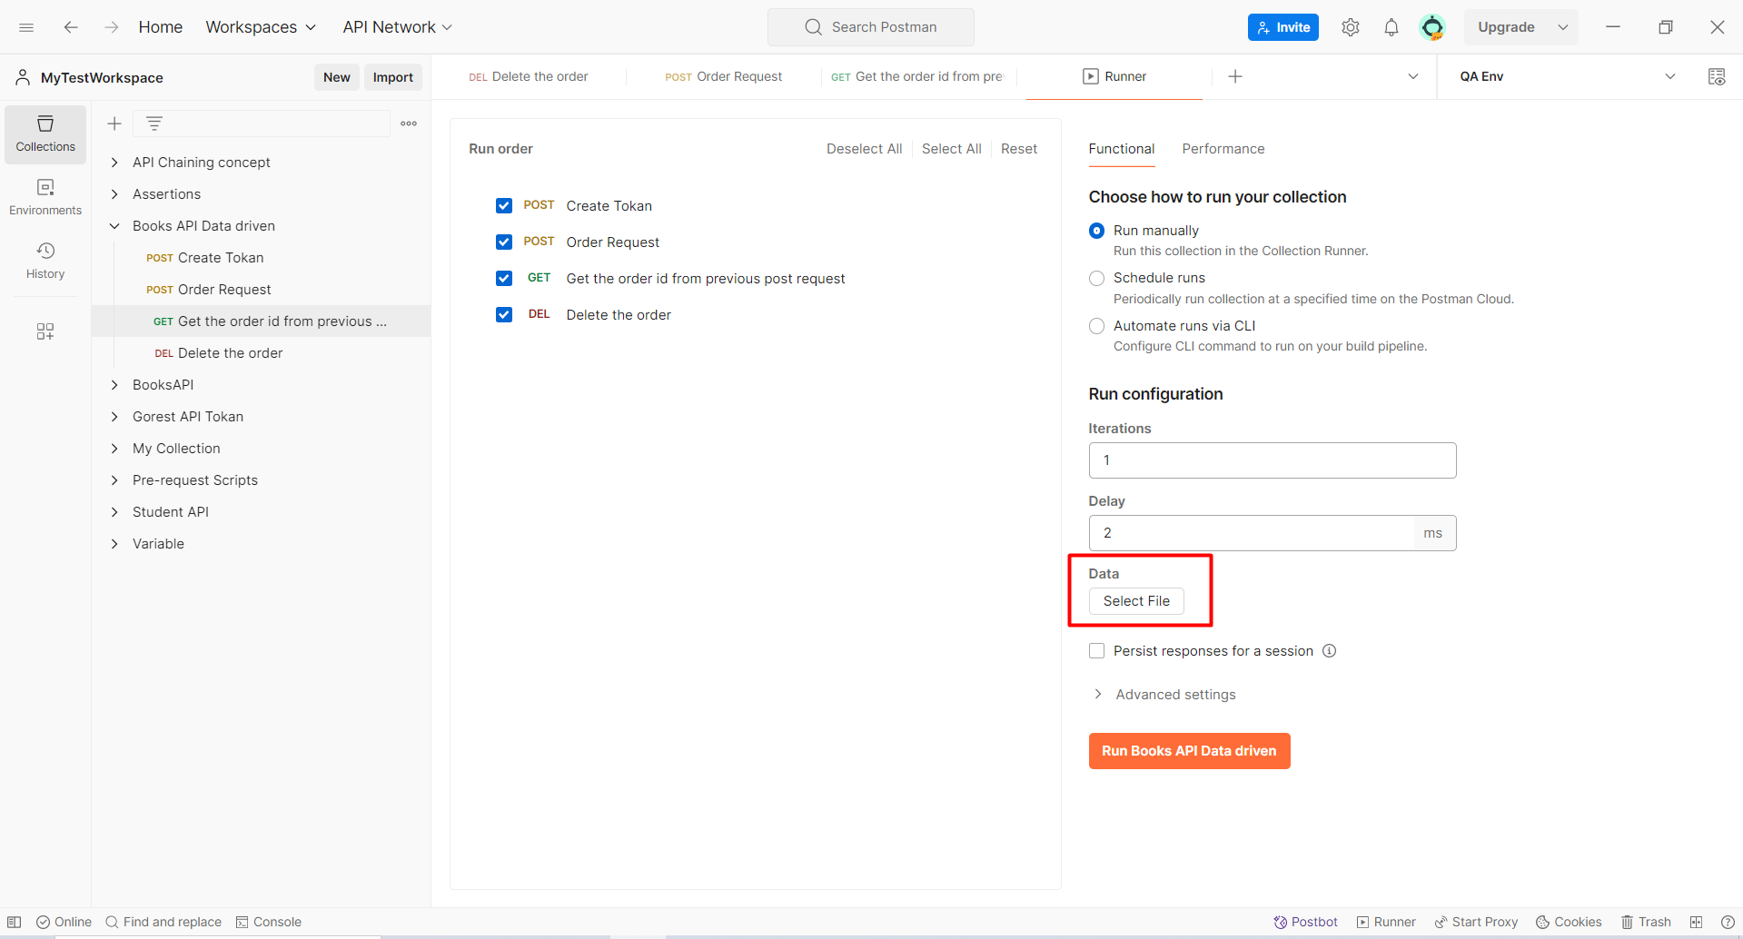

Once the file has been selected, click on how many times the data have to be passed. Specify the same in the **iteration** tab and then run the collection.

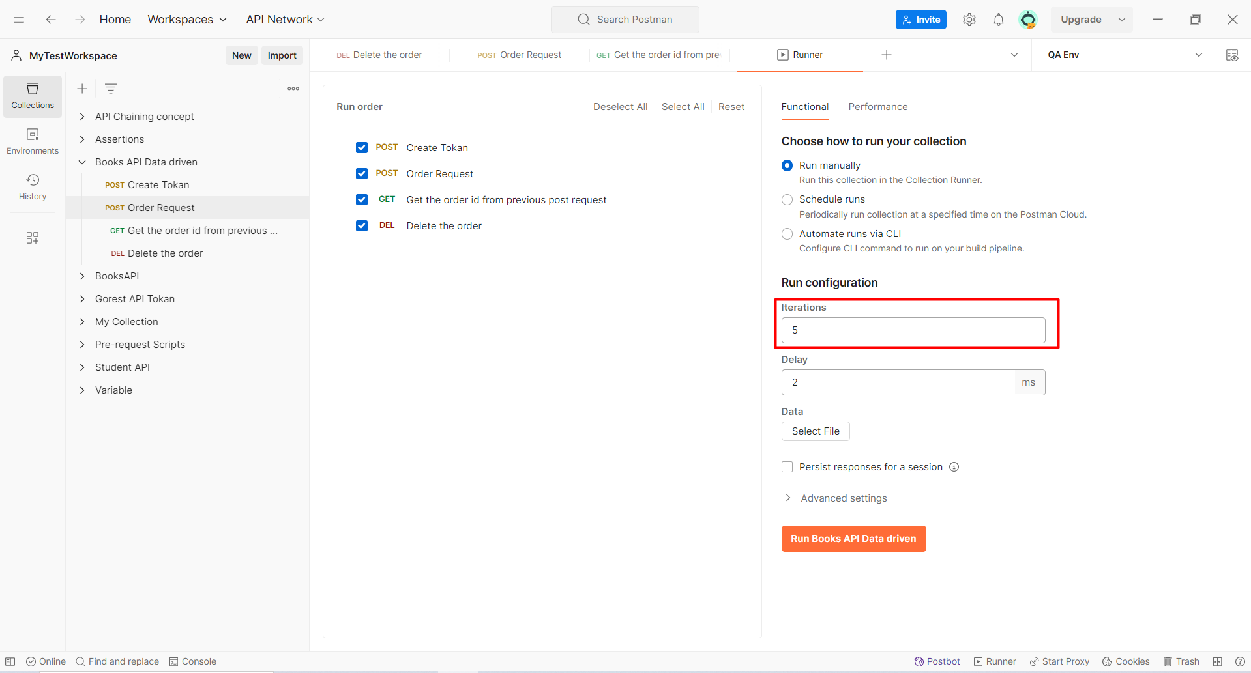

To cross verify the file is the file is proper or not you have one option called as **“Preview”**

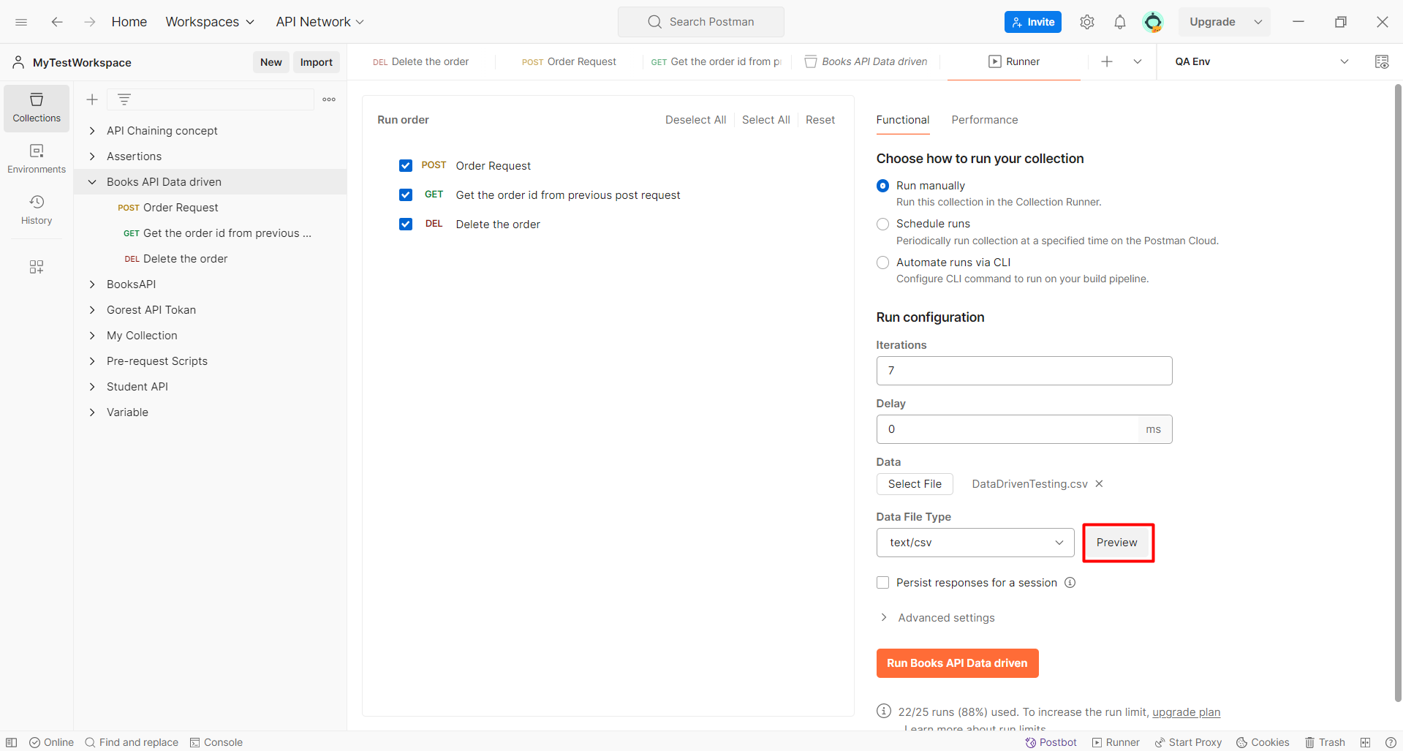

Once clicked on the preview button the below screen shall be shown to you.

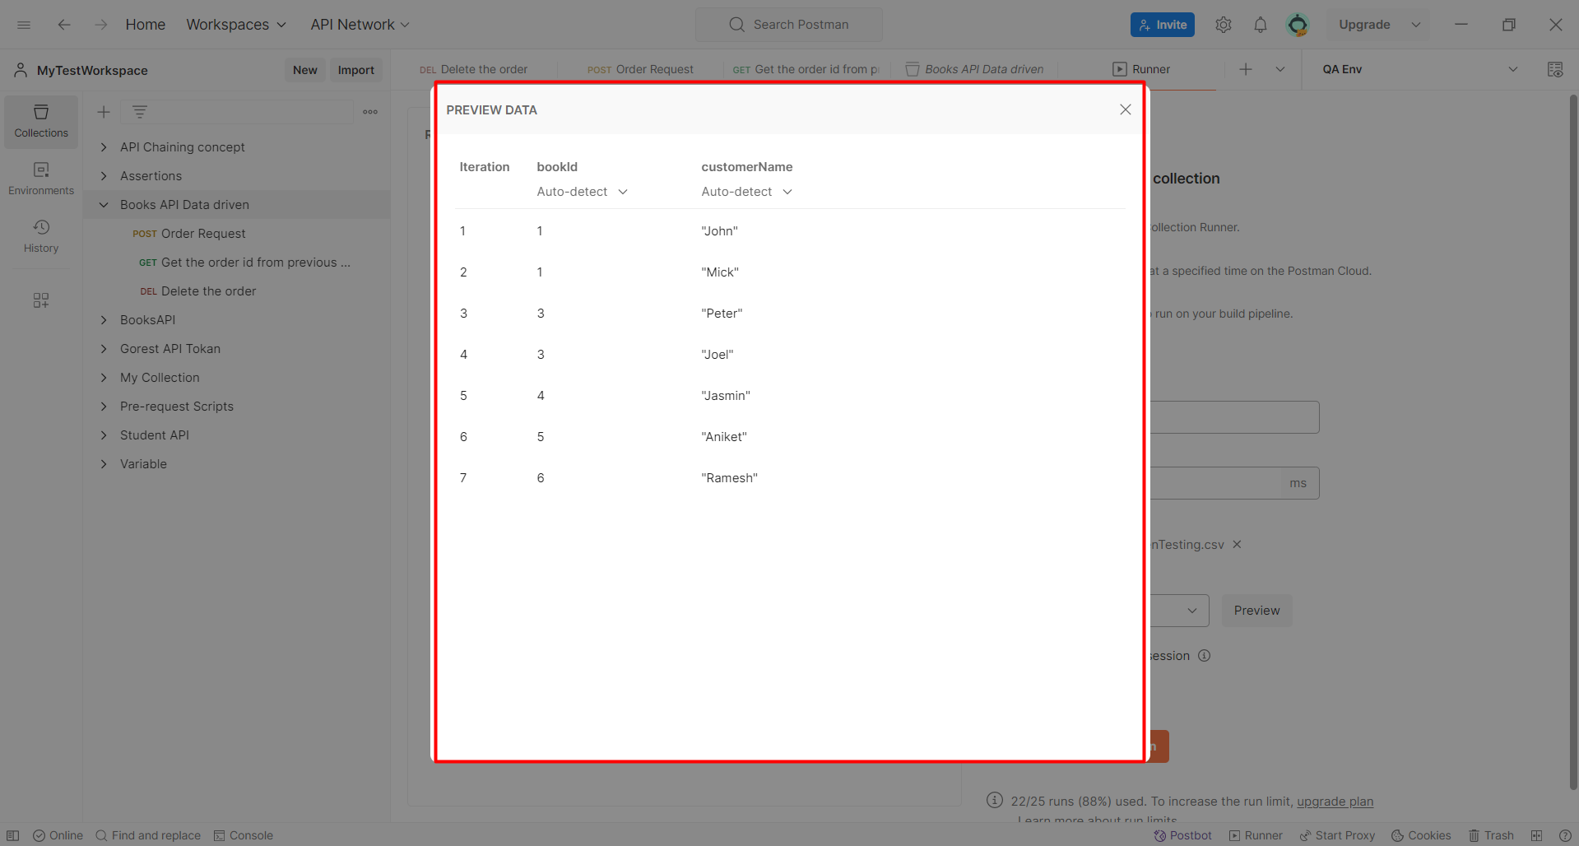

If there is some mistake it shall be shown in the preview screen itself.

Also you can convert the csv file to json file.

<https://www.convertcsv.com/csv-to-json.htm>

**DAY 8 – Upload File through API**

First install java on your machine using the below link.

<https://www.java.com/en/download/>

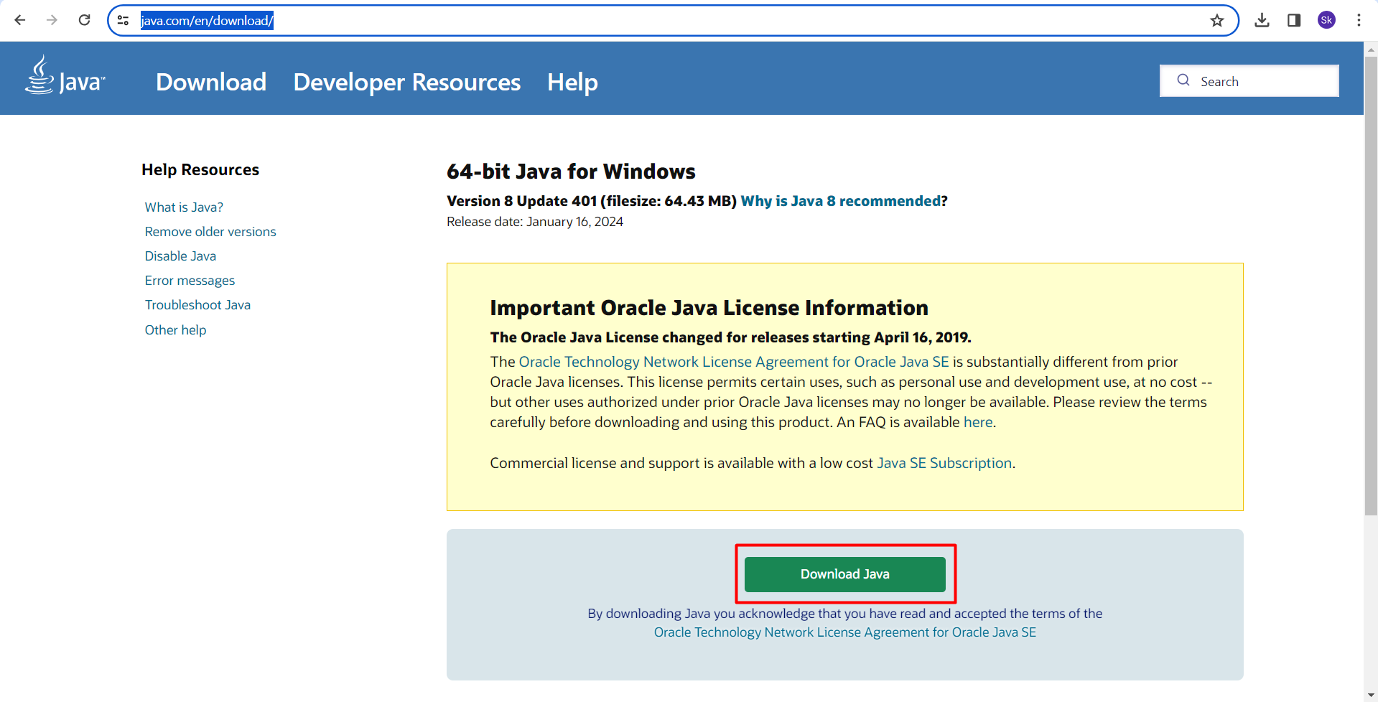

Then download the jar file using the below link

https://github.com/pavanoltraining/spring-boot-file-upload-download-rest-api/blob/master/target/file-demo-0.0.1-SNAPSHOT.jar

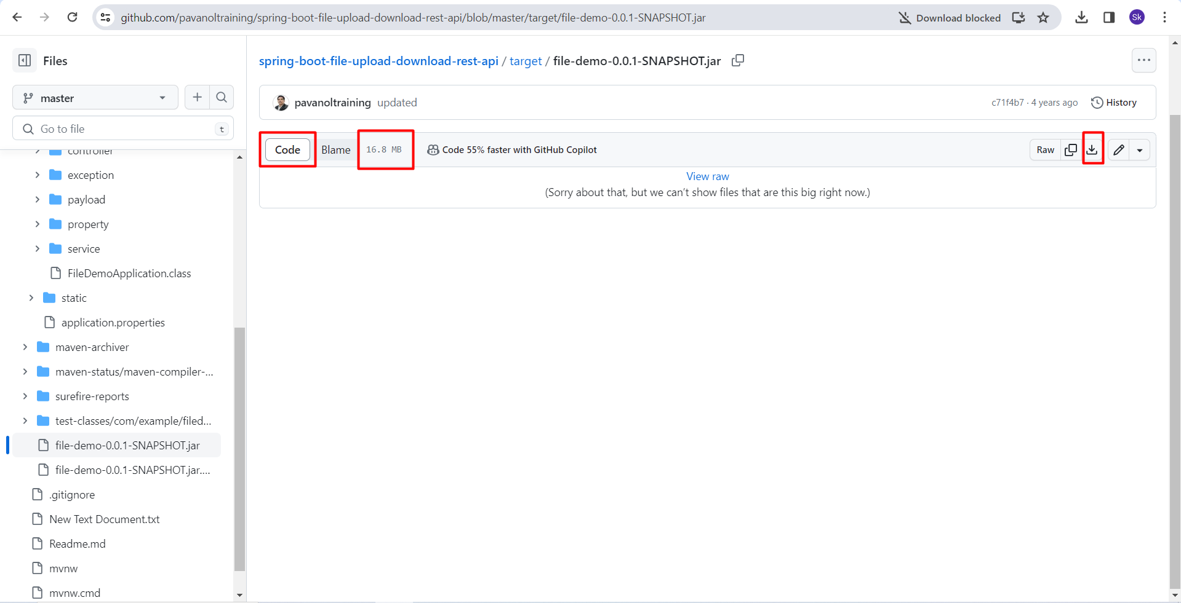

Once this is done open the jar file in cmd. Place the file anywhere in the C drive and open the cmd and put in the below command.

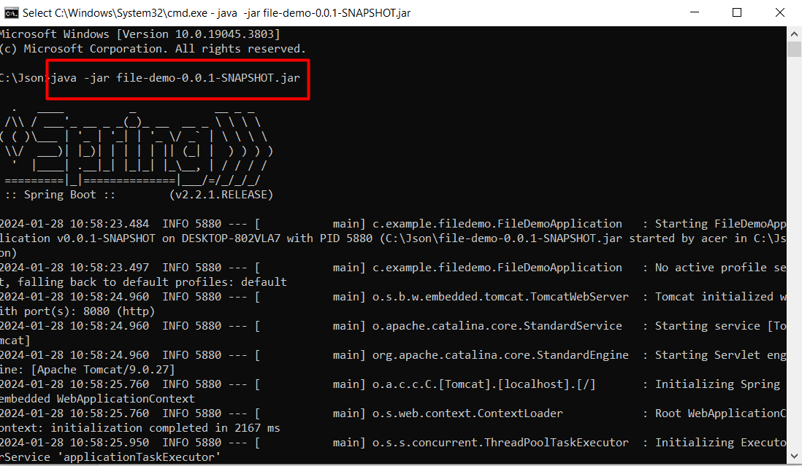

Once it is done. Open the below URL.

http://localhost:8080

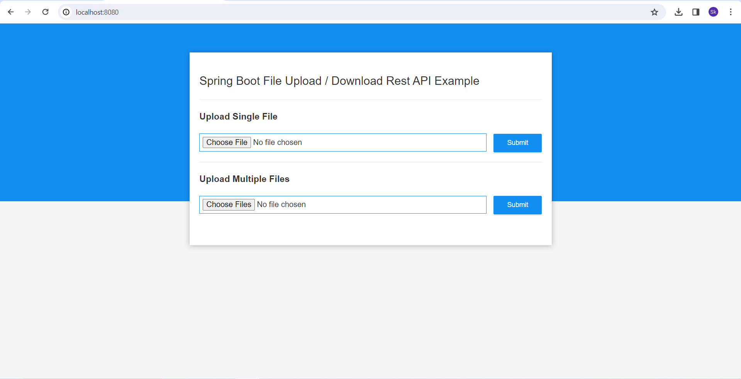

1. **POST :** [**http://localhost:8080/uploadFile**](http://localhost:8080/uploadFile) **-- This is for single file upload**
2. **POST :** [**http://localhost:8080/uploadMultipleFiles**](http://localhost:8080/uploadMultipleFiles)  **-- This is to upload multiple files**

When we are using the API to upload the there is one section in the body as “form-data”.

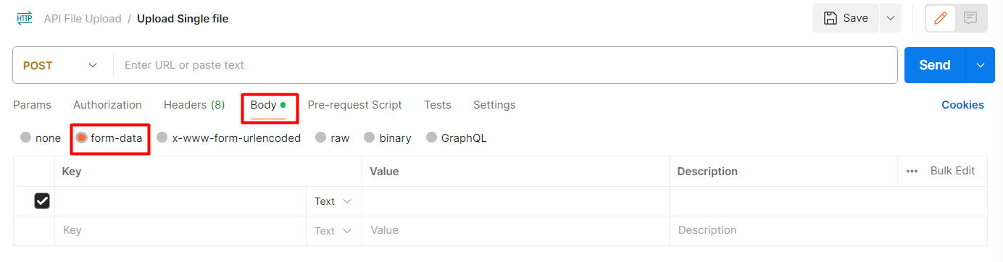

Once clicked on the form-data there we have to choose the dropdown type as file.

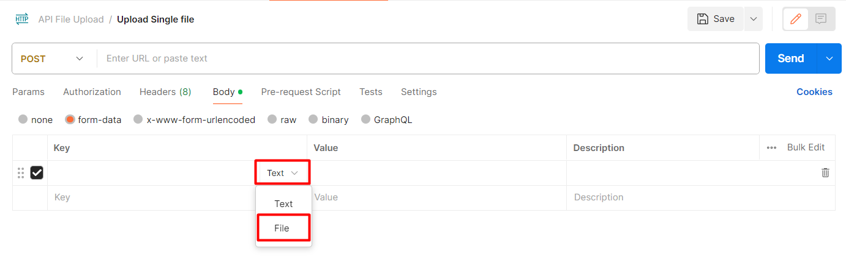

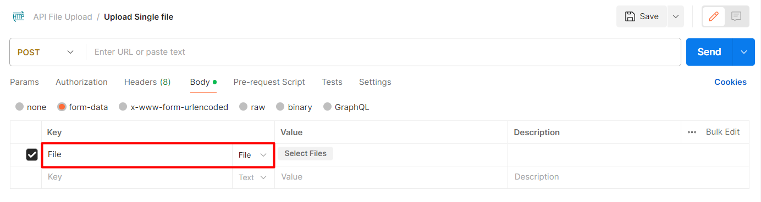

Once the file is uploaded we shall get the response for the same.

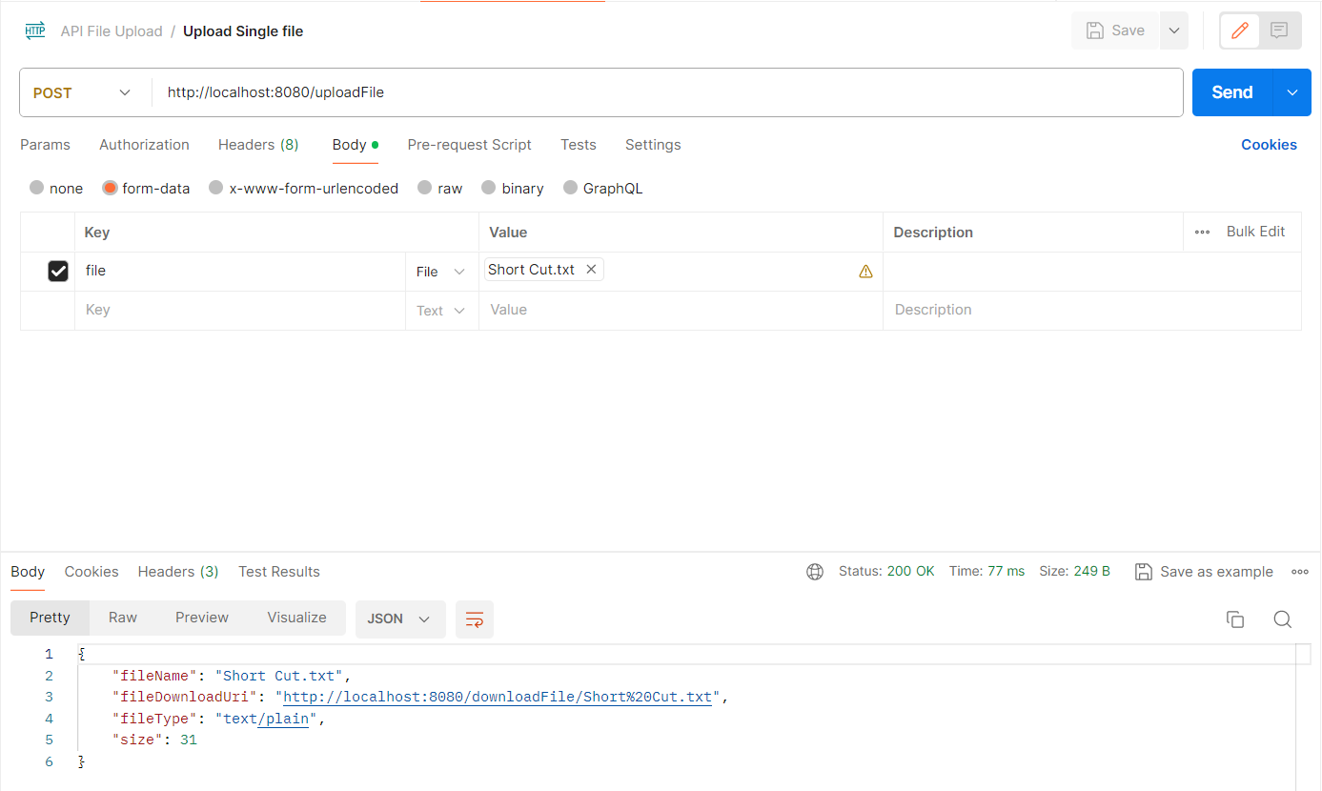

For uploading multiple file. Here is a slight change we have to specify the key as “files” instead of file. And select multiple files and click on the send button.

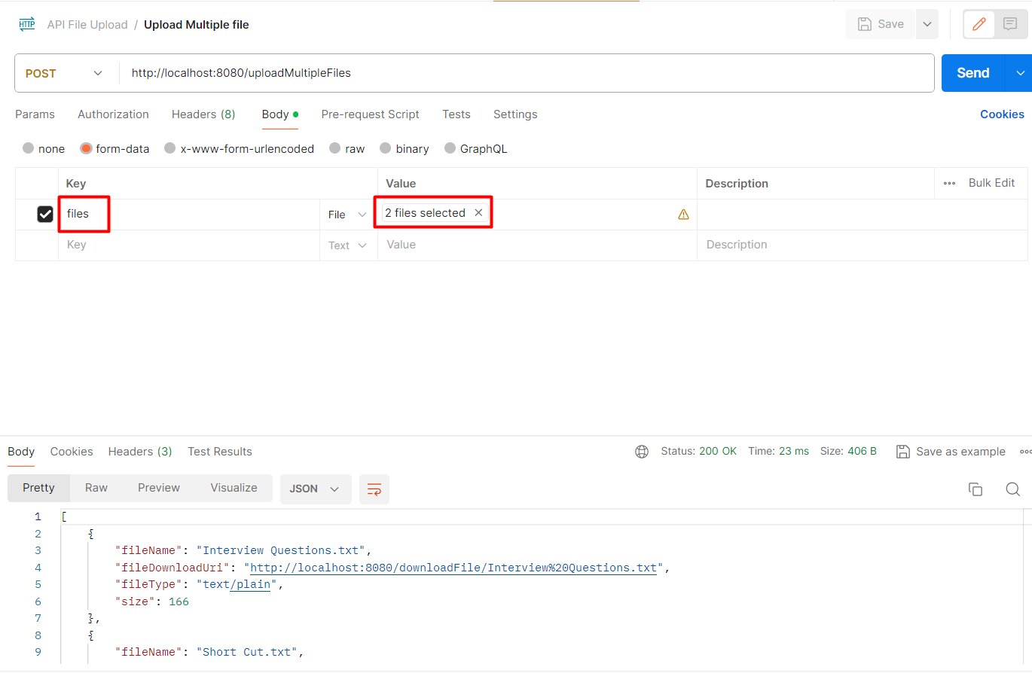

If you have not to select the file. You need to put in the file path in the value section.

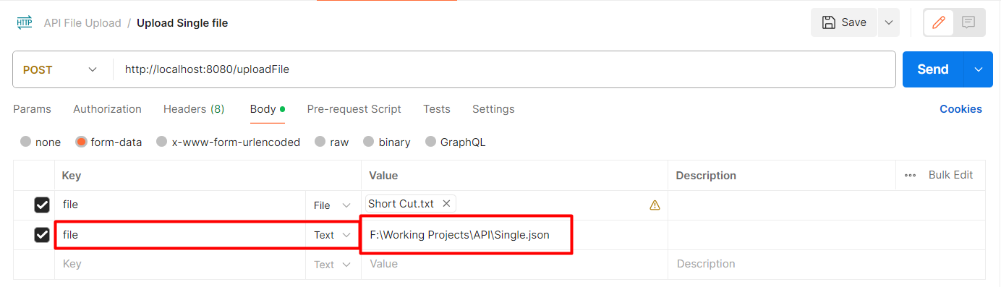

Once the files are been uploaded automatically a new upload folder shall be created in the c drive and the files shall be saved there.

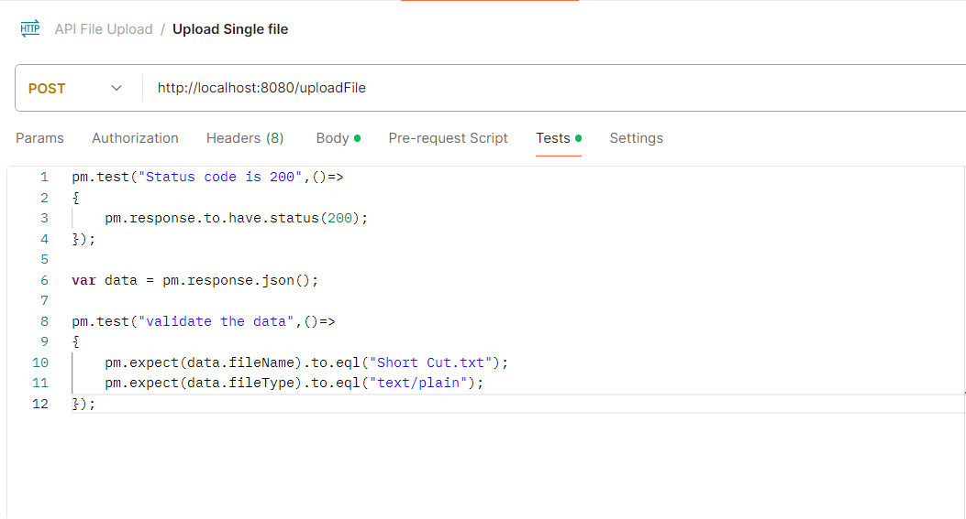

**AUTHENTICATIONS TYPE:**

Authentication is which we use to send the request for any particular URL which required so value to authenticate if the request is genuine or not.

* **API Key**
* **Bearer Token**
* **Basic Auth** 🡪 We need the user name and password. (Data shall not be encrypted)
* **Digest Auth** 🡪 We need the user name and password. (Data shall be encrypted)
* **OAuth 1.0** 🡪 This is a third party authentication. (Companies shall acquire some third party tool) (This is a very lengthy process but it is more secure) (This shall be changing from one application to another application)

We need a developer account for the particular application. Then we need to get the client id and secrete id. On the basis of that we shall generate a token. And then by generating the token we shall be able to access the application.

* **OAuth** **2.0** 🡪 This is a third party authentication. (Rest same as auth 1.0)(It is the latest version)
* **Hawk Authentication**
* **AWS Signature**
* **NTLM Authentication**
* **Akamal EdgeGrid**

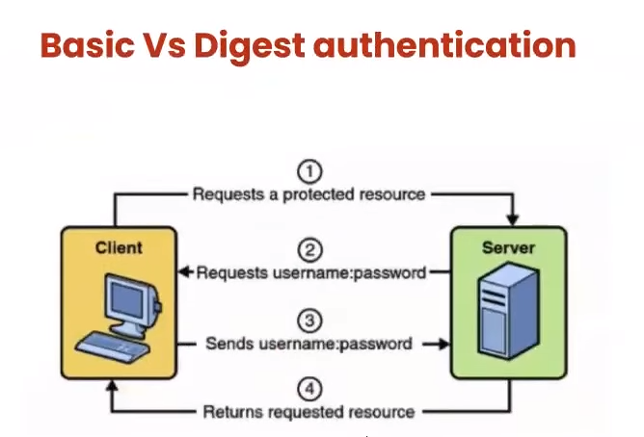

For Bearer Token. Use the below link.

<https://docs.github.com/en/rest/using-the-rest-api/getting-started-with-the-rest-api?apiVersion=2022-11-28>

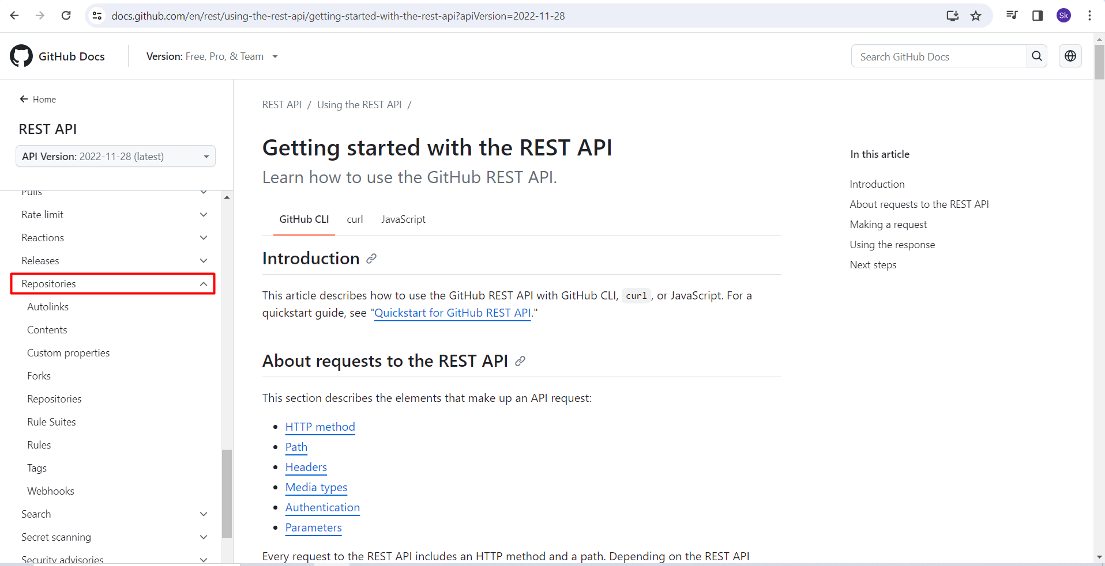

Generate the token from your github account.

**CREATE API KEY for API KEY AUTHENTICATION.**

Open the below URL.

<https://openweathermap.org/api>

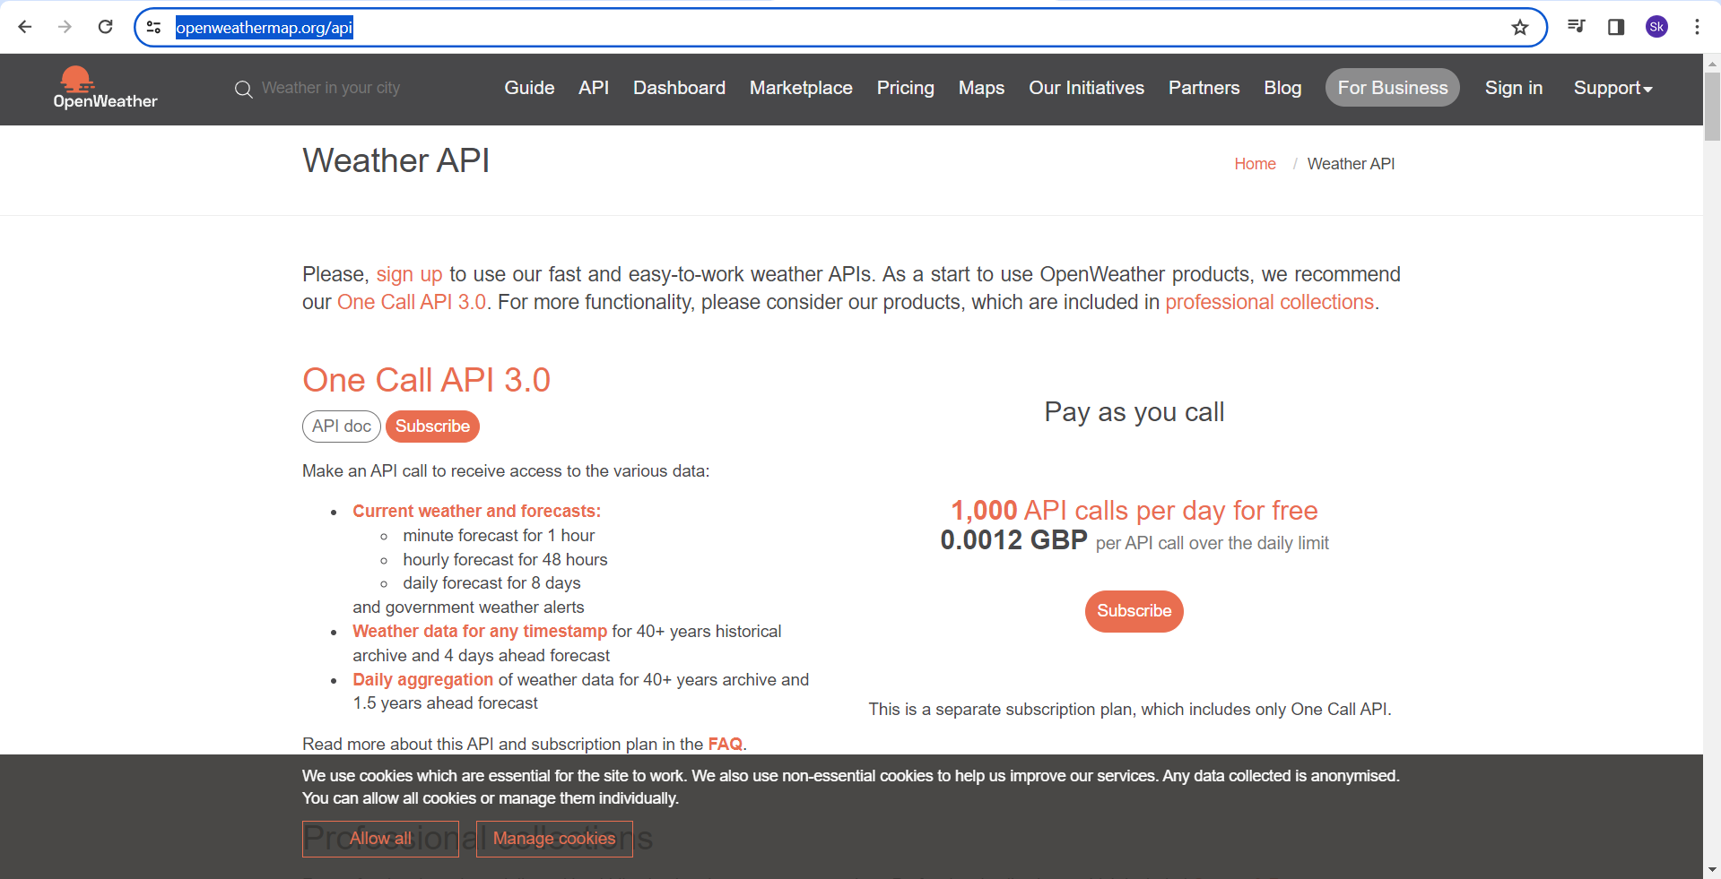

Create the account in the and get the API key. It shall be temporary.

68ef60033d617e02d2730703dff62661

So when every we are using API key. There should be key and value pair for that.

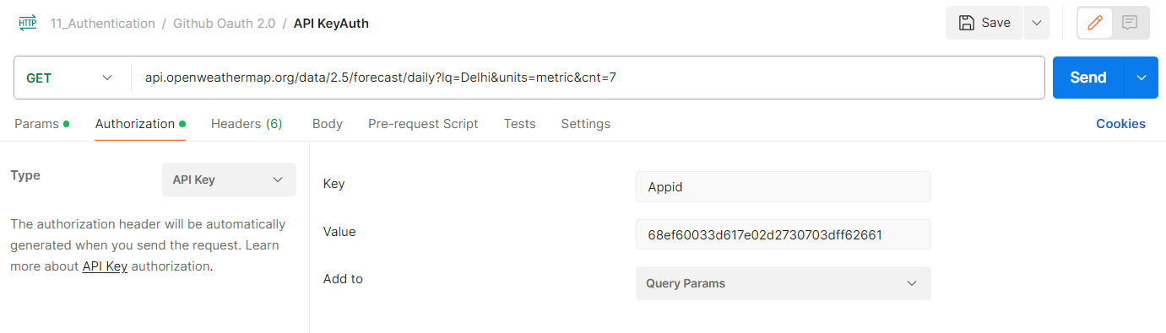

**OAUTH:**

OAuth 1.0 and OAuth 2.0 are almost same, but in OAuth 2.0 the first 2 steps for are been removed.

* OAuth authorization is a type of internal algorithm, it shall authenticate the users based on different type of information and token is also part of it. But it does not have the direct token.
* The token shall be generated by the client
* In OAuth 2.0 we shall first send the information to the service provider (Client id, request url, scope).
* Before getting the actual token we shall 1st pass one client id and in the response we shall get the Code, 2nd we shall pass the secrete key & code and then we shall get the token, 3rd by using the token we shall pass the API request.

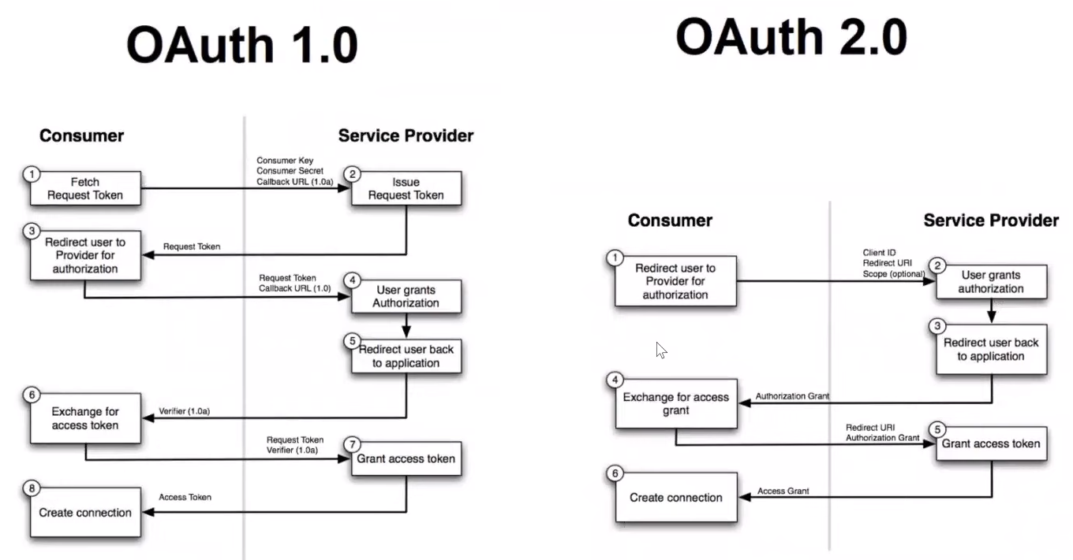

How to do the OAuth 2.0.

* First we have to create the developer account in GitHub, Also you can do the same in FB, Linkdin, Instagram.
* 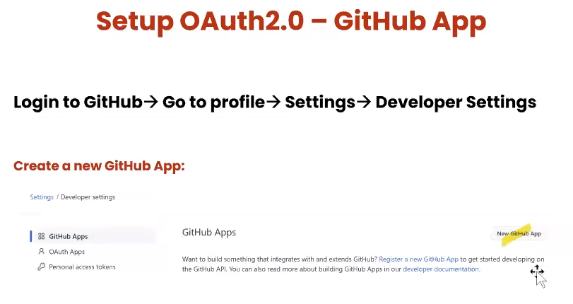

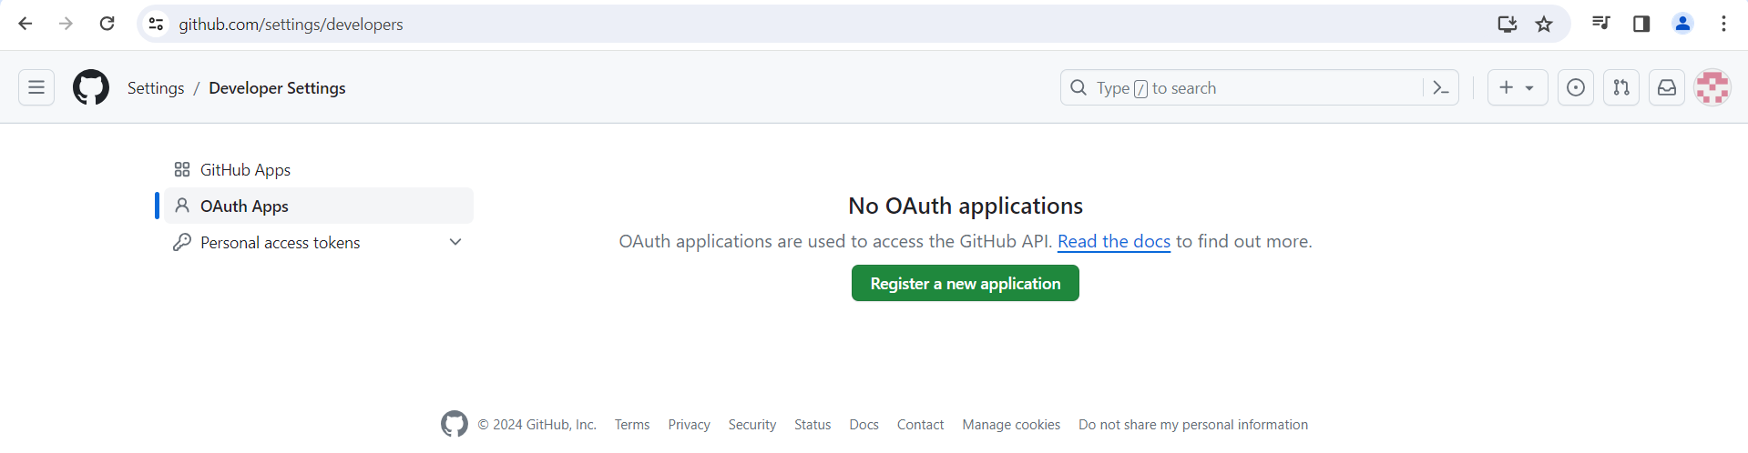

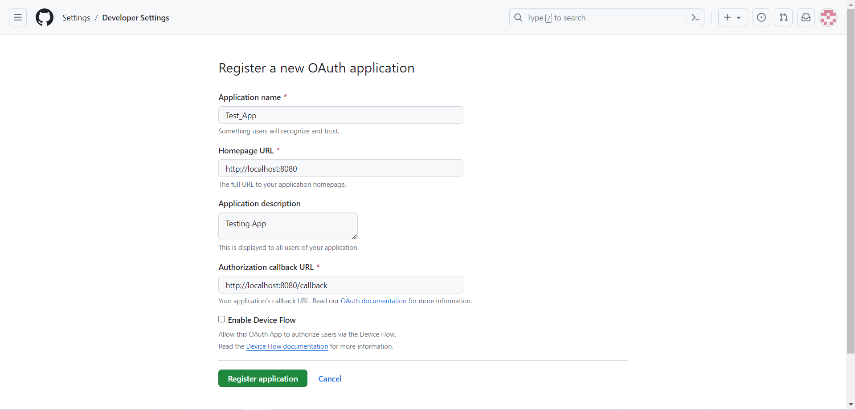

Once you register you shall get the client id.

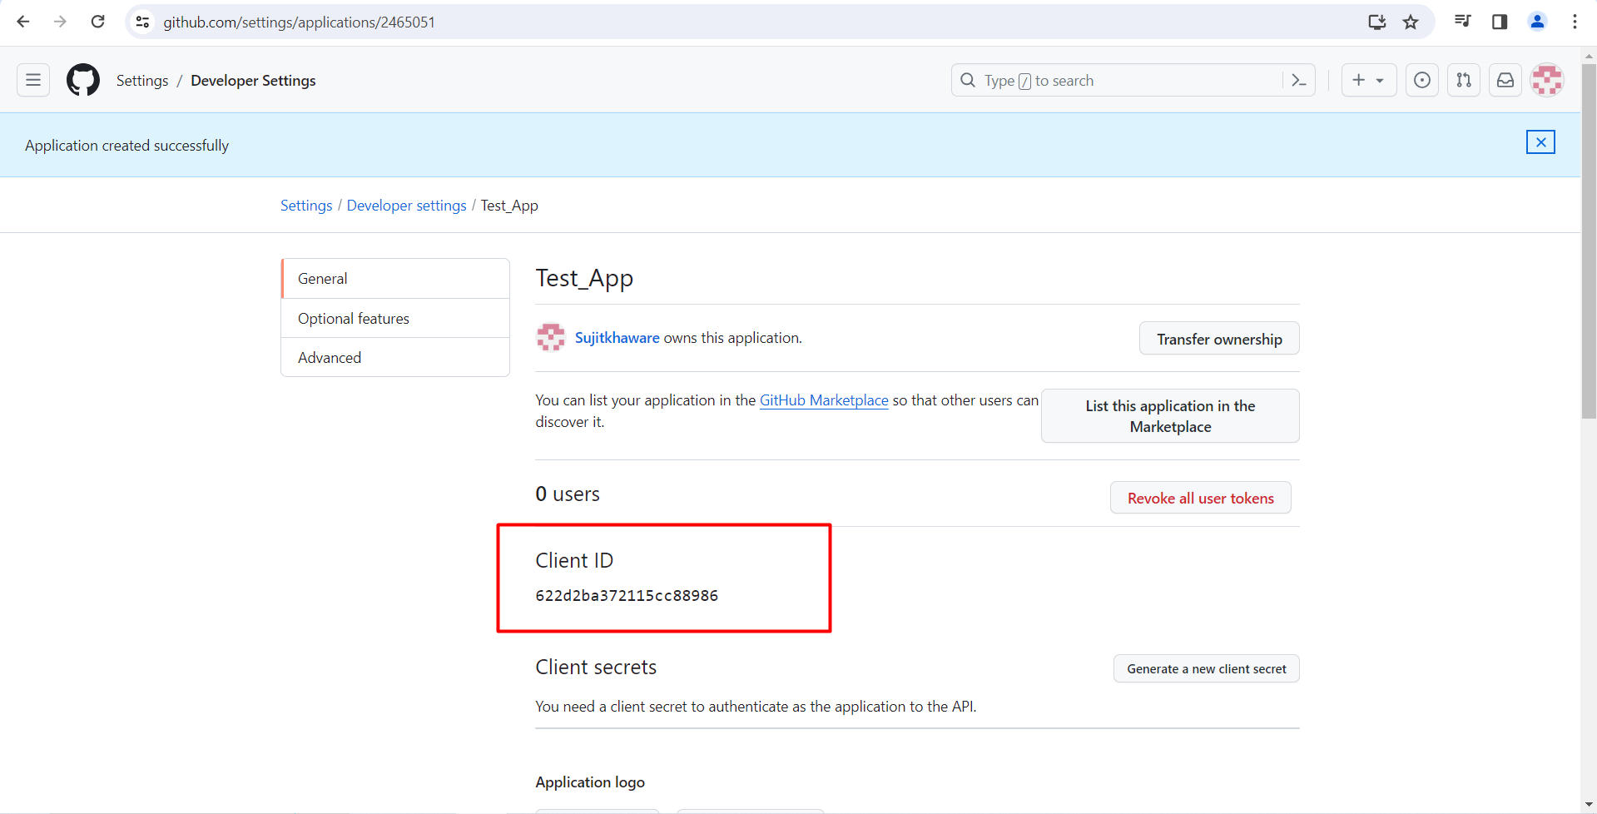

Then we have to generate Client Secrete also.

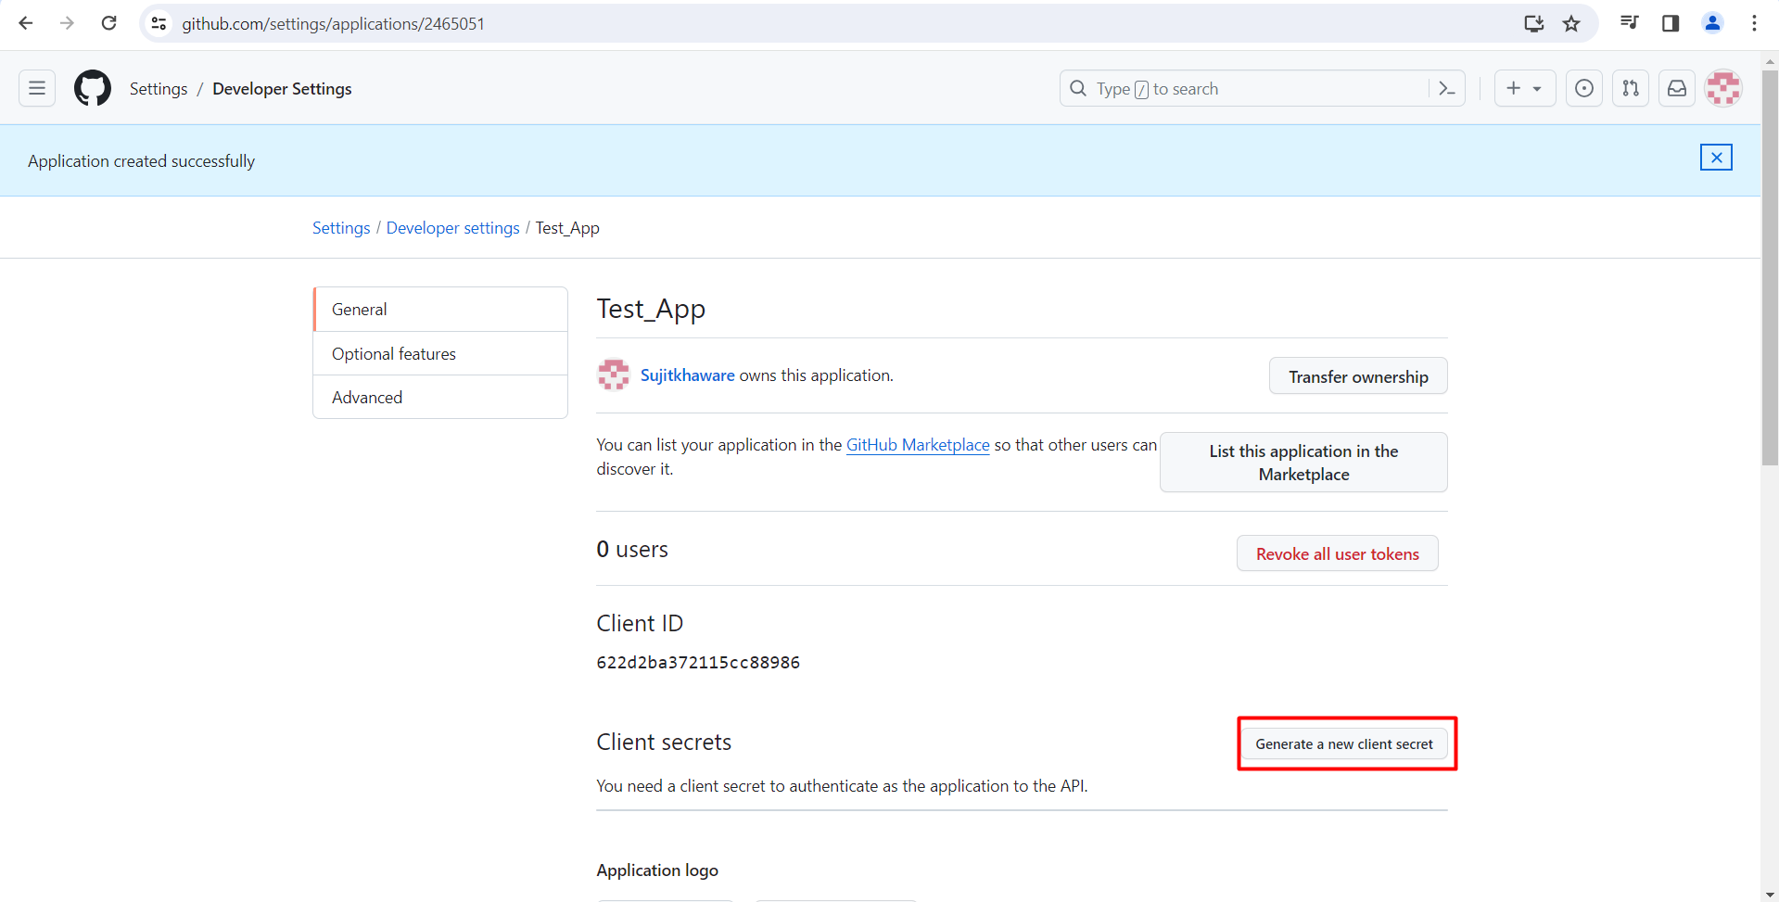

Client ID - 622d2ba372115cc88986

Client secrete ID - 41d91faf611282edd4852de218410072f3ee4237

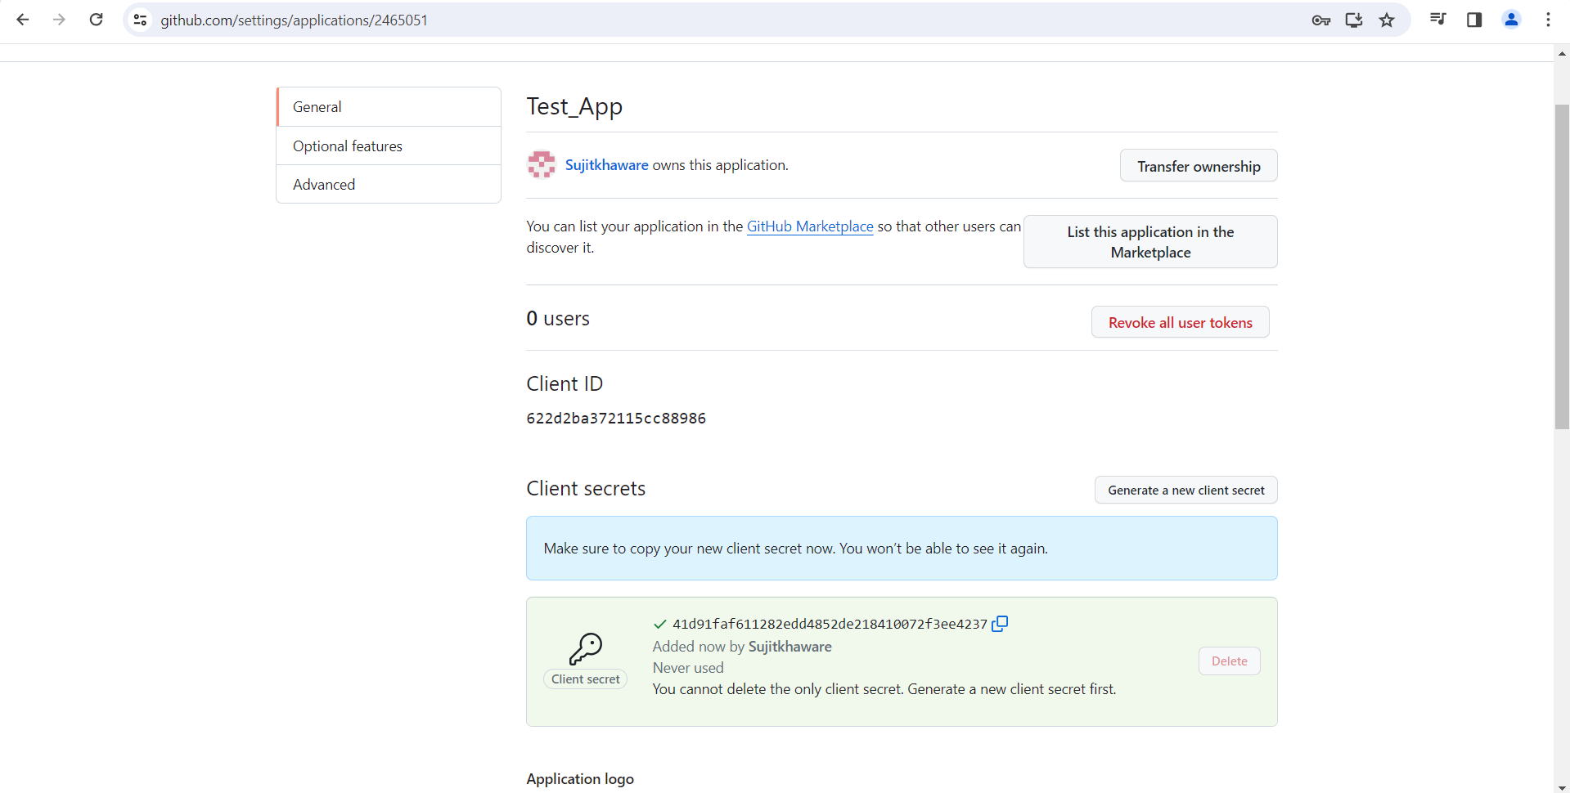

Now we shall send the request.

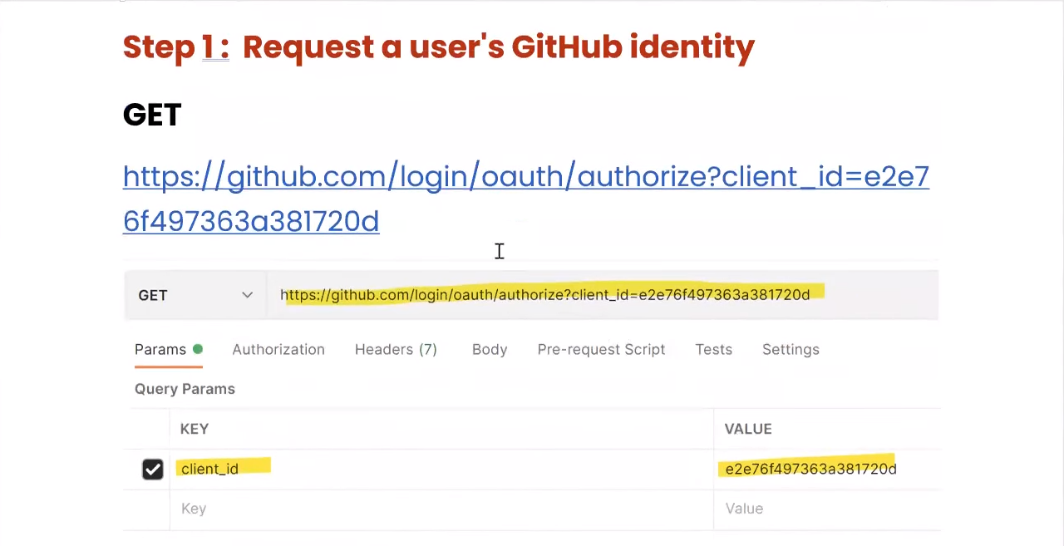

To enable the local host 8080. We need to download one app XAMPP Control Panel.

Link - <https://www.apachefriends.org/>

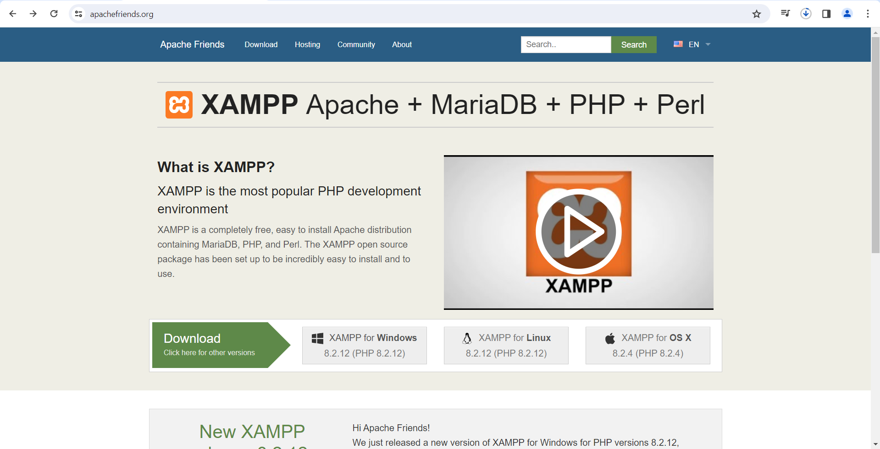

Once it is installed. Up the tomcat server which is port 8080.

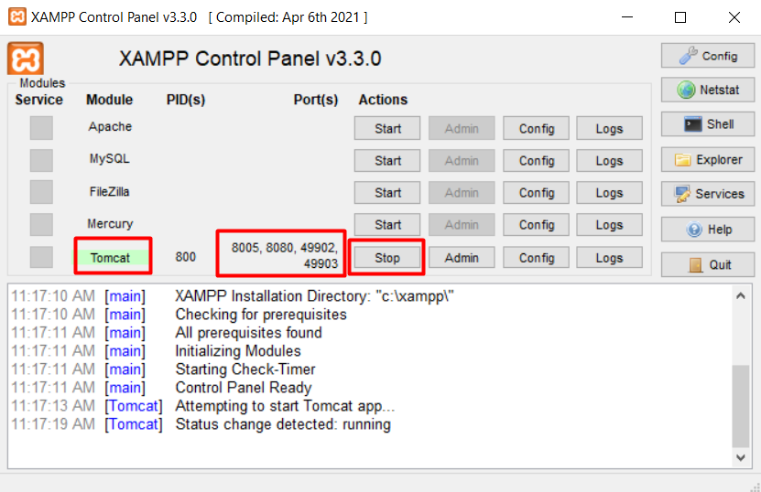

Then we shall pass the 1st get request.

https://github.com/login/oauth/authorize?client_id=622d2ba372115cc88986

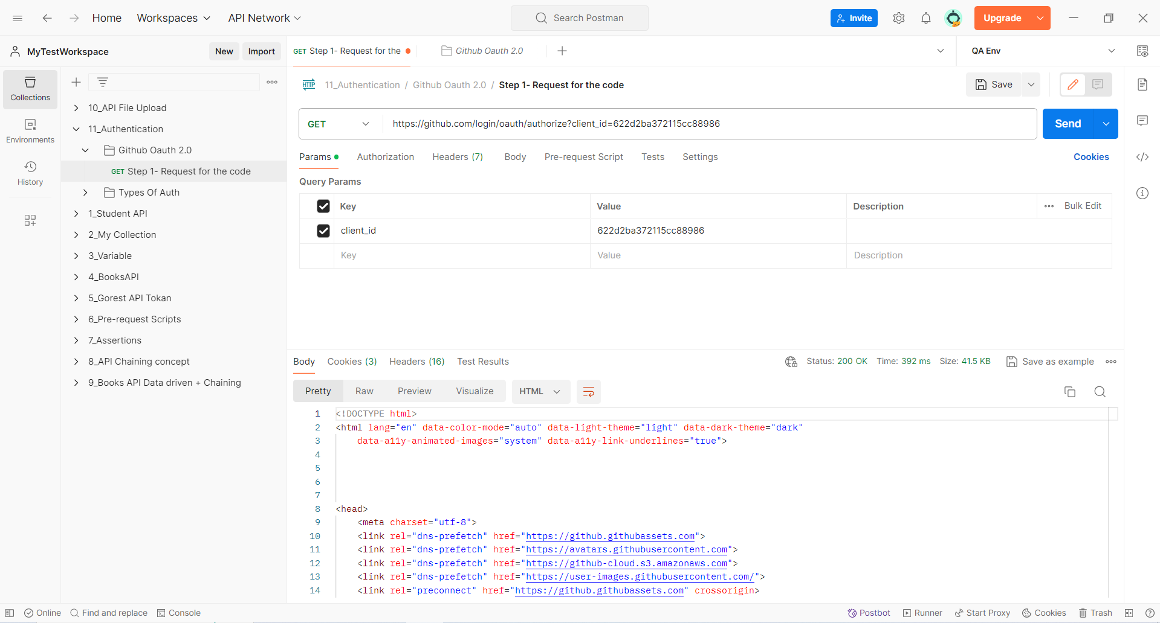

Then we shall browse the same in url in the browser for the code id.

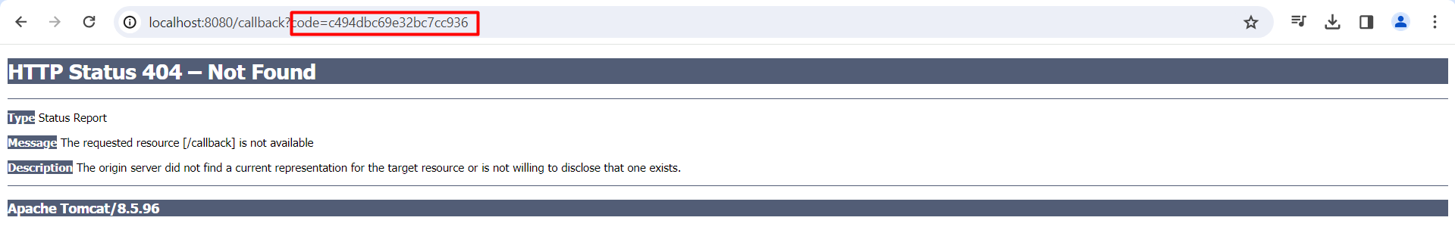

After? Mark an entry shall be created in the Query parameter and after every & a new entry shall be added.

<https://github.com/login/oauth/access_token?client_id=622d2ba372115cc88986&client_secret=41d91faf611282edd4852de218410072f3ee4237&code=c494dbc69e32bc7cc936>

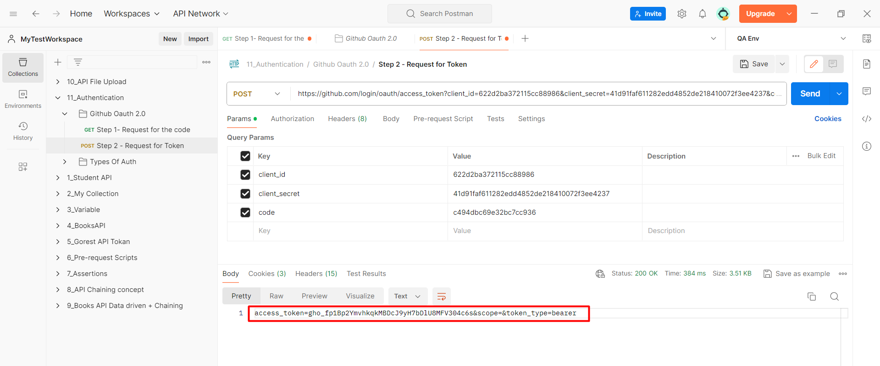

Now we can use the access token for the API requests.

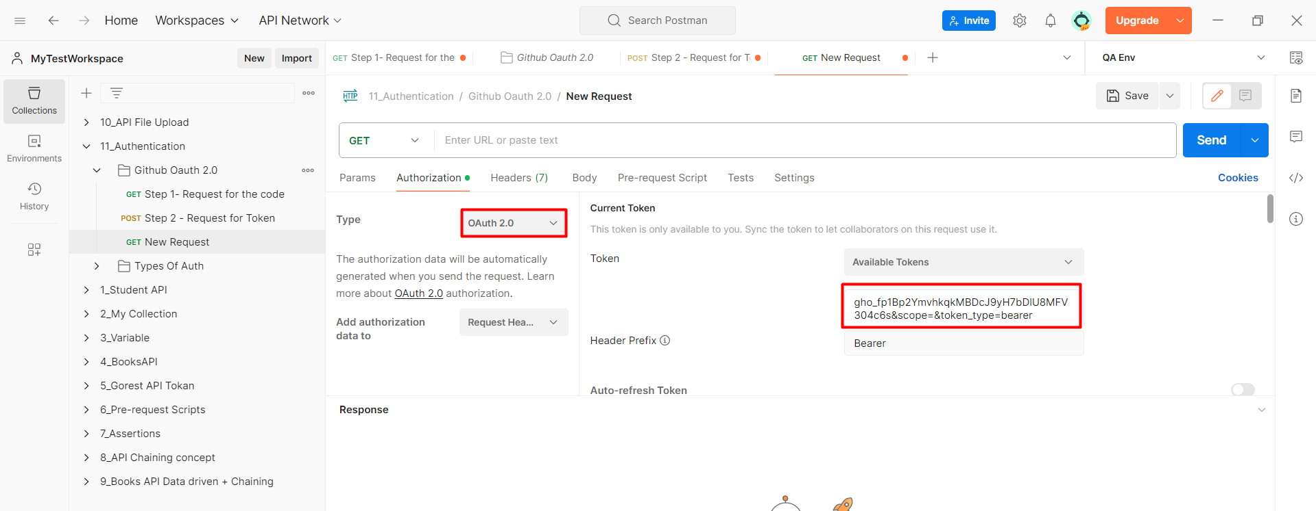

**WHAT IS Swagger?**

* Swagger is basically interactive documentations.
* The document provided by the developer to the testing team.
* Swagger is nothing but a tool, which developer use to make the API documentation.
* Documents are of two type
* **Static Document** – It is readable and rewrite able.
* **Interactive Document** – It is a document in which we can perform some type of testing.
* It is used for exploring the API and not for the testing purpose as we cannot specify the test scenarios in it. Can’t put any validations. We cannot save any results and generate the reports.
* Swagger also contains the curl.

Links:

https://petstore.swagger.io/

[**https://fakerestapi.azurewebsites.net/index.html**](https://fakerestapi.azurewebsites.net/index.html)

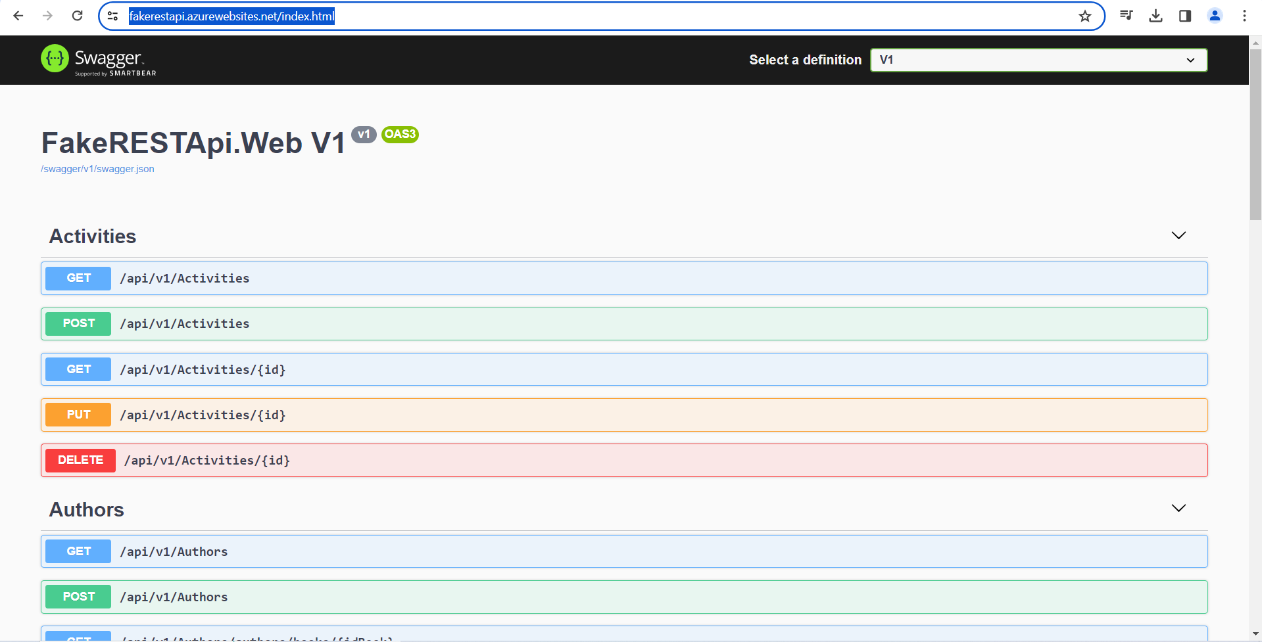

**WHAT IS CURL?**

* Sometimes the developer shall not provide directly with the URL they shall provide the cURL.
* cURL is which contains the URL along with the header, authentication everything is a part of cURL.
* It is a consolidated string.
* **Client URL** is the full form of cURL.

cURL is nothing but a command

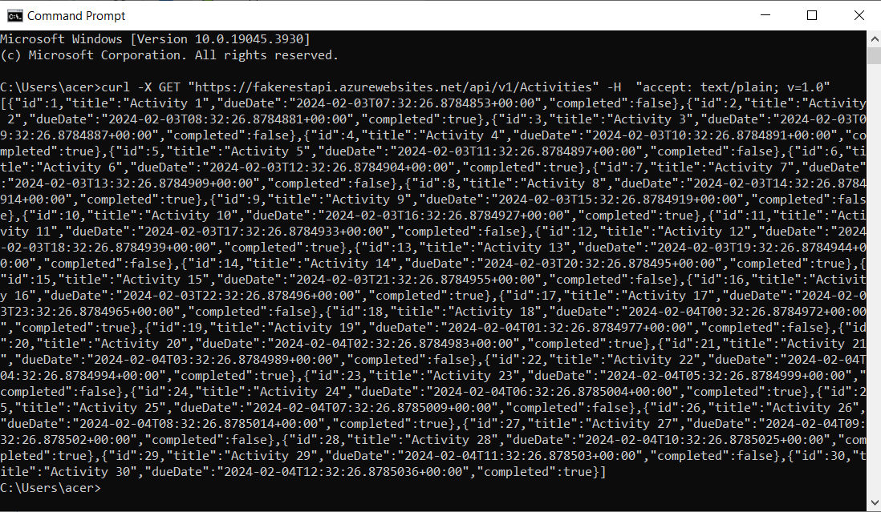

So instead of providing all the information the developer shall provide with the single cURL having all the details for the request.

We have to import the cURL.

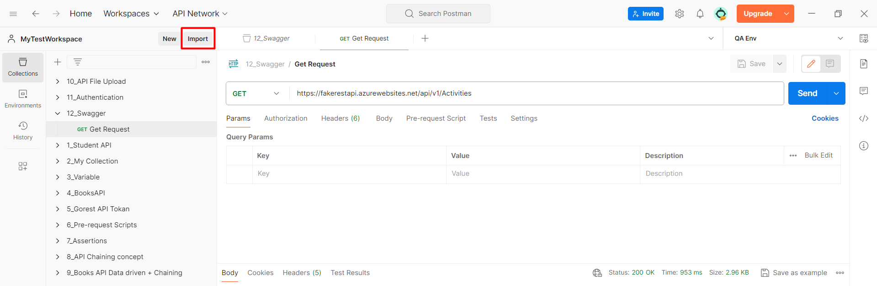

We have past the cURL in the below space.

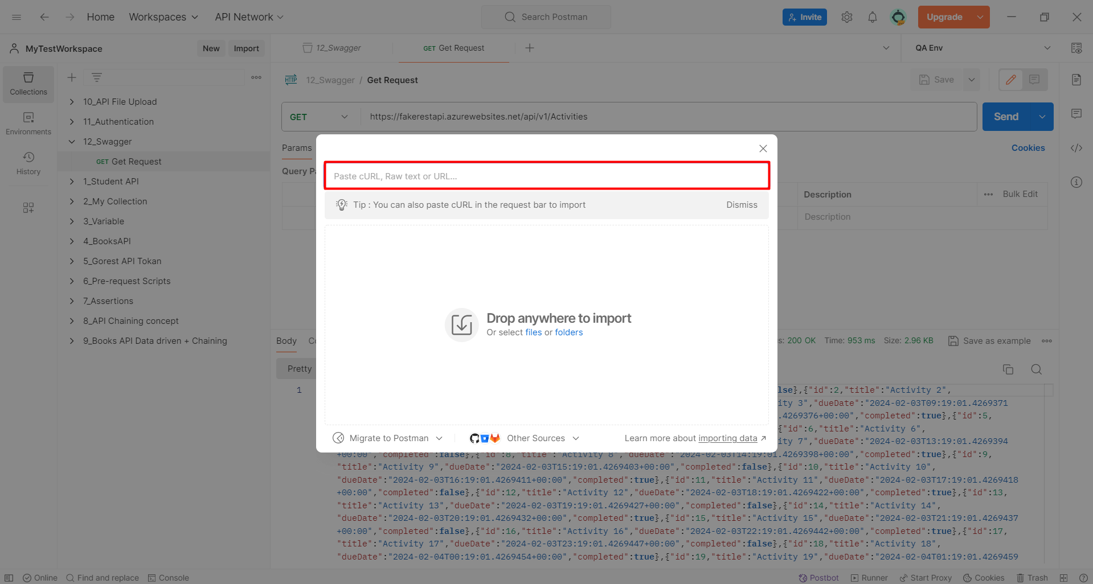

Automatically the request shall be created with all the details.

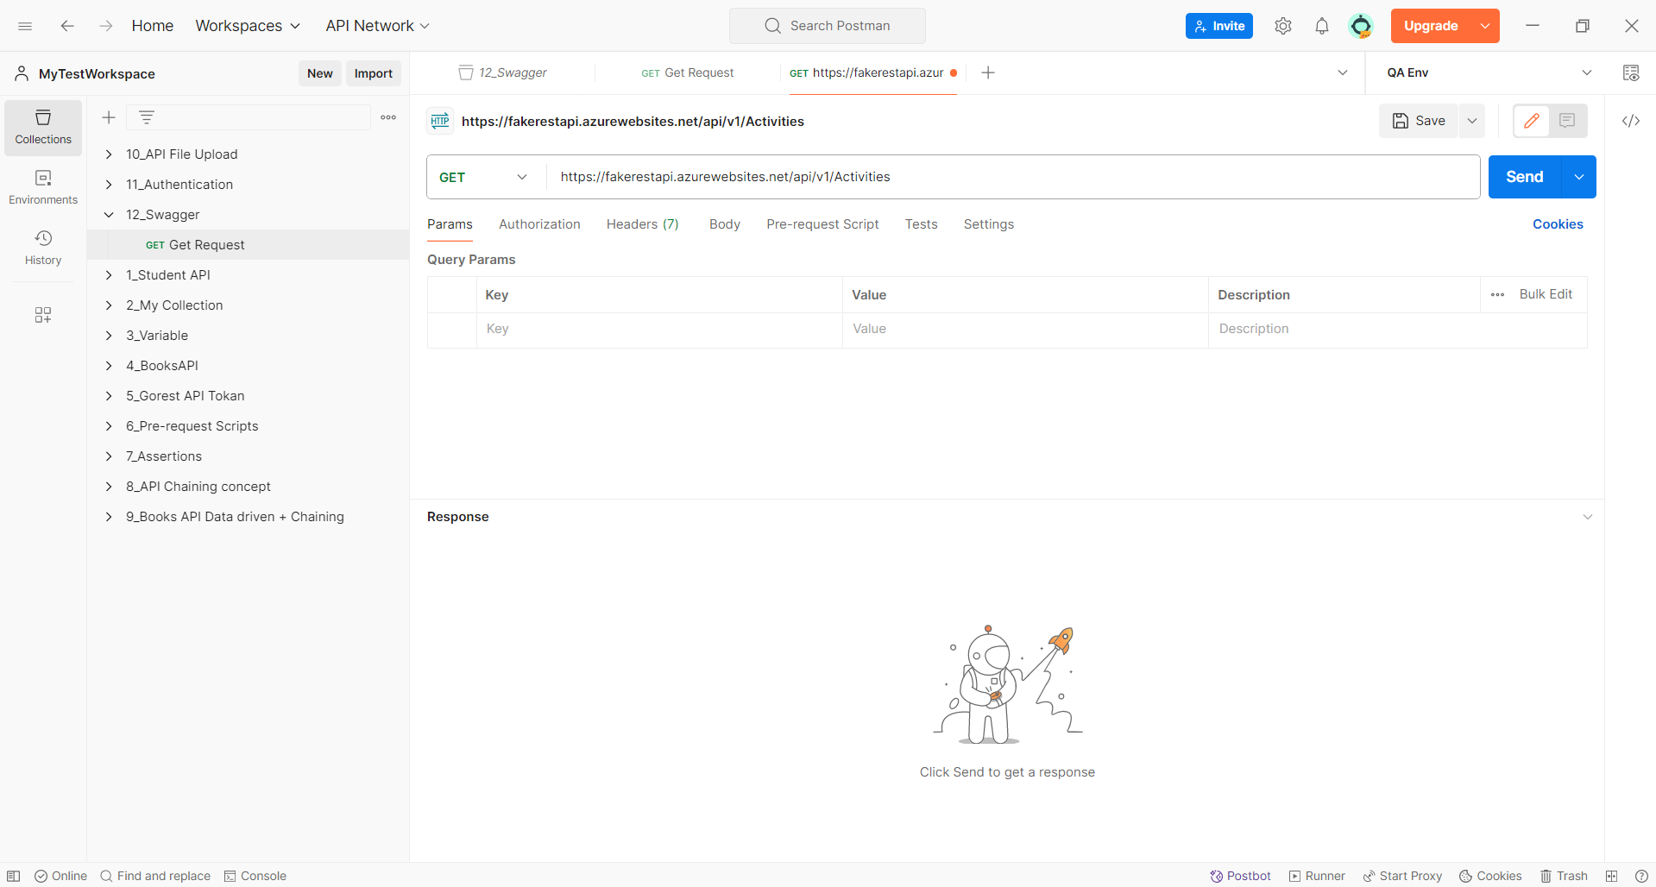

**HOW TO DOCUMENT OUR COLLECTION.**

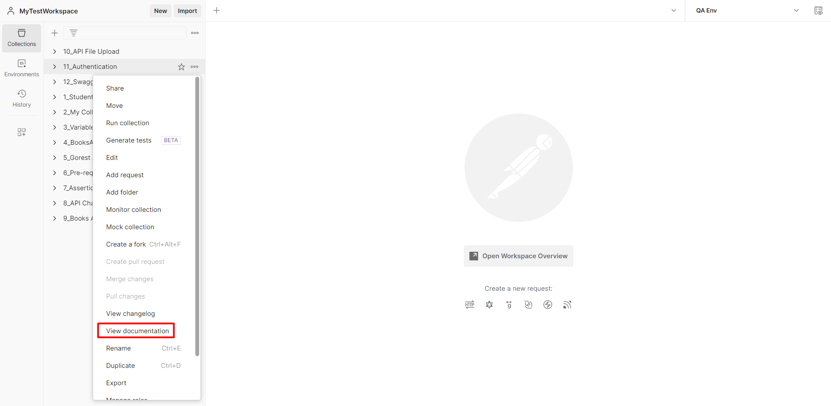

**Can also change language and click on publish?**

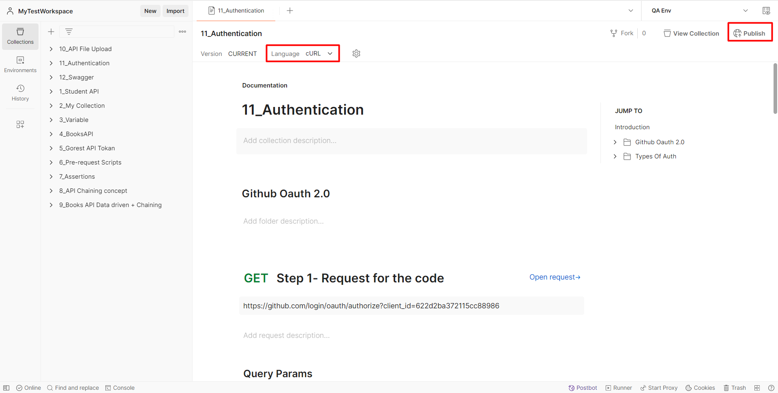

**OTHER**

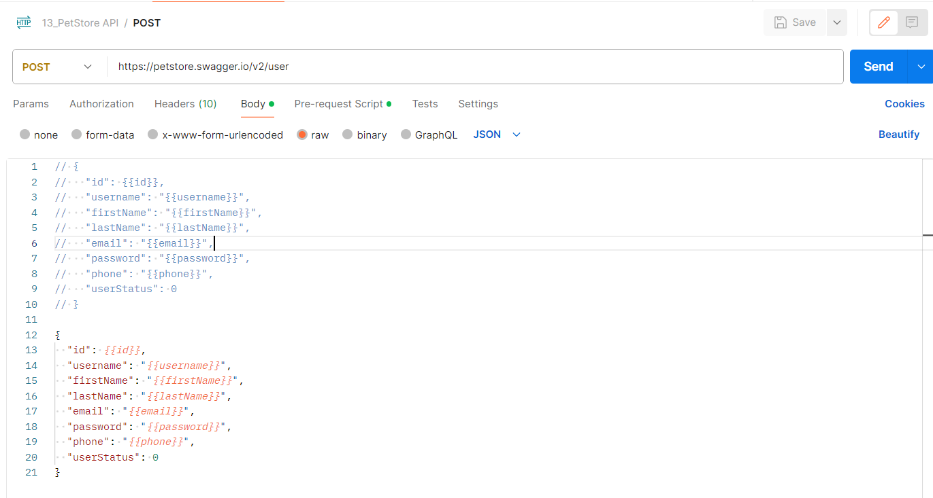

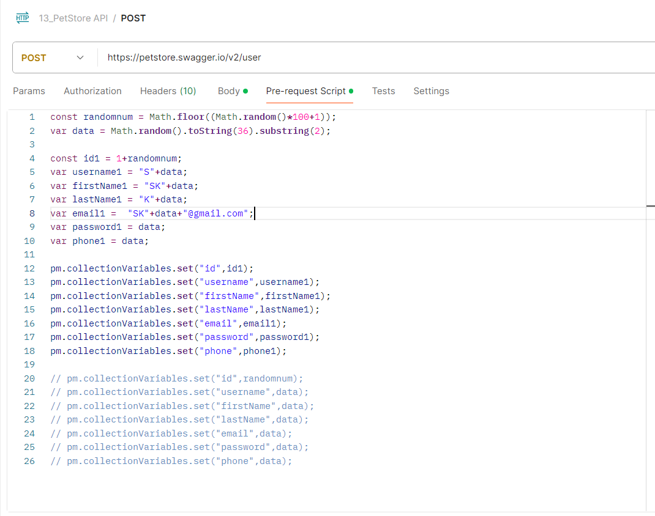

**DAY 9 – Documenting & Publishing API’s**

To generate the random number in java we shall use the below statement in the pretest script

**const** randomnum = Math.floor((Math.random()*100+1));

We can export the collection by clicking on export.

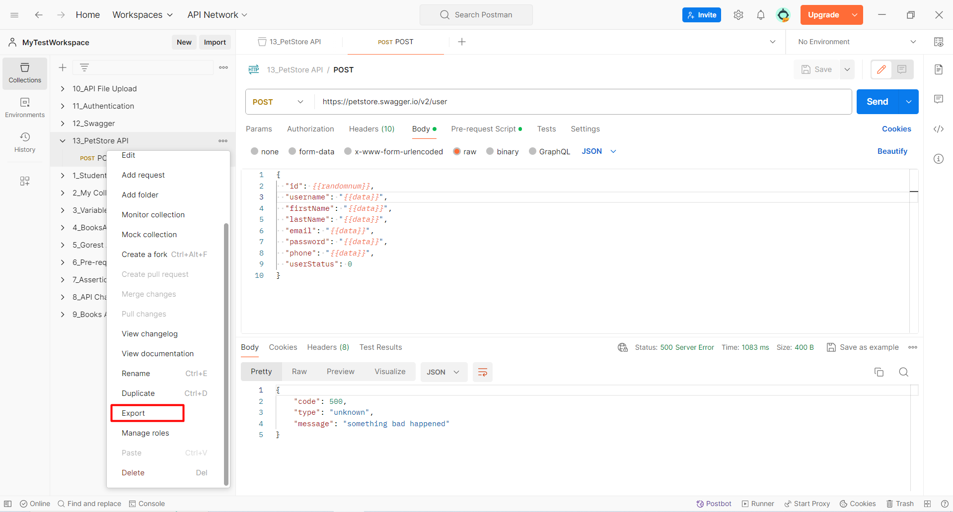

We can document the collection and share the link with other to access it.

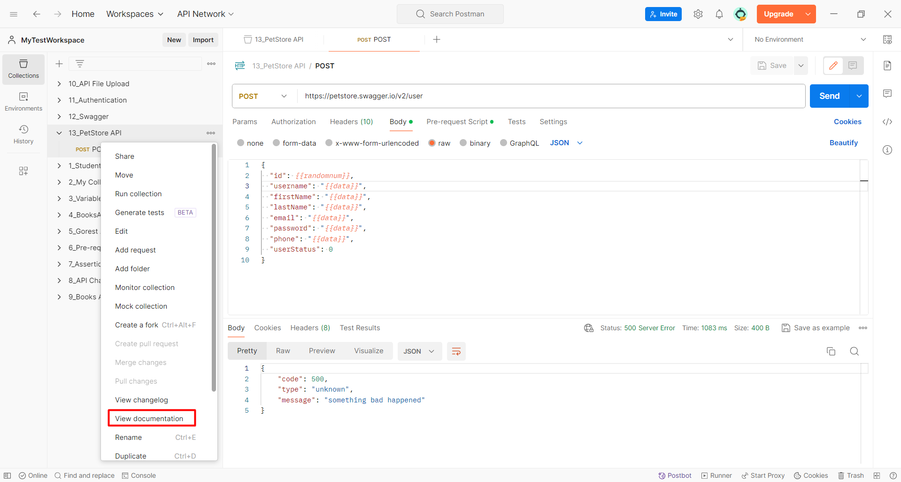

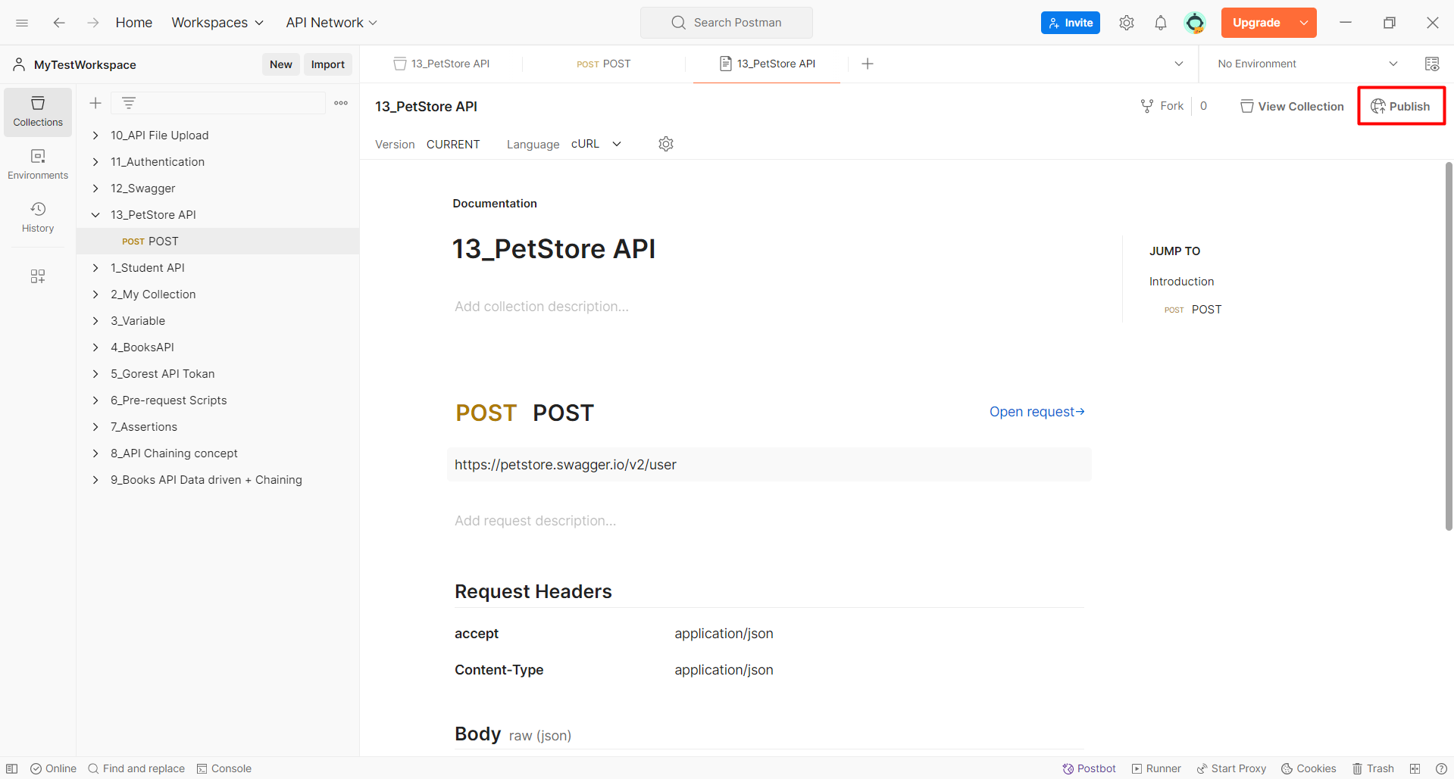

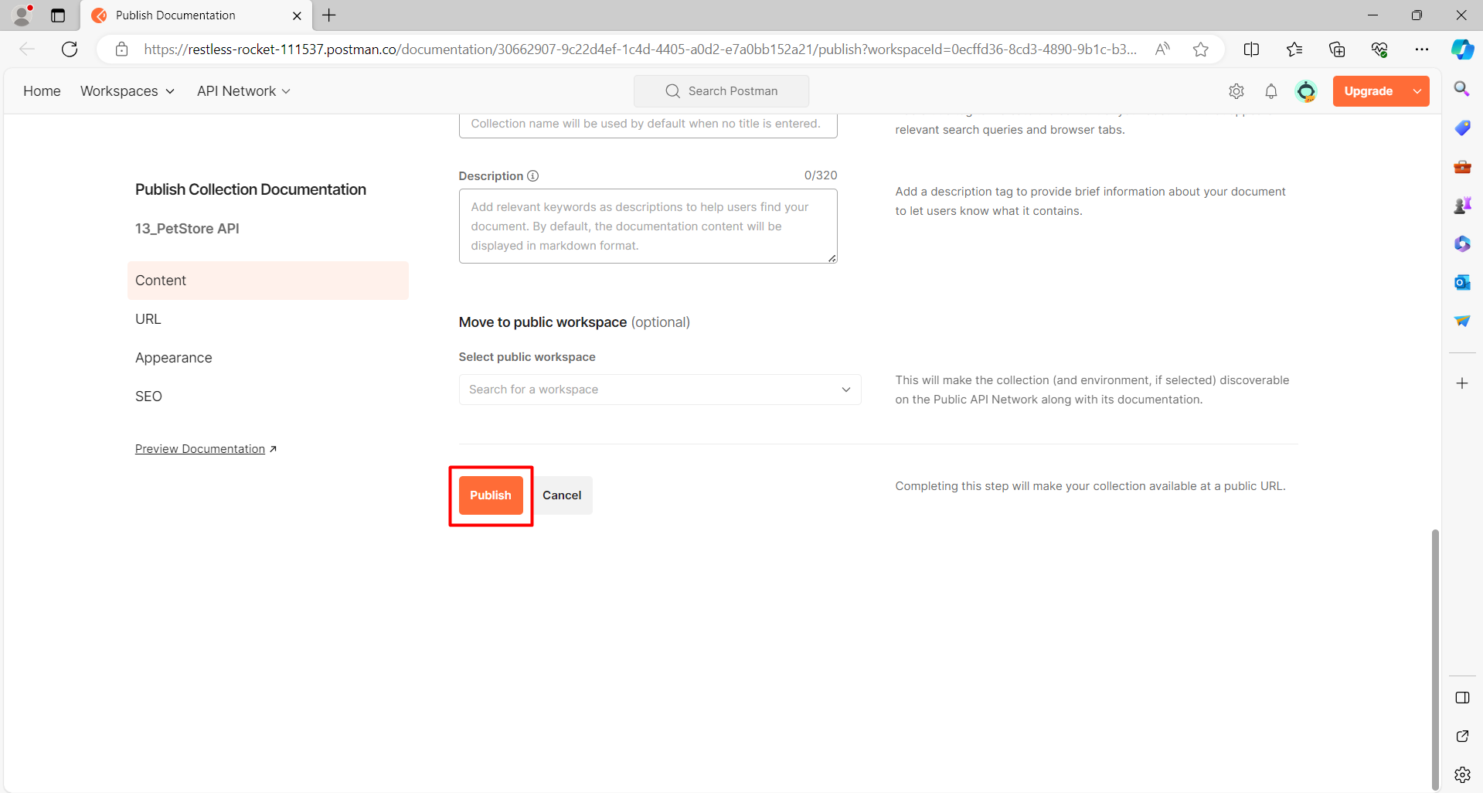

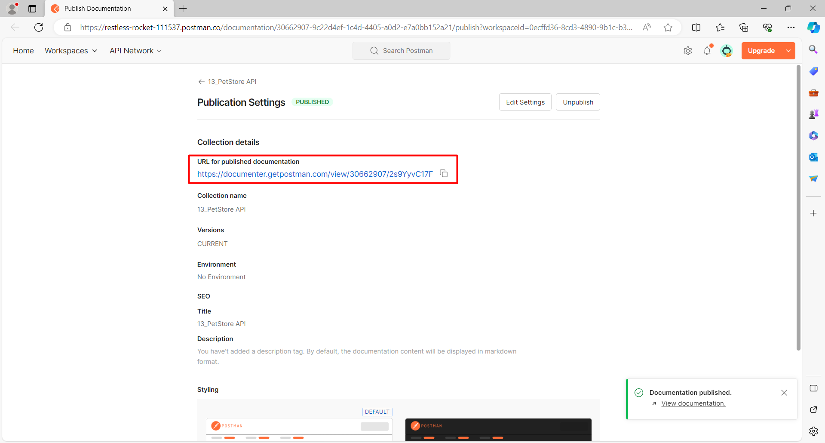

**PUT VALIDATIONS FOR XML REQUEST**

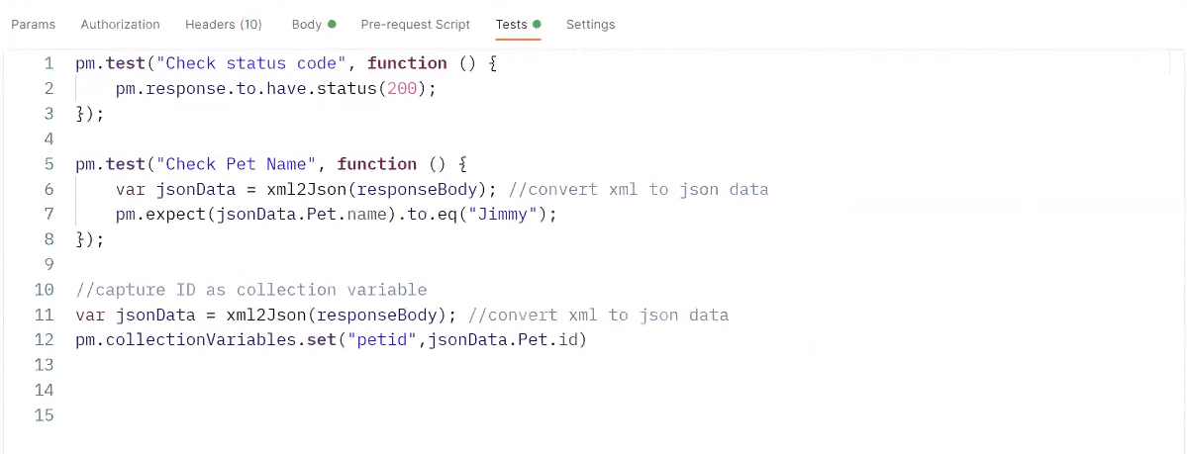

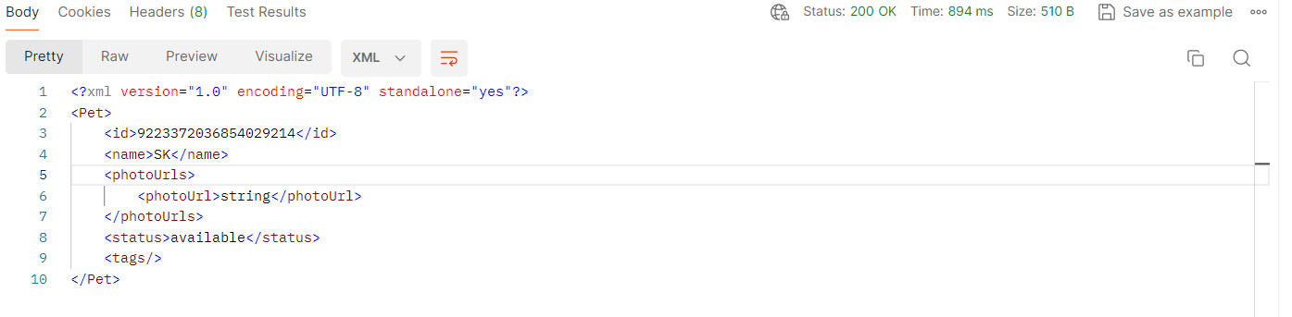

**The data for the XML is put in the tags.**

**<Name> Sujit </Name>**

* We cannot do direct validation on the XML format we have to first convert the response into json and then validate it.

**DAY 10 – PROJECT E-COMMERCE**

Download the open cart V.3.0.3.8

<https://www.opencart.com/index.php?route=cms/download/download&download_id=64>

The download the Xampp server.

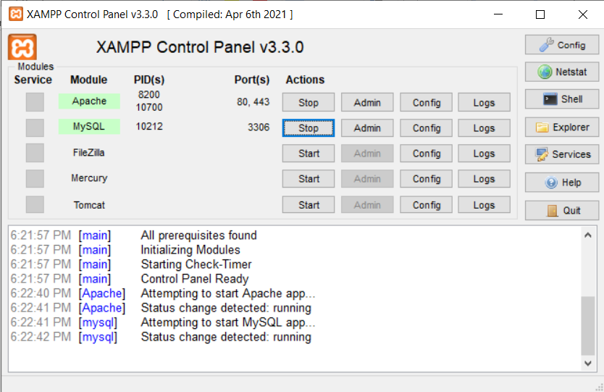

Copy the opencart folder at this path - C:\xampp\htdocs

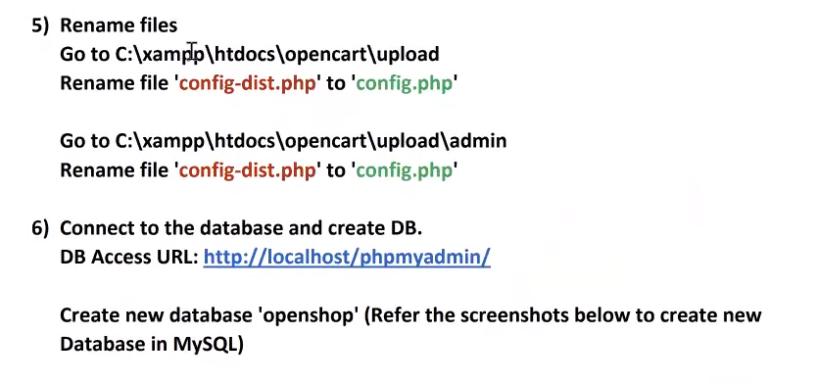

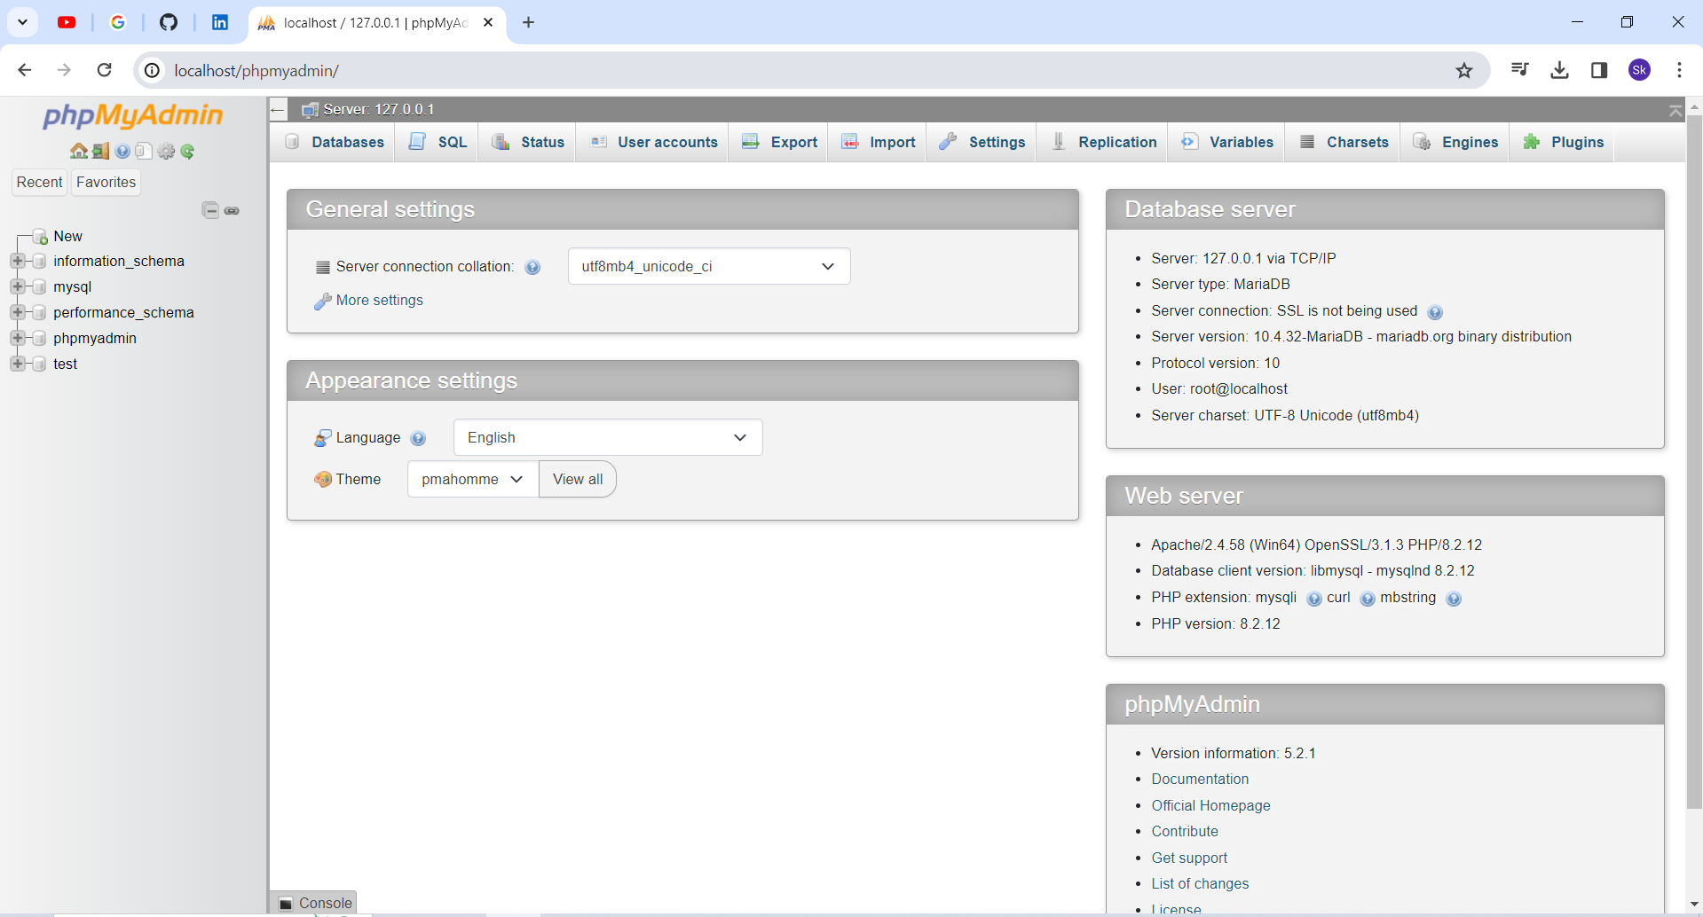

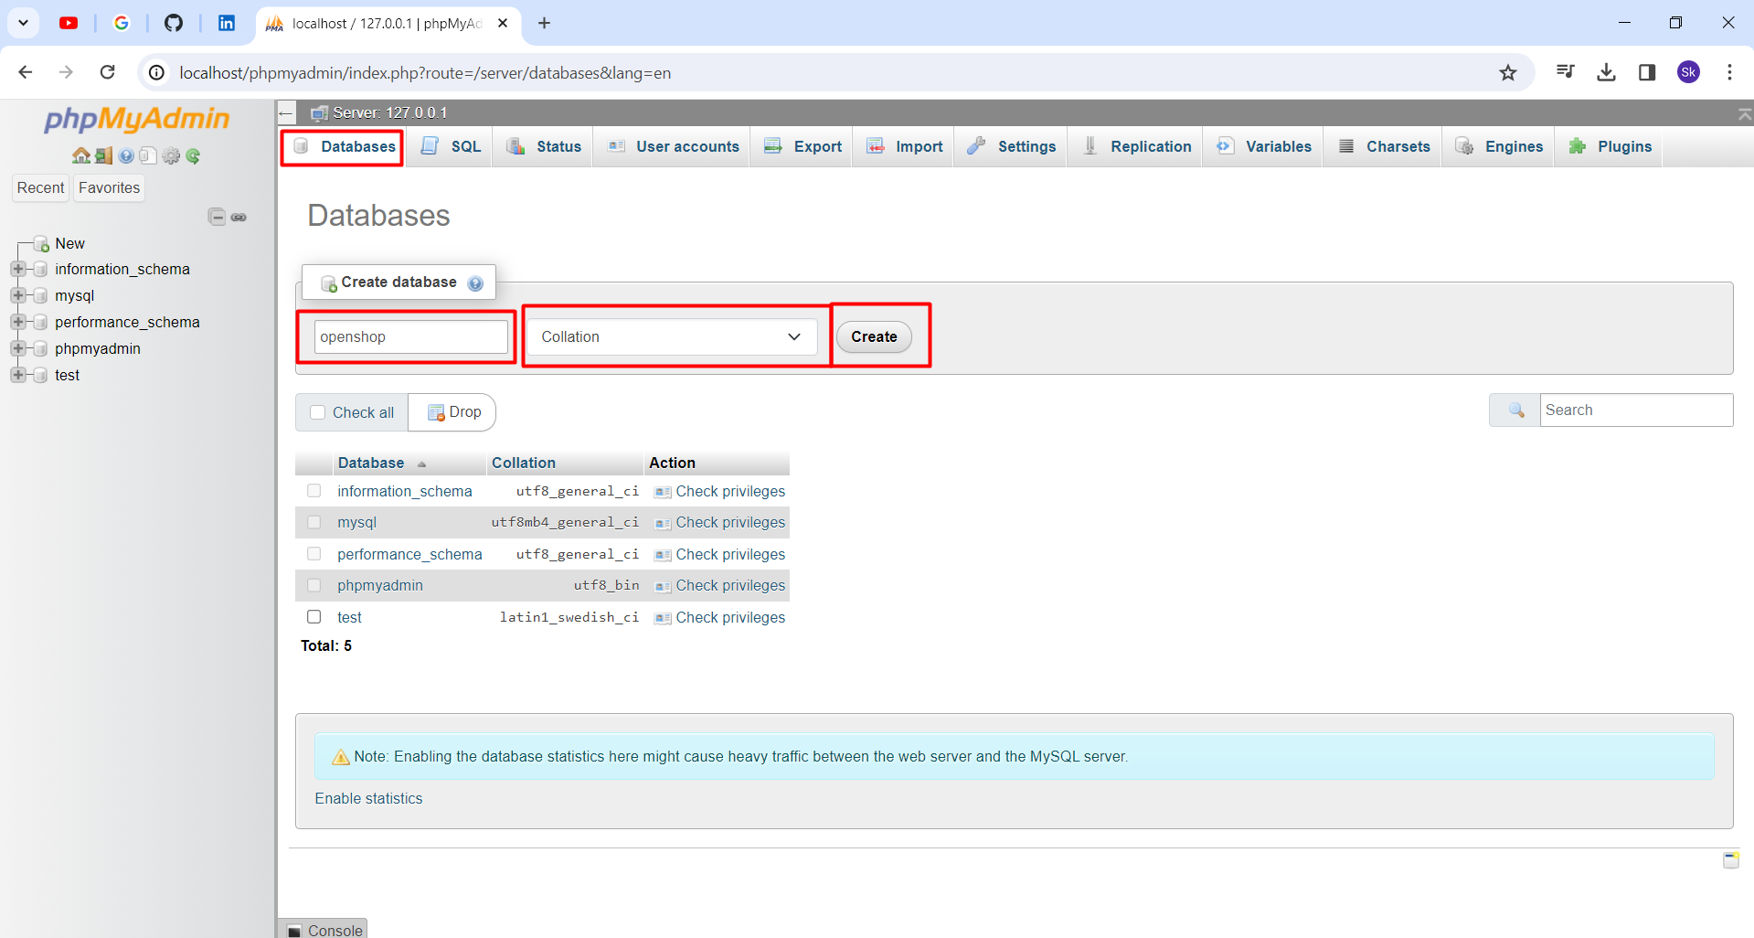

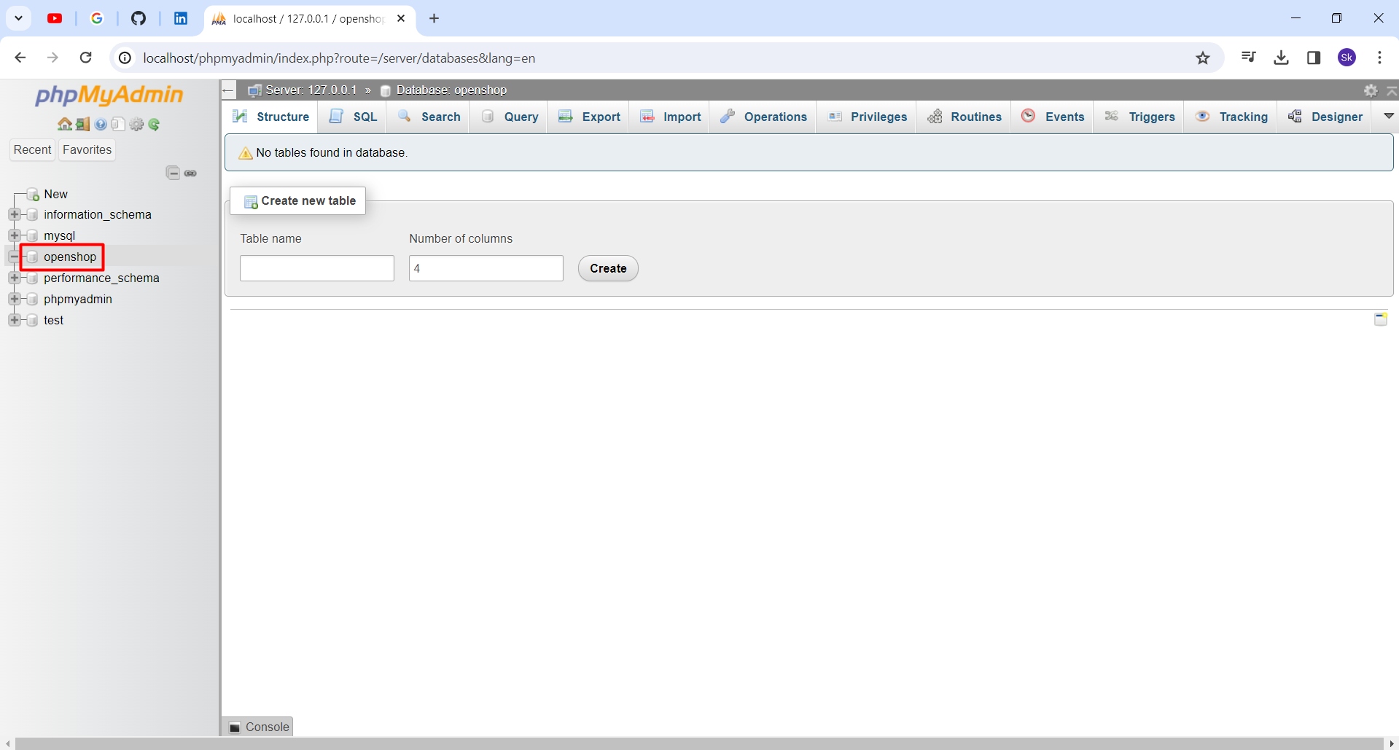

Open the site: <http://localhost/opencart/>

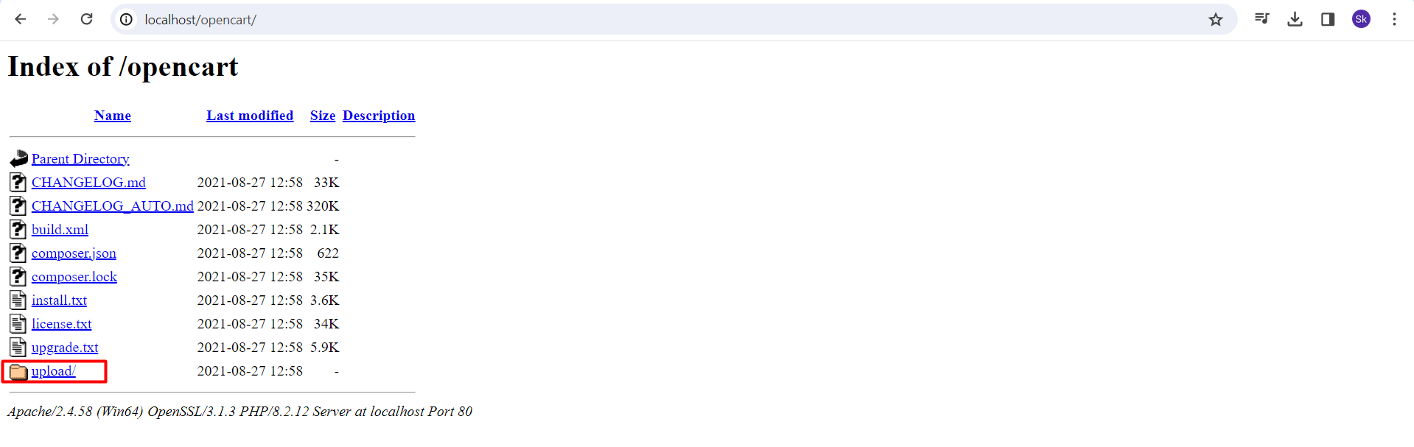

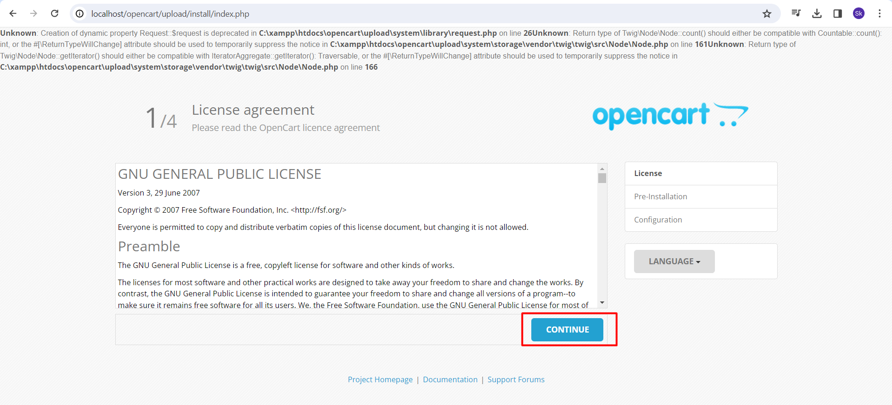

If having the below error.

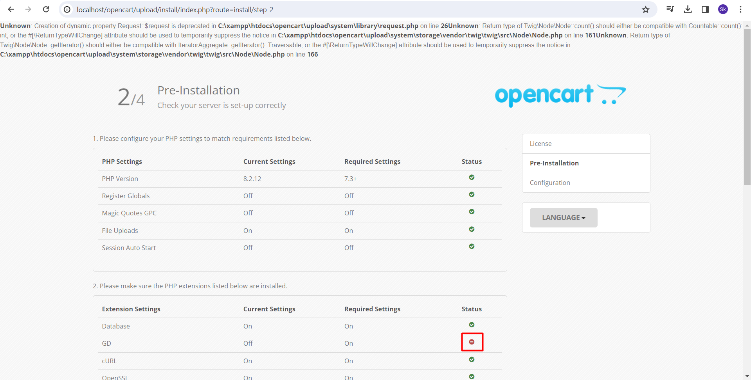

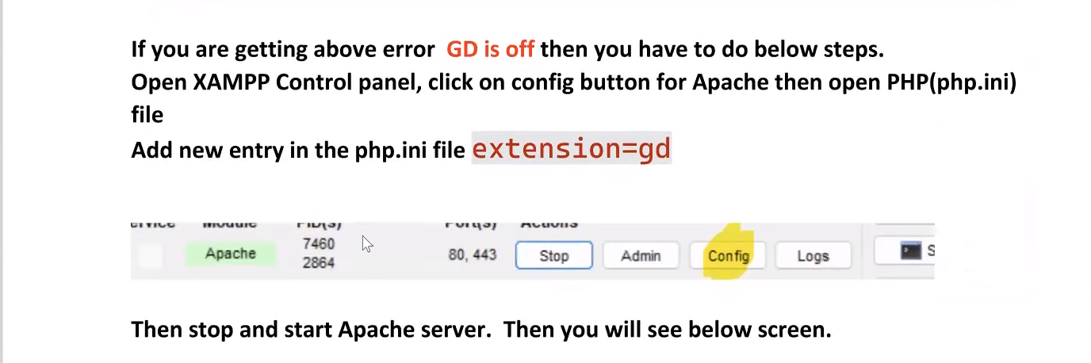

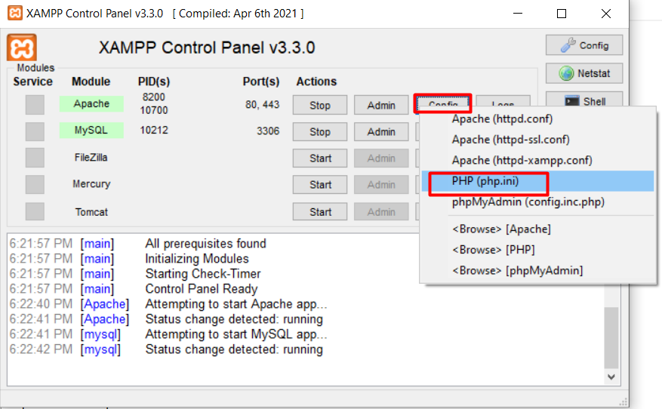

Remove the semicolon

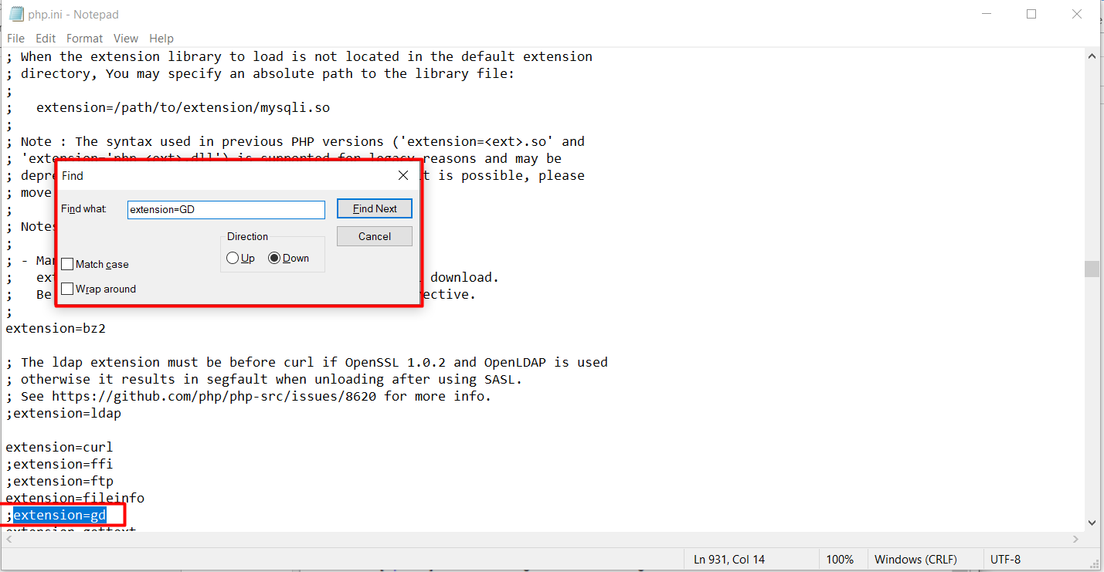

Once all is green click on continue.

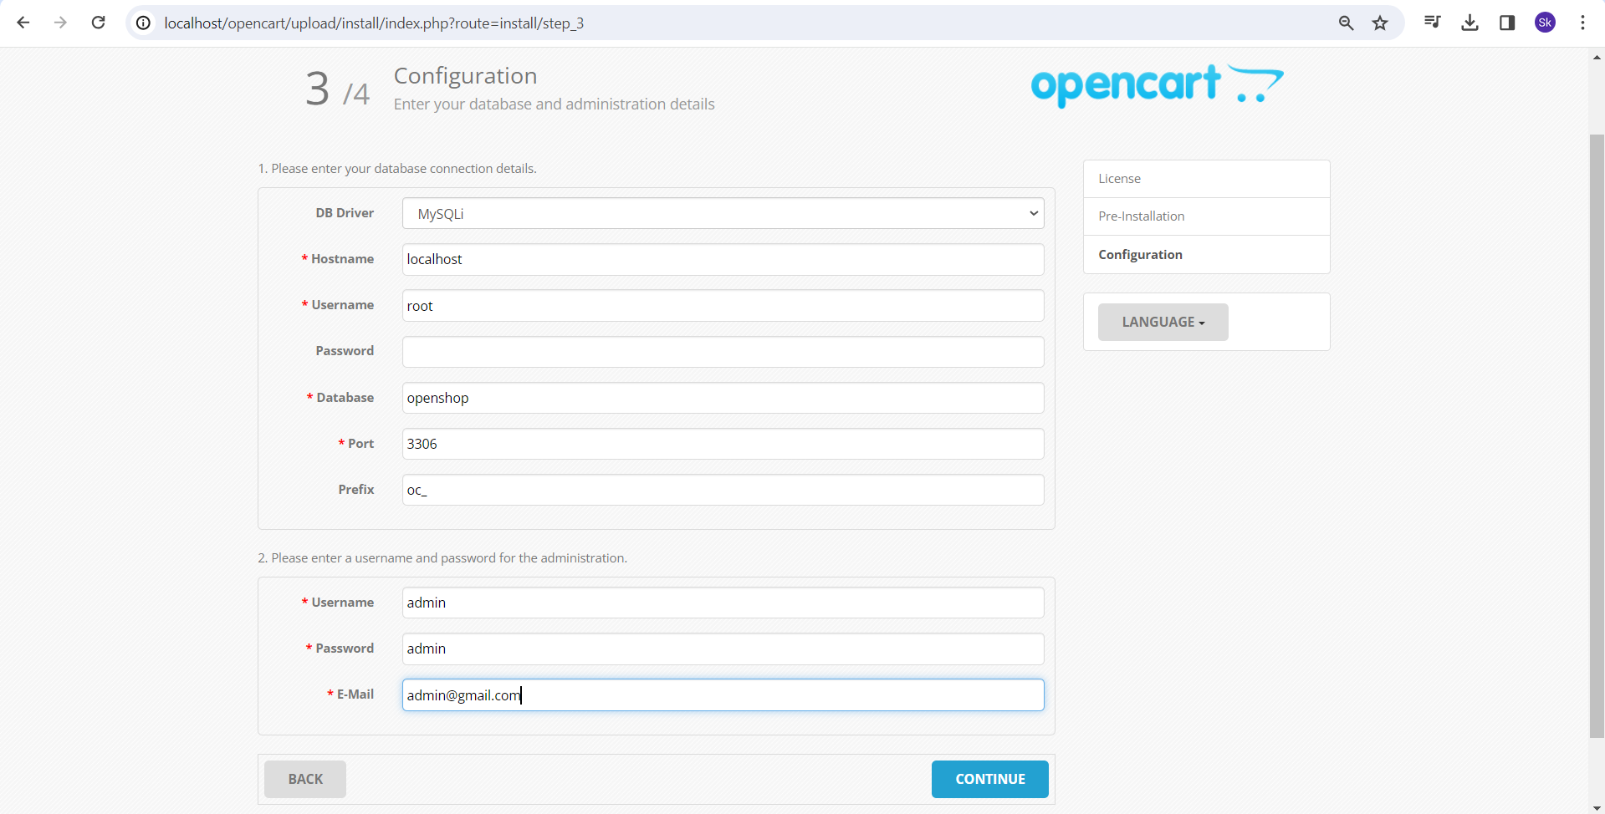

Once click on continue.

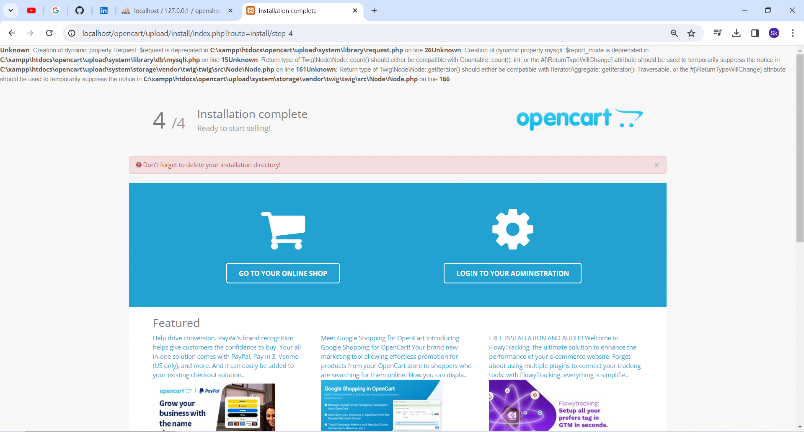

Then delete the below install folder

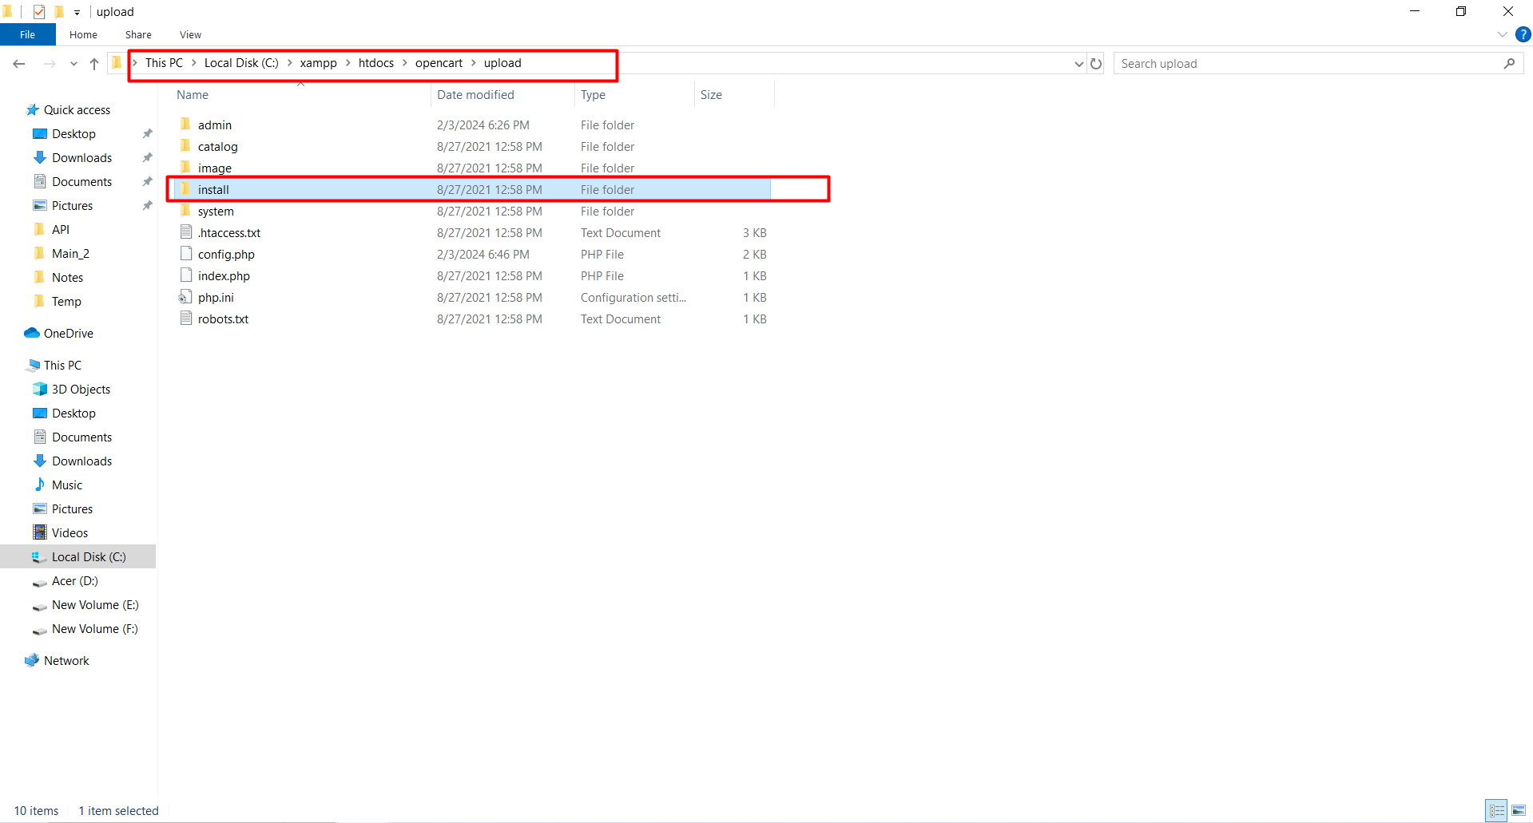

Go to the app URL: Front end app

<http://localhost/opencart/upload>

Backend App URL:

<http://localhost/opencart/upload/admin>

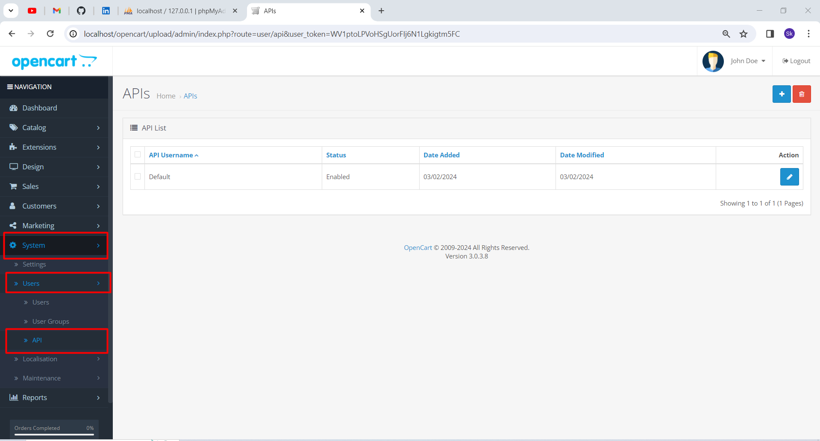

How to create the API user.

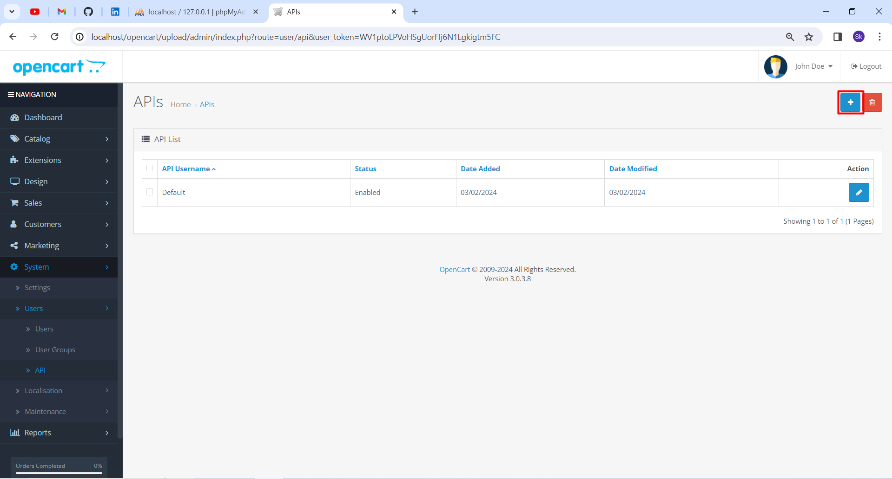

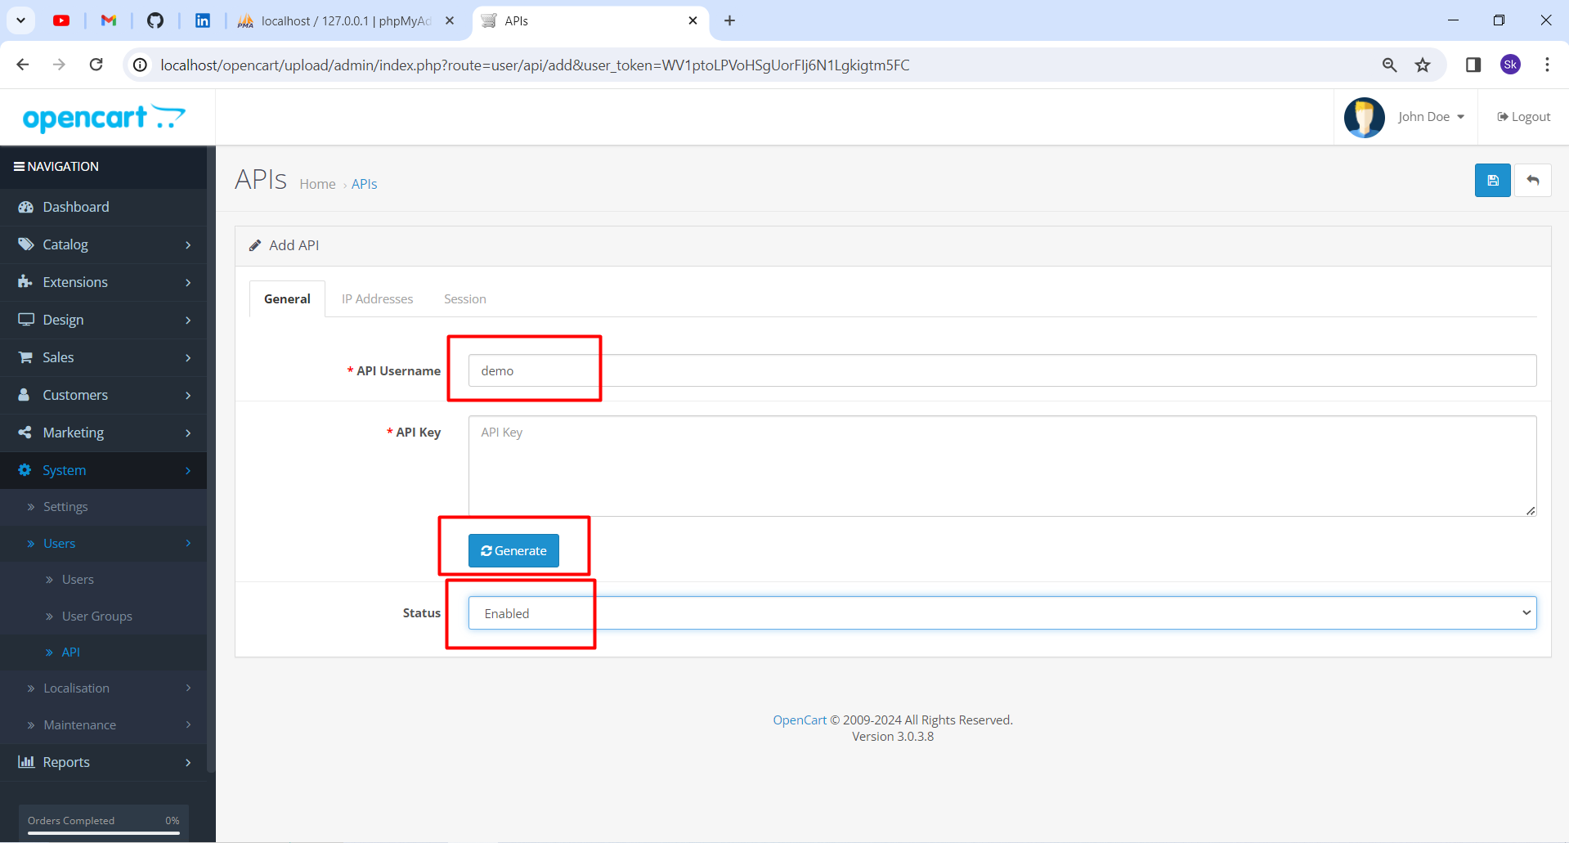

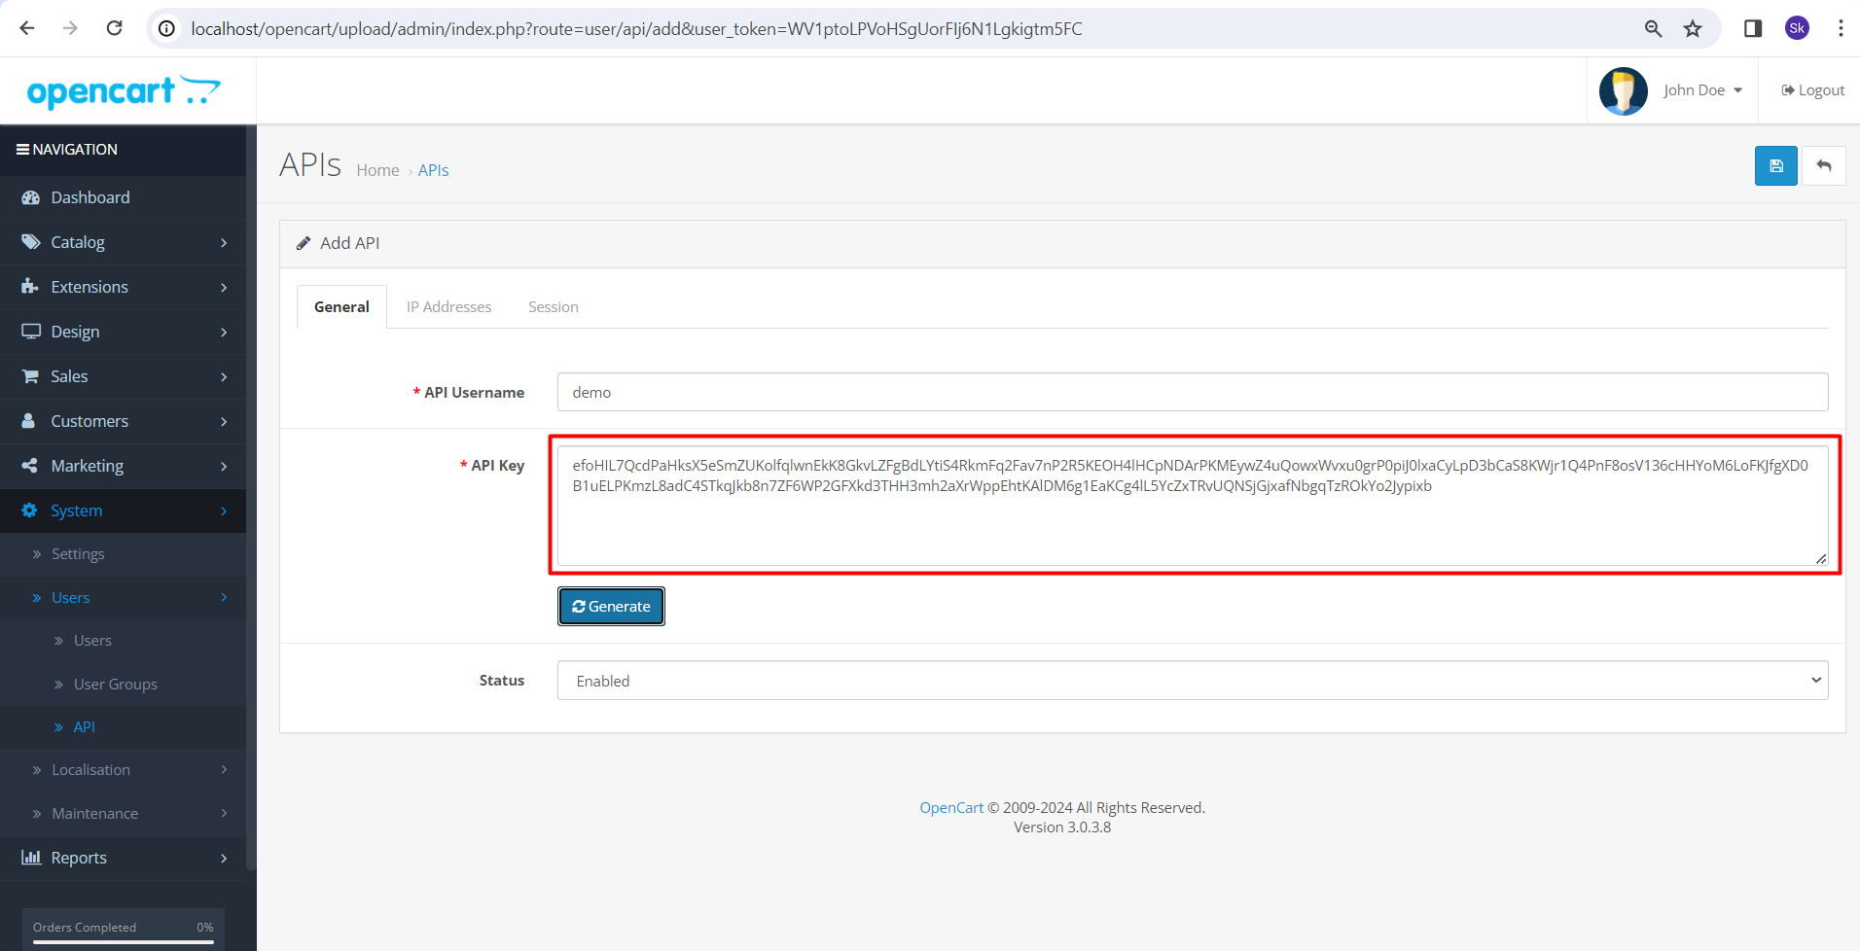

Provide Machine IP: Open CMD – ipconfig IPv.4

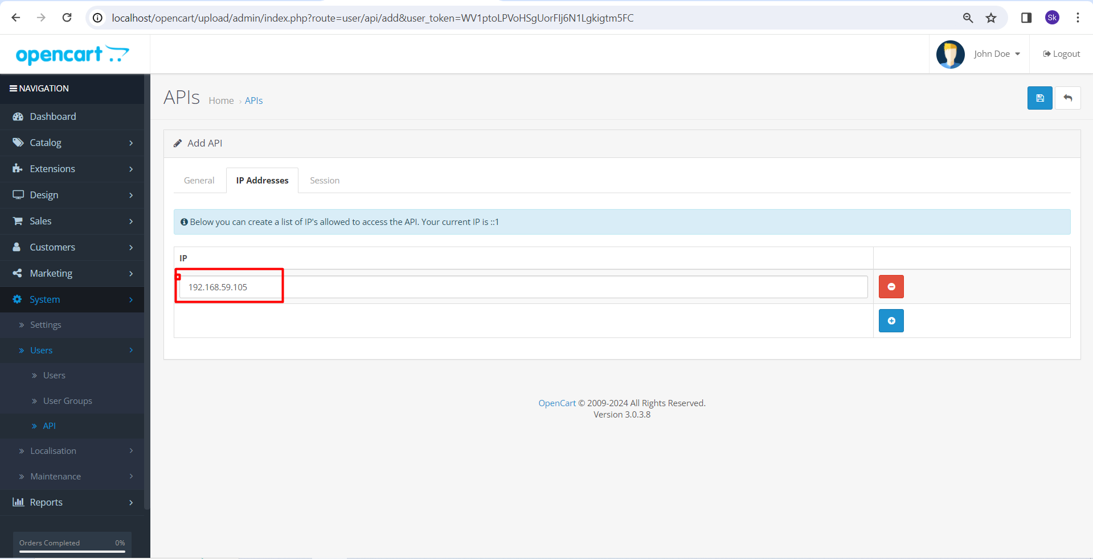

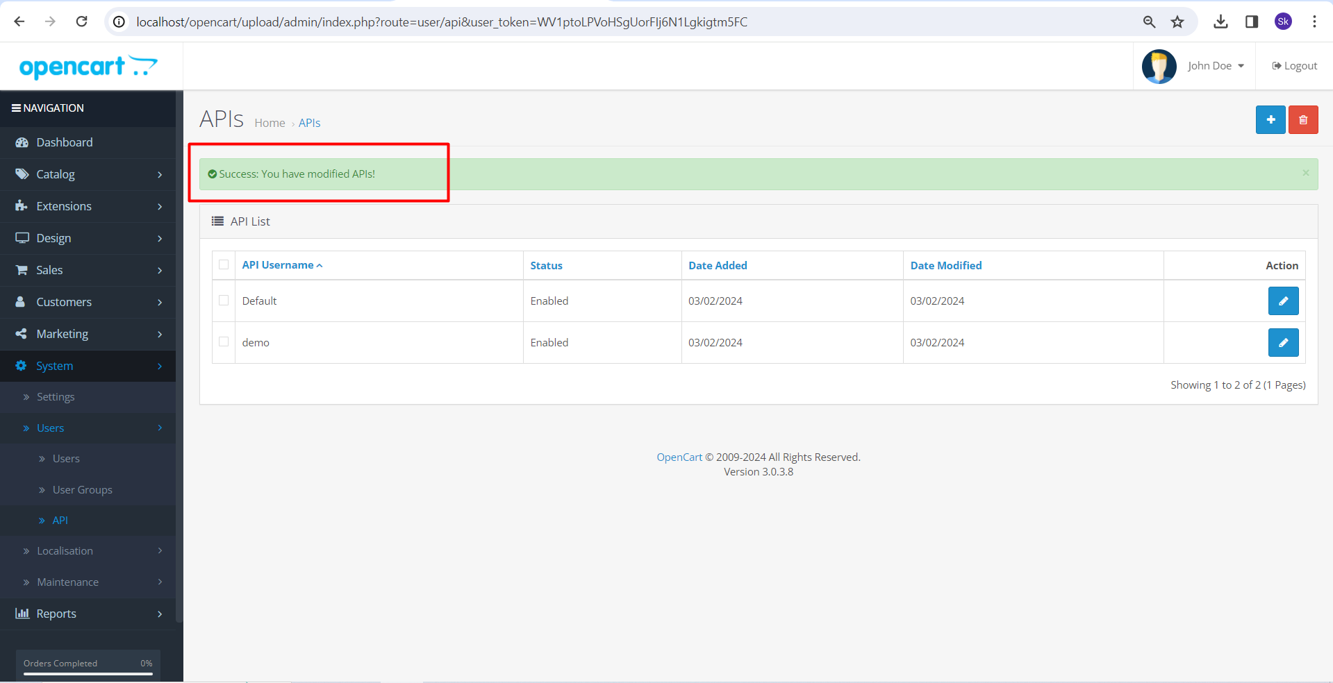

Then we shall get the documentation.

<https://docs.opencart.com/en-gb/system/users/api/>

Work flow for the open cart API

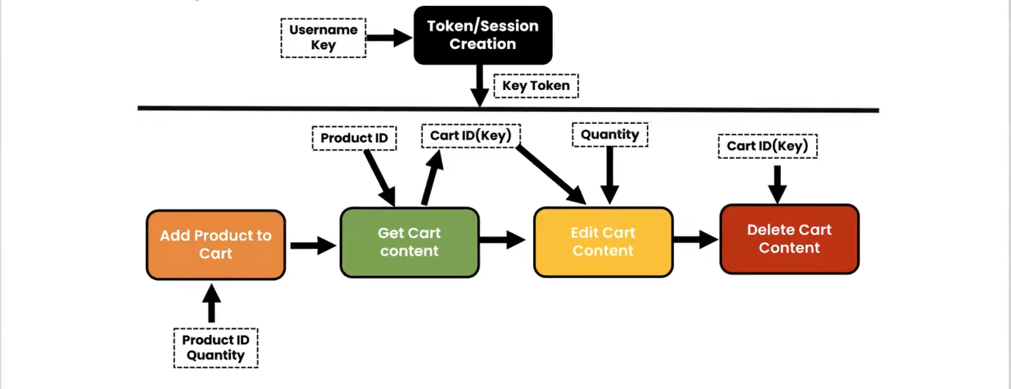

Collection link.

<https://documenter.getpostman.com/view/4924228/UzXM1JmQ>

**HOW MANY WAYS WE CAN RUN THE COLLECTION.**

* **Run collection locally.**

We have to install the Newman component, it is related to nodejs.

Prerequisite – nodejs+npm

Also Newman-reporter-html.

* Install newman : Run the command in cmd 🡪 npm install –g newman

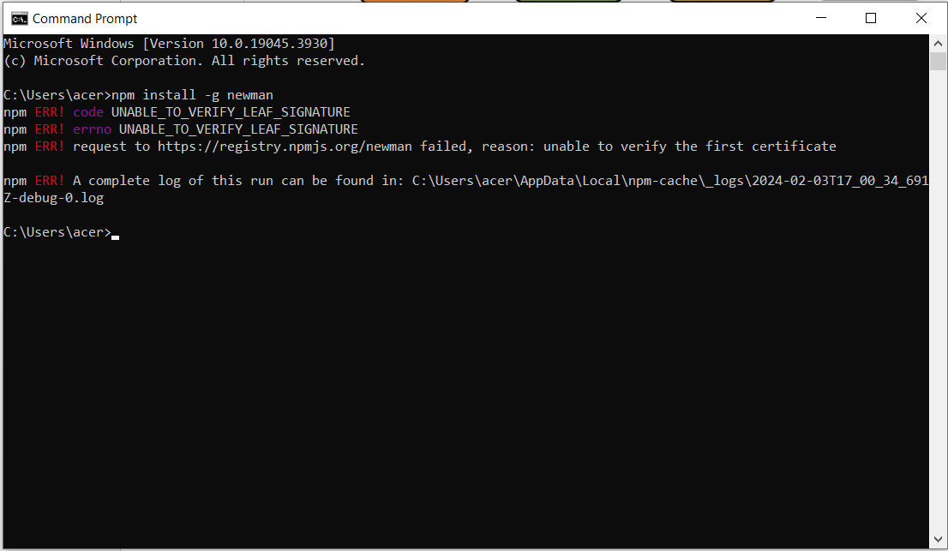

* Install newman-report-html : Run the command in cmd 🡪 npm install –g newman-reporter-html

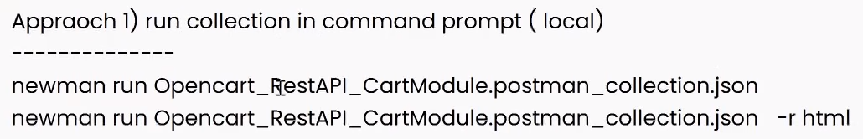

The html file shall be generated for the r html command in the same path where the file is available.

* The below command is for the users who can remotely use URL collection.
* Also they can open the same in the cmd.

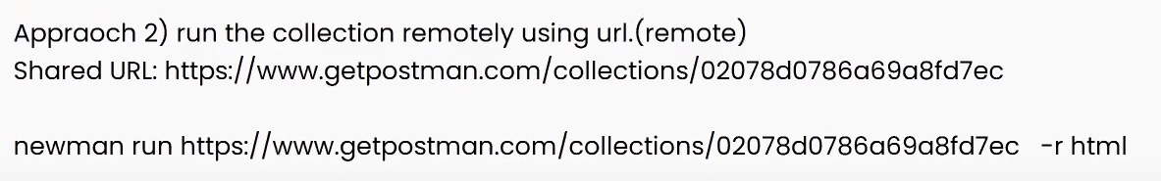

How to generate share link.

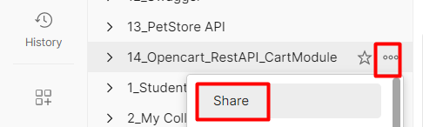

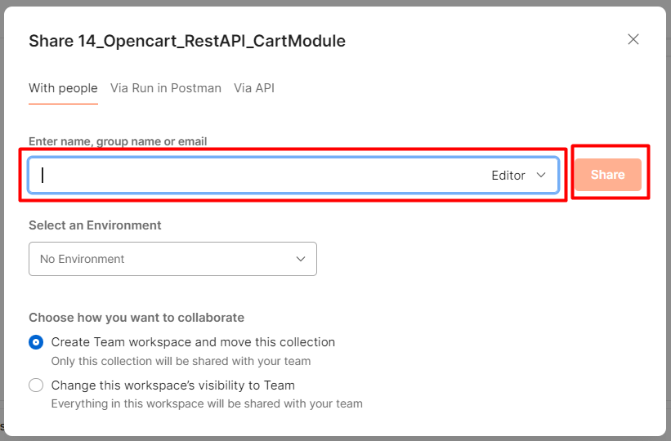

**HOW TO RUN THE COLLECTION IN JENKINS.**

* **It is a continuous integration tool.**
* Have to download the Jenkins war file (Need not to install the same).
* Link - <https://www.jenkins.io/download/>

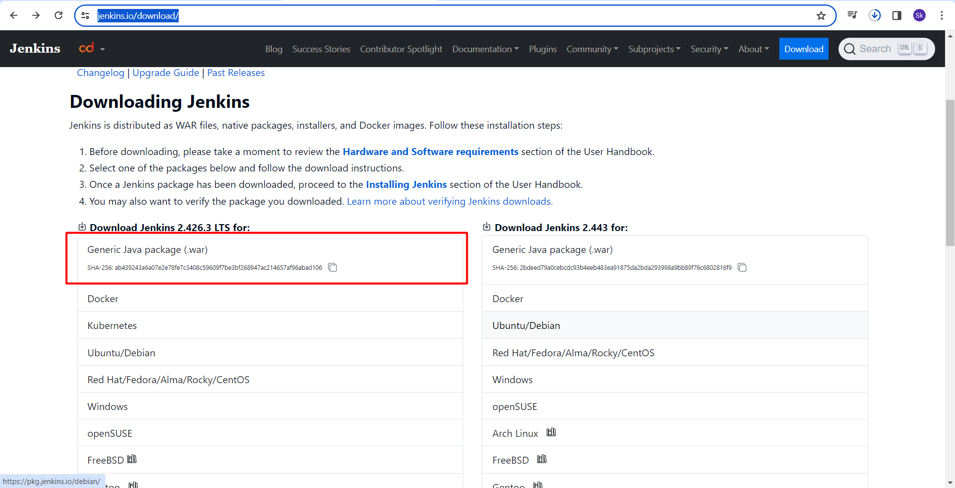

Once the jenkin.war file has been downloaded, we have to place the same in the C drive.

Create the jenkin folder and place the war file in it.

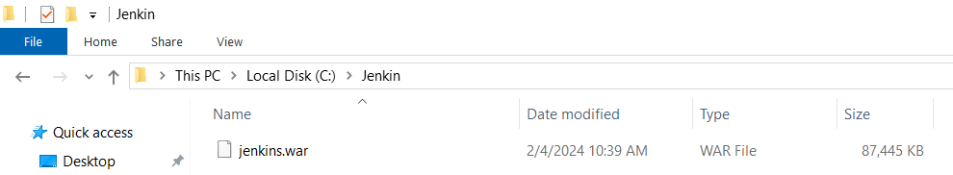

Then run the below command in cmd.

Java –jar Jenkins.war

It shall run the Jenkins.war file.

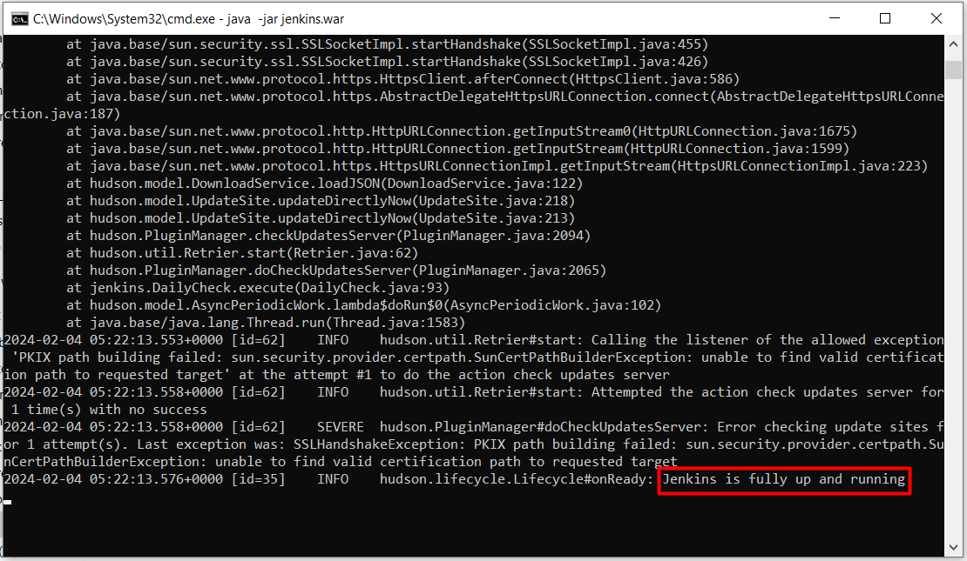

Now up your xamp app and run the below URL in browser.

<http://localhost:8080>

The login into Jenkins with admin and admin (first create the account).

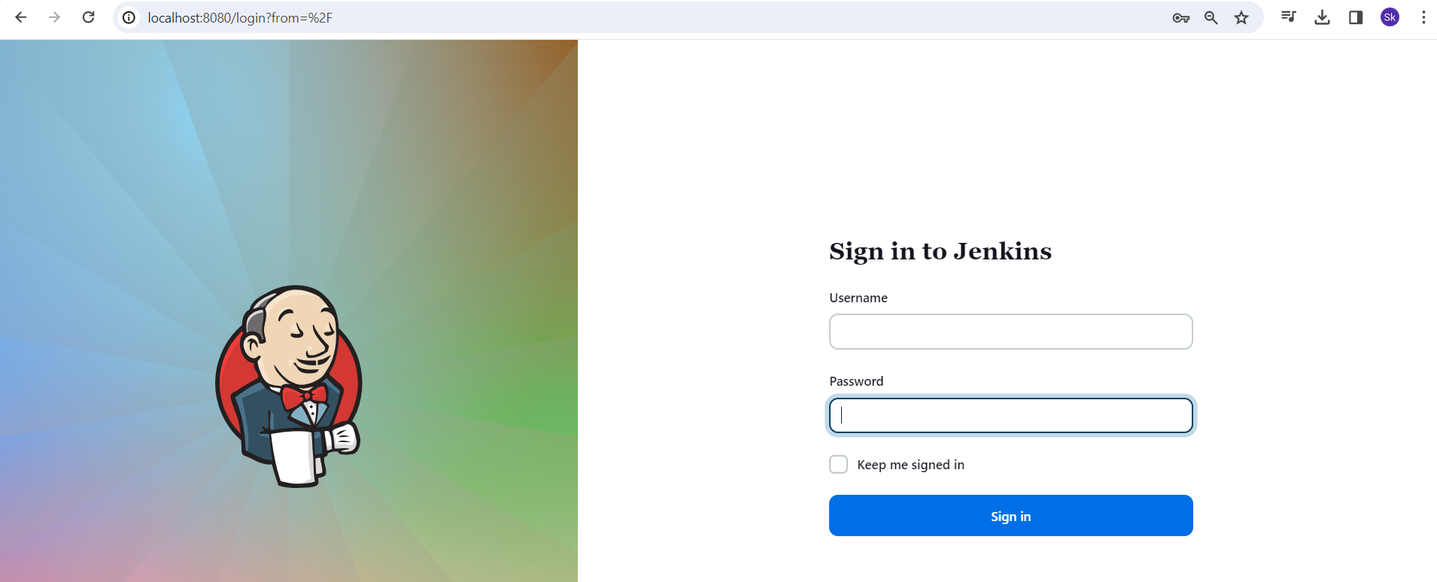

Create new item as the project name.

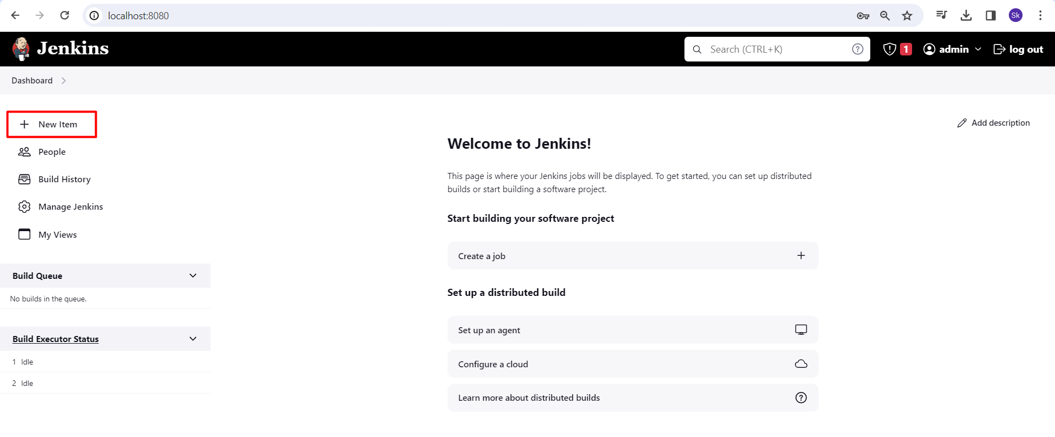

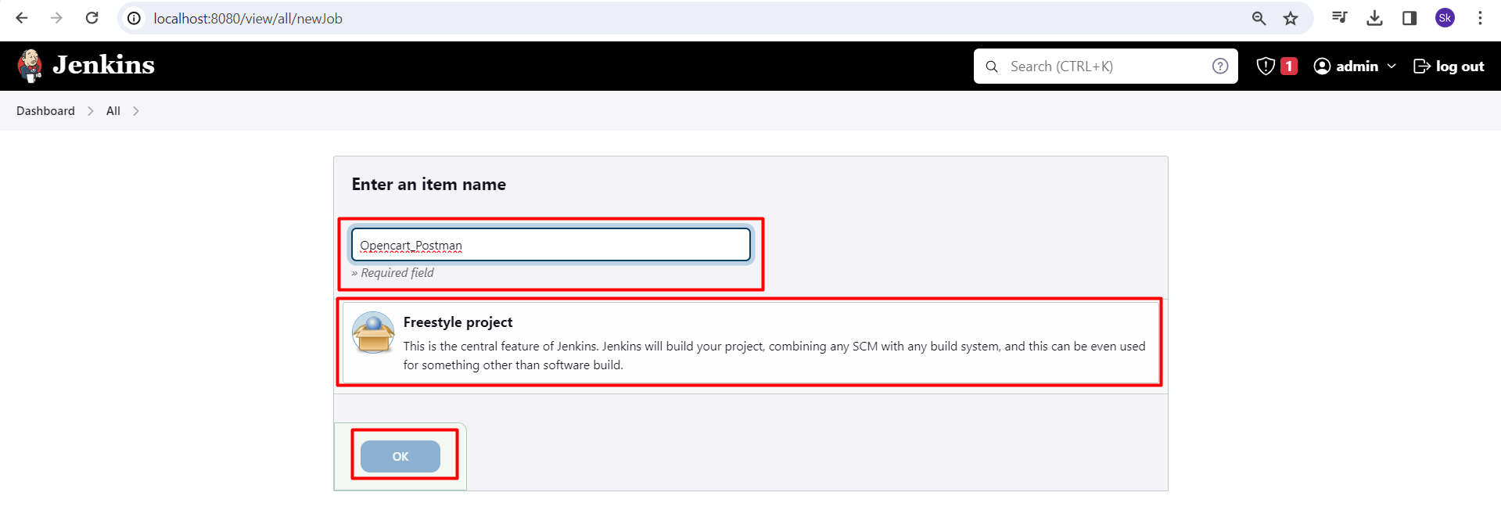

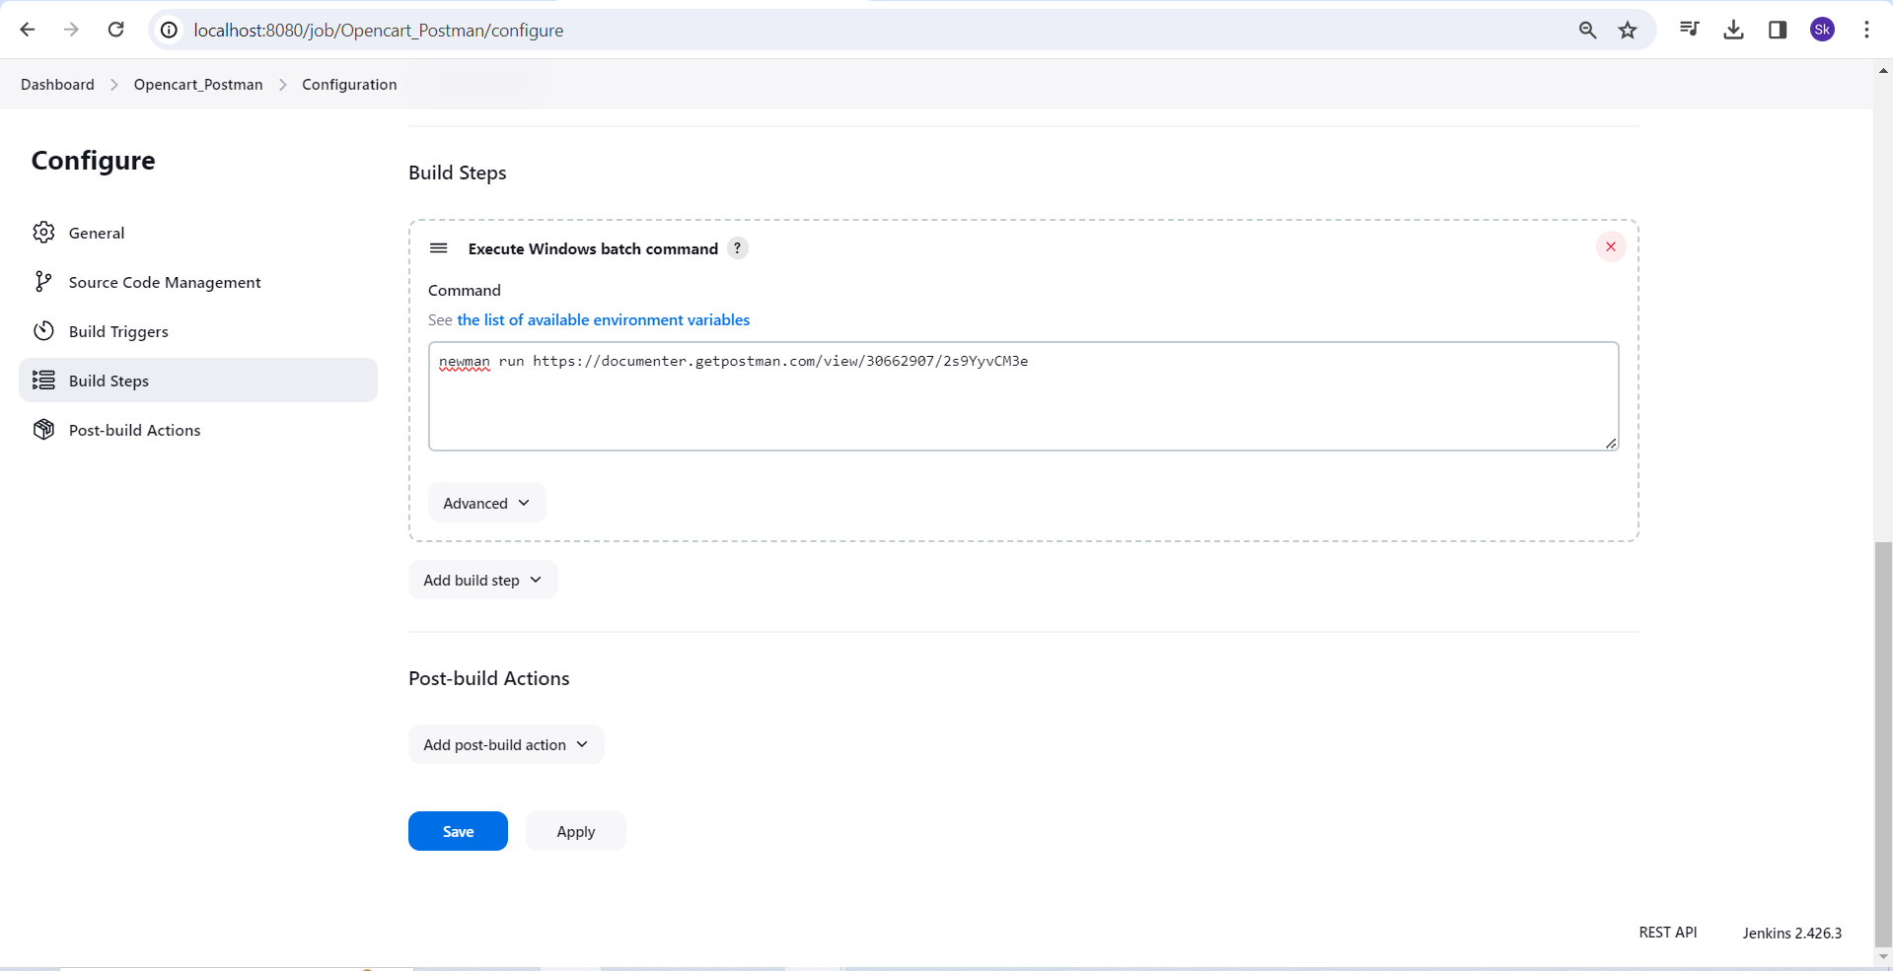

We can now run it from anywhere.

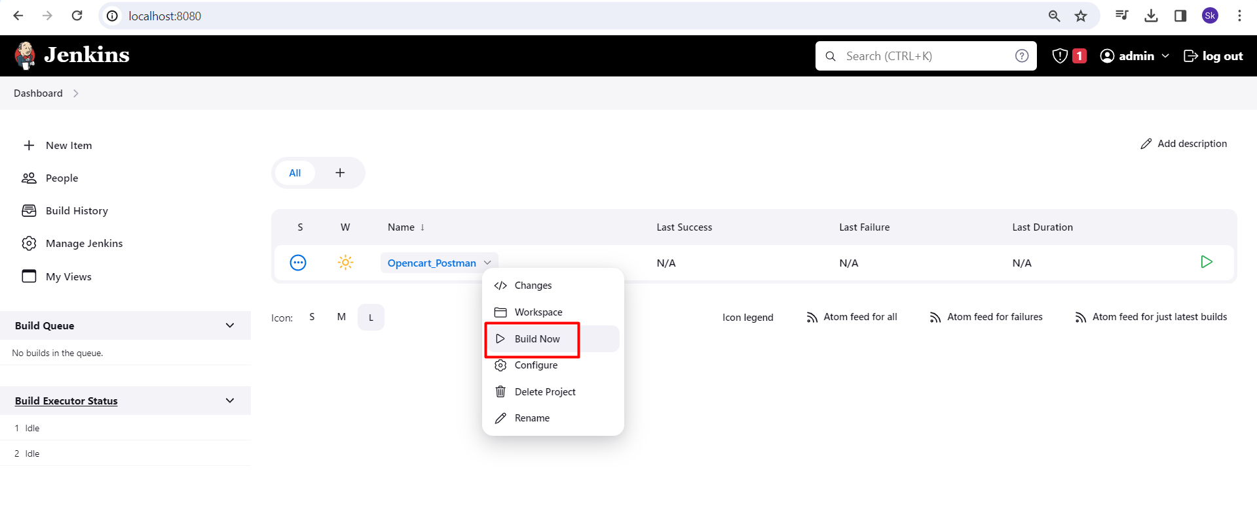

**Export the collection to the GITHUB repository.**

* Download the git
* Link - <https://git-for-windows.en.lo4d.com/windows>

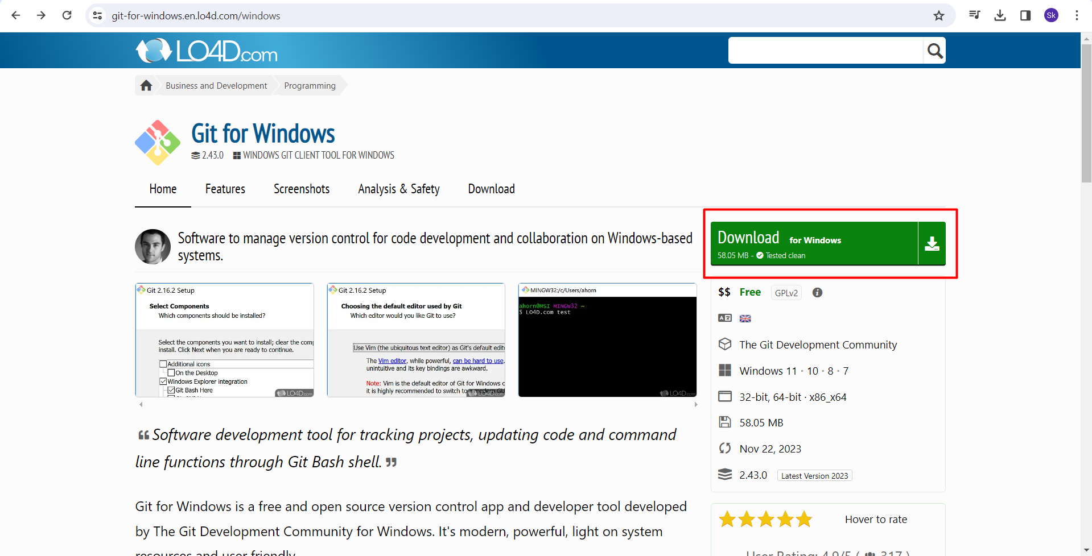

* Then create the local repository in the github.
* Once the github repository has been made copy the repository URL.
* [**https://github.com/Sujitkhaware/API_Project.git**](https://github.com/Sujitkhaware/API_Project.git)

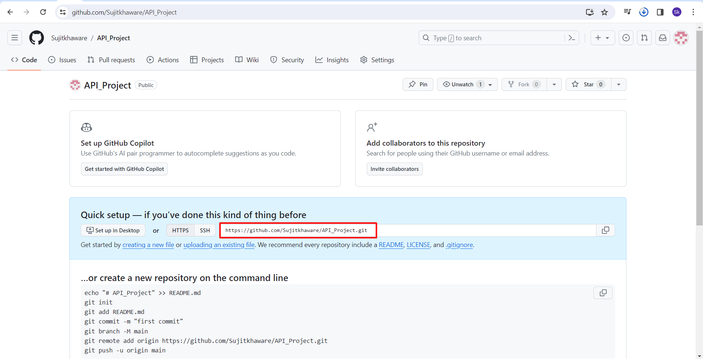

* Once the git software is install, you can view the below option.

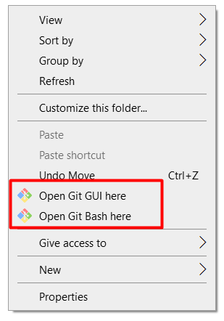

* Create local repo. Open git bash.
* Git init – cmd (By using this we shall create the local repository)

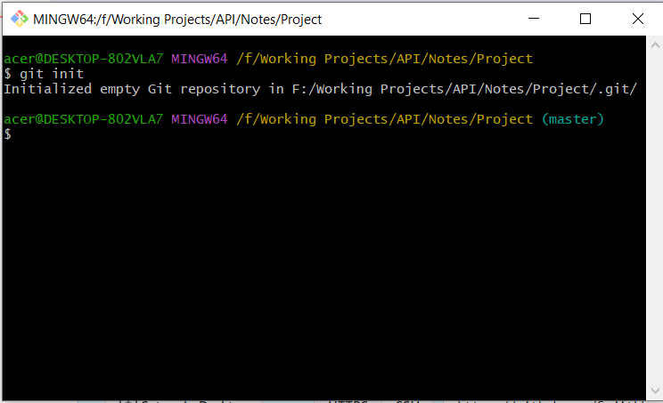

* Now we have to connect the local repository to the remote repository
* git remote add origin <https://github.com/Sujitkhaware/API_Project.git> -- cmd (This shall connect the local repository to the remote repository)

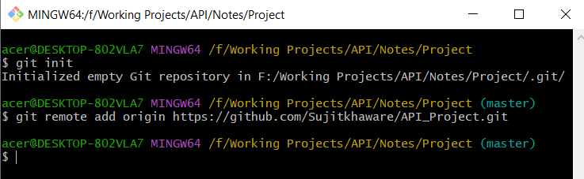

* Now we shall able to commits and push our collection to the repository.
* Fist check the status

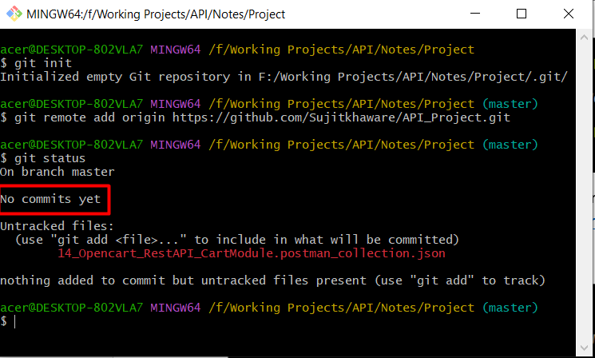

* Then we need to add the collection to the index or staging area.
* git add 14_Opencart_RestAPI_CartModule.postman_collection.json – cmd

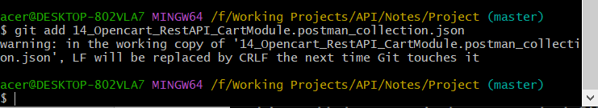

* now check the status

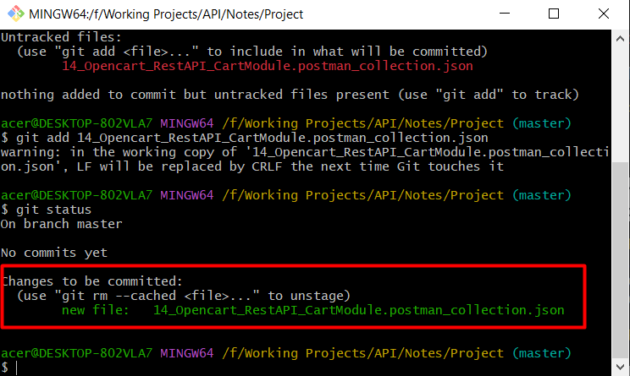

* It is now added to the staging from there you can commit it in the repository.
* git commit –m “first commit” – cmd

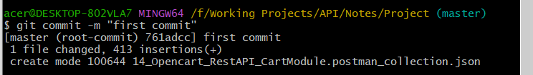

* Now recheck the status.

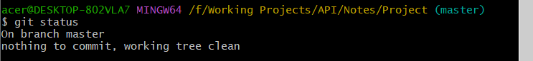

* Now it is present in the local repository.
* Now we shall push the local to main repo.
* git push origin master – cmd
* Then shall able to view the file in git.